Appendix A: Market Research

Page
Specifications for Focus Group Research Services 2

Focus Group Protocols 6

Decal Samples 13

Focus Group Reports 16

Phone Survey 32

Strategy Revisions 37
CITY OF WALTHAM, MASSACHUETTS
DEPARTMENT OF PUBLIC WORKS

Specifications for Focus Group Research

BACKGROUND

A 1999 survey of Waltham residents indicated that residents strongly supported increasing the frequency of curbside collection from every other week to weekly collection, even though they were informed during the survey that it would cost taxpayers substantially more. Accordingly, in the fall of 2000 the City made this change, increasing its collection costs by $250,000 per year in the process. Tonnage increased dramatically during the first few months of weekly curbside collection, but has since subsided to the same levels observed during every-other-week collection. Waltham made a strong financial commitment to waste diversion. Now it is important that the city increase its recycling rate. A variety of information intensive initiatives have been tried over the last year including newspaper articles and paid ads, a city-wide postcard, and flyers distributed to school children, in utility bills and in recycling bins. Given the lack of success of these initiatives, the City’s administration believes it is particularly important to uncover the barriers to participation in the curbside program in order to guide future promotional efforts. Therefore, the City is interested in designing a strategy to increase participation using community-based social marketing (CBSM) techniques.

A variety of tools are used in the process of planning a program using CBSM techniques. Literature reviews, focus groups, and phone surveys are used to uncover the barriers to various waste reduction activities. Once the barriers are uncovered, a strategy is developed to overcome them. The strategy utilizes behavior change tools such as: commitment techniques, prompts, community norms, persuasive communication, incentives, modeling and social diffusion. Focus groups, and small-scale pilots are then used to refine and test behavior change strategies. Baseline and follow up measurements are used to evaluate the pilots. More information about cbsm can be found at www.cbsm.com

A combination of state and city funding will be used to carry out this community-based social marketing project. State funding will be used to procure project management, design and evaluation services to be provided by the consulting team of Jan Aceti and Dr. Doug McKenzie-Mohr. Additional information on the roles and backgrounds of Aceti and McKenzie-Mohr is furnished below for clarification. The City will fund the services of a market research firm to perform the tasks set out in the Scope of Work below. Eileen Zubrowski, Recycling Coordinator for the City of Waltham, will oversee procurement of and payment for the services described in the Scope of Work.

SCOPE OF WORK

The City of Waltham seeks to contract with a market research firm to do the following:

- Conduct four focus groups consisting of City of Waltham residents. The first two focus groups are to be conducted during the week of November 12-16, 2001. The second two focus groups are to be conducted during the week of January 30 – February 6, 2002.

2. Recruit focus group participants. Each focus group should contain 8-10 participants. Two of the focus groups will be exclusively male and two exclusively female. Participants must live in buildings with 15 or fewer housing units. Within each group, a range of age, income and educational levels is desired, as well as a distribution across race, ethnicity, language and Waltham neighborhoods. Participants representing various language groups must be fully bilingual.

- Pay focus group members a stipend for their participation.

- Provide a facility in which to hold the focus group meetings.

- Moderate the focus groups and provide a note taker.

- Provide beverages for focus groups members.

7. Audiotape the focus groups meetings. An audio check must be done to ensure that each focus group participant can be heard clearly on the tape. No transcript is required. .

- A questionnaire and protocol will be provided for use with the first two focus groups and another questionnaire and protocol for use with the second two focus groups. The focus group moderator will be responsible for reviewing the questionnaires and protocols with Ms. Aceti in order to ensure clarity on the areas in which the City of Waltham requires input from the focus group members.

- Provide the following reports and materials to the Aceti/McKenzie-Mohr team: 1) Good quality audiotapes of each focus group meeting; 2) Original written responses made by focus group participants as a result of instructions to write a response to a question before answering verbally; 3) A log of verbal participant responses as recorded by the note taker; 4) A summary of the participants’ responses, indicating the main themes. All reports must be printed on 30% postconsumer recycled paper and available electronically. The reports and research materials are to be couriered directly to:

Doug McKenzie-Mohr, PhD
McKenzie-Mohr Associates
290 Wright St.
Fredricton, NB
E3B 2E4

- The tasks relevant to the first two focus groups are to be completed between October 26, 2001 and November 23, 2001. The tasks relevant to the second two focus groups are to be completed between January 16, 2002 and February 13, 2002.

ROLE AND BACKGROUNDS OF ACETI/MCKENZIE-MOHR TEAM

Prior to bid submission, requests for clarification regarding the Scope of Work should be addressed to Ms. Aceti. Ms. Aceti will also serve as the liaison to the market research firm that is contracted by the City of Waltham to carry out the scope of work described above. Dr. McKenzie-Mohr will serve as technical consultant on the questionnaires and protocols.

Jan Aceti has fourteen years of professional experience successfully promoting waste reduction on a community scale. She served as Recycling Director for the City of Cambridge, Massachusetts from 1991 – 2001.

Dr. Doug McKenzie-Mohr has been working to incorporate scientific knowledge on behavior change into the design and delivery of community programs for over a decade. As a consultant, Dr. McKenzie-Mohr has worked with a diverse array of clients, assisting them in identifying the barriers to behavior change and in developing and evaluating community-based social marketing initiatives to overcome these barriers. He is a Professor of Psychology at St. Thomas University, Fredericton, where he teaches community-based social marketing, social psychology and survey research methods.

CONTACT INFORMATION

For Questions On: | Contact | Contact Information
1)Bid Submission Process  2) Payment | Eileen Zubrowski | 119 School St.  Waltham, MA 02451  Ph: 781-314-3391  Fax: 781-314-3032  ezubrowski@city.waltham.ma.us
- Clarifications on Scope of Work  - Project Coordination  - Questionnaires and Protocols | Jan Aceti | 19 Allen St. #2  Arlington, MA 02474  781-646-4593  j.aceti@worldnet.att.net
QUOTE SUBMISSION:

- Quotes must be submitted by 5pm on October 19, 2001 to Eileen Zubrowski at the address or fax number above.
- A contract will be awarded by October 26, 2001.
- Potential vendors must provide three references for focus group research they have done, with contact names and phone numbers
4) Potential vendors must provide a one page description of the background/experience of the staff that will be conducting the focus group research

PRICE SUMMARY FORM

All costs associated with the services set forth in the scope of work must be included in the total price. Prices must remain firm thoughout the entire period during which work is being done.

Total price $________________

_________________________________________
(repeat sum in words)

Name of company representative

Signature of company representative

Phone Number of company representative

Email Address of company representative

Name of company

Address of Company

Fax Number

Focus Groups to Evaluate Barriers to Participation
in Curbside Recycling in the City of Waltham

Guide for Focus Group
November 15, 2002

General Protocol

- a response is obtained from each participant on every question, and each person has an equal opportunity to share their views and perspectives;
- the discussion is focused on the topic/question at hand, and is commenced and completed on time (1.5 hour meeting duration);
- each participant has a pen/pencil and paper;
- the note-taker records the full range of responses for each focus question, enabling frequencies to be easily determined for the purposes of preparing the meeting summary;
- the note-taker and facilitator keep an eye out for gender and other potential demographic differences in response to the focus questions.

1.0 OPENING REMARKS AND INTRODUCTIONS (5 minutes)

Hello, my name is Karla Buhsmer. I am a consultant with a local firm, Research International of Cambridge.

My job is to chair the meeting. My colleague, ________, will be taking notes during the meeting.

Before we start, I'd like to thank you all for coming and we look forward to hearing your ideas and perspectives during the meeting.

So why have we asked you here?

We’d like to get a sense of what residents know and think about recycling. We would also like to know what you believe the City of Waltham can do to make it easier to participate in curbside recycling.

Before we start, I'd like to bring a few things to your attention…

First, this meeting is one of several that are being conducted with City of Waltham residents on this topic.

Second, I'm not an employee of the City of Waltham, and am unlikely to be able to answer any questions you may have that go beyond this specific project. If you do have specific questions you'd like to ask the City, we will take your name and number after the meeting and have one of their representatives contact you in the next few days.

Third, we will be taking notes and tape recording the session. For most questions we will also be asking you to jot down your responses on the provided paper prior to sharing them with the group. You should know that anything you say or write will be treated in confidence. We will use our notes, your written responses and the recording to prepare our report on this meeting, and no names will be used. So, please feel free to speak frankly.

As you know, we chose you randomly to take part in tonight's meeting. This is to help us make sure we hear from typical people from the City of Waltham, not just from people who know or care a lot about recycling.

Finally, in just a minute, I'm going to ask you a series of questions. Be assured…there are no right or wrong answers…just your opinions, ideas and perspectives.

Lessons Learned: The focus group facilitator was unaccustomed to asking participants to write their answers down before answering and to soliciting a response from each participant. She was concerned that both of these protocol elements would cause participants to be less engaged in the conversation. In fact, observations confirmed that both of these protocol elements were very important. In the focus group of non-recyclers, initial comments about the inconvenience of recycling included statements of belief that recycling was picked up only every other week in Waltham. It appeared that none of the non-recyclers were aware that the City had increased the frequency of collection to once per week. However, after the facilitator asked participants to write down their answers to a specific question about the frequency of collection, several participants acknowledged that they knew that recyclables were picked up weekly. Also, when responses were solicited from each participant individually, more opinions were offered and the comments were more extensive than when the facilitator simply opened up the floor for discussion. It did not appear that either of the protocol elements caused the participants to become disengaged.

The number of questions in this guide did make it difficult to allow time for people to write their responses and to query each participant individually. In the end, the facilitator cut corners on these protocol elements in order to end the session on time. The number of questions in the second focus group guide was more conducive to allowing time for writing and individual responses.

Introductions…

Please tell me your name, the number of people in your household, and the area you live in.

2.0 FOCUS QUESTIONS

If you recycle most or all of the time, what motivates you to do this? If you don't recycle or don’t recycle as much as you could, what has stopped you?
Give people a minute to write down their answers, and then ask each person to share their response. [10 minutes]

For those of you who do recycle, would you say that you recycle more, less or about the same than you did last year at this time? Why?

Give people a minute to write down their answers, and then ask each person to share their response. [5 minutes]

Is there anything that you can think of that would lead you to recycle more than you do now? What prevents you from recycling now?
Give people a minute to write down their answers, and then ask each person to share their response. [10 minutes]
3.0 KNOWLEDGE AND CONVENIENCE OF RECYCLING
Do you feel that you are knowledgeable regarding what can and cannot be recycled?
How did you learn about the City of Waltham’s recycling program? Do you think the City provides you with enough information regarding its recycling program?

Give people a minute to write down their answers, and then ask each person to share their response. [5 minutes]

What types of items can and cannot be recycled in the City of Waltham’s curbside program?
Ask that participants make separate lists of items that can and cannot be recycled on a new piece of paper that can be turned in. Give people a minute or two to write down their answers, and then ask each person to share their response. [20 minutes] Finish by providing people with the list of items that can and cannot be recycled.

After reviewing this list, are you surprised to learn of specific items that can or cannot be recycled?
Do you recall receiving materials from the City regarding what is recyclable? Have you kept those materials? What, if anything, would make it easier to know what items can be recycled?

How convenient is it to recycle? If you don’t find recycling convenient, what would make it more convenient?

Give people a minute to write down their answers, and then ask each person to share their response. [10 minutes]

How frequently does the city pick up your papers, bottles and cans? Have you had any problems with the hauler who collects your recyclables? What would you do if you wanted to have an old appliance, TV or computer picked up?

You may need to clarify who the hauler is though most participants will glean this from the wording of the question. Give people a minute to write down their answers, and then ask each person to share their response, through a show of hands or otherwise. [10 minutes]

4.0 YARD WASTE RECYCLING
Do you feel that you are knowledgeable regarding what yard waste is recyclable? What types of items can and cannot be recycled via the City of Waltham’s yard waste program? What, if anything, would make it easier to know what types of material can be recycled?

Ask that participants make separate lists of yard waste items that can and cannot be recycled on a new piece of paper that can be turned in. Give people a minute or two to write down their answers, and then ask each person to share their response. [10 minutes] Finish by providing people with the list of items that can and cannot be placed in the yard waste container.
After reviewing this list, are you surprised to learn of specific yard waste items that can or cannot be recycled?

Do you know when to put the yard waste at the curbside for pickup? When does the City pick up yard waste?

Give people a minute to write down their answers, and then ask each person to share their response through a show of hands or otherwise. [2 minutes]

5.0 GENERAL
What do you believe is most likely to motivate people in the City of Waltham to recycle?

Give people a minute to write down their answers, and then ask each person to share their response, by a show of hands or otherwise. [5 minutes]
Do friends, family, or colleagues expect your household to recycle? Whose opinion do you care about most when it comes to recycling?
(ASK RECYCLERS) Do you expect your neighbors or friends to recycle?

(ASK OF NON-RECYCLERS) Do you take notice of whether your neighbors or friends recycle?

Give people a minute to write down their answers, and then ask each person to share their response, by a show of hands or otherwise. [5 minutes]

What do you feel is the most effective way for the City of Waltham to encourage people to recycle as much as they possibly can?

Give people a minute to write down their answers, and then ask each person to share their response. [5 minutes]

Do you have any additional comments that you would like to share?
Ask each person if they have additional comments that they would like to share (5 minutes)
6.0 CLOSING REMARKS (1 minute)
On behalf of City of Waltham, I would thank to thank you for participating in this meeting. We appreciate your answers and perspectives. These will be very helpful in further development of the City of Waltham’s recycling program. Based in part on what we learn from these discussions, we will be testing a revised curbside recycling program in parts of the City of Waltham. If the pilot is successful in diverting more waste, we then plan to deliver the revised program to the remainder of the City. The City of Waltham is very interested in your opinions and perspectives on the topic of recycling. The feedback we receive from you will help us to develop the best possible recycling program.

Focus Groups to Evaluate Social Marketing Strategies

Guide for Focus Group
February 5, 2002
General Protocol

- a response is obtained from each participant on every question, and each person has an equal opportunity to share their views and perspectives;
- the discussion is focused on the topic/question at hand, and is commenced and completed on time (1.5 hour meeting duration);
- each participant has a pen/pencil and paper;
- the note-taker records the full range of responses for each focus question, enabling frequencies to be easily determined for the purposes of preparing the meeting summary;
- the note-taker and facilitator keep an eye out for gender and other potential demographic differences in response to the focus questions.

1.0 OPENING REMARKS AND INTRODUCTIONS (5 minutes)

Hello, my name is Karla Buhsmer. I am a consultant with the firm, Research International of Cambridge.

My job is to chair the meeting. My colleague, ________, will be taking notes during the meeting.

Before we start, I'd like to thank you all for coming and we look forward to hearing your ideas and perspectives during the meeting.

So why have we asked you here?

We’d like to get a sense of what residents think about several strategies we are considering to increase the amount of material recycled in the City of Waltham. Based in part on what we learn from these discussions, we will be testing a revised curbside recycling program in parts of the City. If the pilot is successful in diverting more waste, we then plan to deliver the revised program to the remainder of the City. The City of Waltham is very interested in your opinions and perspectives on our proposed strategies. The feedback we receive from you will help us to develop the best possible recycling program.

Before we start, I'd like to bring a few things to your attention…

First, this meeting is one of two that are being conducted with City of Waltham residents on this topic.

Second, I'm not an employee of the City of Waltham, and am unlikely to be able to answer any questions you may have that go beyond this specific project. If you do have specific questions you'd like to ask them, we will take your name and number after the meeting and have one of their representatives contact you in the next few days.

Third, we will be taking notes and tape recording the session. For most questions we will also be asking you to jot down your responses on the provided paper prior to sharing them with the group. You should know that anything you say or write will be treated in confidence. We will use our notes, your written responses and the recording to prepare our report on this meeting, and no names will be used. So, please feel free to speak frankly.

As you know, we chose you randomly to take part in tonight's meeting. This is to help us make sure we hear from typical people from the City of Waltham, not just from people who know or care a lot about recycling.

Finally, in just a minute, I'm going to ask you a series of questions. Be assured…there are no right or wrong answers…just your opinions, ideas and perspectives.

Introductions…

Please tell me your name, the number of people in your household, and the area you live in.

2.0 QUESTIONS

- One problem with the present curbside recycling collection program is that residents are not diverting as much material as they possibly could. We know from other research that we have done that many residents do not know all of the items that can be recycled and that many do not keep or refer to the Recycling Flyers that the City provides. As a result, one of the strategies that we are considering is attaching decals to the recycling containers that clearly indicate what is recyclable. What do each of you think of this idea?

Now that you have had a chance to hear everyone’s opinion, do you have anything else that you would like to add?

Give people a minute or two to write down their answers, and then ask each person to share their response. Finish by providing people with the list of products that can and cannot be recycled. [15 minutes]
- I have brought to this meeting several mock-ups of decals that we are considering using. I’d like to show you several versions of the decal we are contemplating for the recycling containers and ask you to provide me with feedback on each.

Show each of the recycling decals. Give people several minutes to write down their feedback on each decal, and then ask each person to share their response.

Once feedback from each person has been received, ask if there is anything else that they would like to share. [25 minutes]

- We are considering calling households to ask them to make a commitment to refer to the decal. This commitment would simply mean that a household pledges to refer to the decal when they first receive it in the mail, and to also refer to it whenever they are unsure of what can be recycled. By gaining this commitment we expect that residents will become more knowledgeable about what can be recycled. What do you think of this idea?
One possibility that we are considering is asking for permission to publish in the newspaper the names of households who make a commitment to increase their recycling by referring to the decal. By publishing their names in the newspaper we believe that we can build greater community support for recycling. What do you think about this idea?
Ask each question individually, give people several minutes to write down their response, and then ask each person to share their response. Once each person has shared his or her response ask for a general discussion. [20 minutes]

- We are considering providing residents with information about the types of products that are made from the recyclables collected by the City. By providing this information, it is expected that residents will have a fuller understanding of the benefits of curbside recycling. What do you think of the idea of providing this information to residents?
We are also considering providing residents with feedback on the amount of waste that is diverted each year from the landfill by recycling and on the amount of money that is saved by the City as a result of recycling. What do you think of the idea of providing this information to residents?
This information could be provided via radio or newspaper ads, billboards, direct mailings to households or a variety of other forms of communication. What do you think would be the most effective way to provide information on the products that are made from the recyclables we collect and on the amount of waste that is diverted by recycling?
For each question, give people a minute to write down their answers, and then ask each person to share their response. Once each person has shared his or her response ask for a general discussion. [25 minutes]

3.0 CLOSING REMARKS (1 minute)
On behalf of City of Waltham, I would thank to thank you for participating in this meeting. We appreciate your answers and perspectives. These will be very helpful in further development of the City of Waltham’s recycling program.
WEEKLY COLLECTION

Same Day as Trash

Place These Items in Bin

- Plastic Containers  thru 
- Glass Containers
- Metal/Aluminum Containers
- Milk & Juice Cartons

Place These Items in Paper Bag
(Next to or on top of bin)
- Newspapers/Inserts/Magazines
- Junk Mail/Phone Books
- Paperboard (Cereal/Shoe Boxes)
- White & Colored Paper

Need an extra bin? Need information?

Recycling Hot Line 781-314-3395

1

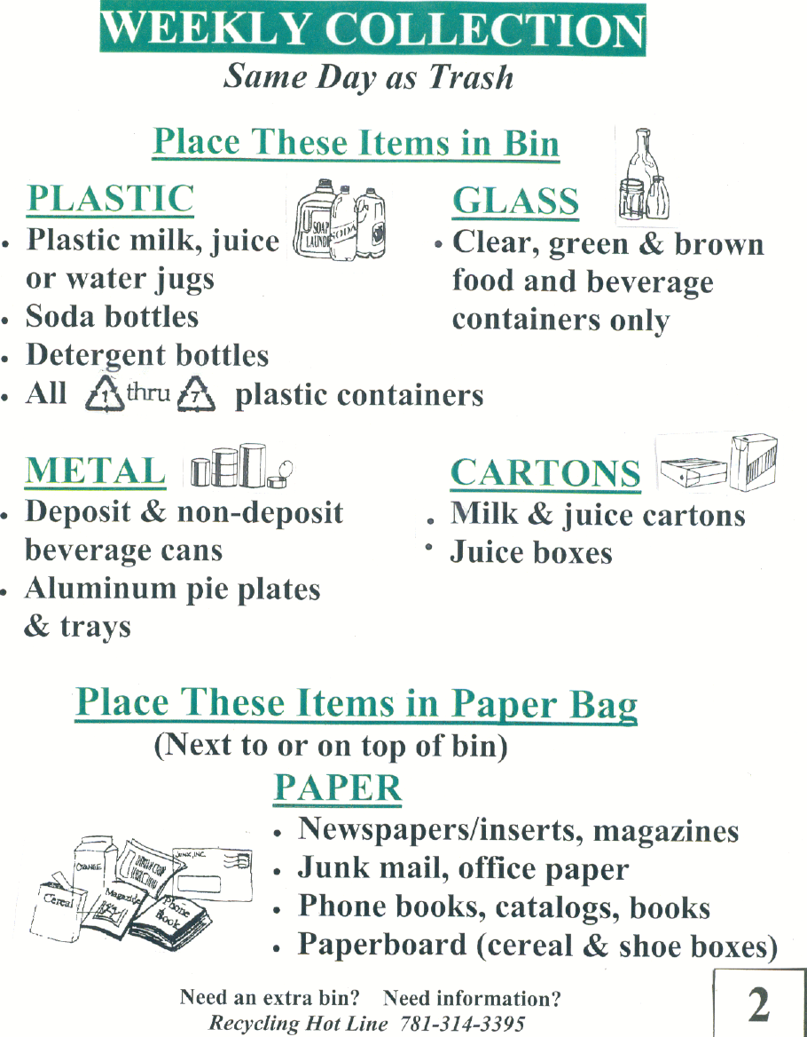

\  Papers  Containers  white and colored paper and envelopes  Clear & colored glass bottles and jars  Metal & Aluminum cans, foil, & trays  Stiff plastic containers  Flatten cardboard and cut down to no bigger than 3ft x 3ft  Papers in a brown bag or bundled with string  Remove caps, rinse & put loose in blue bin  newspapers  phone books  Junk mail  magazines  Paper bags  softcover and spiral notebooks  wrapping and packaging paper  Paperboard boxes and beverage cartons  cardboard  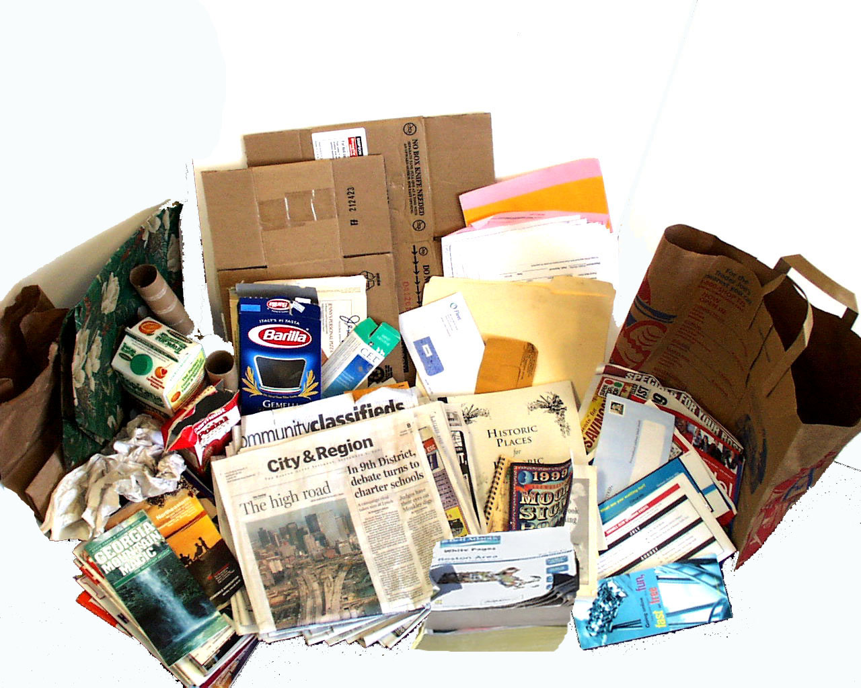  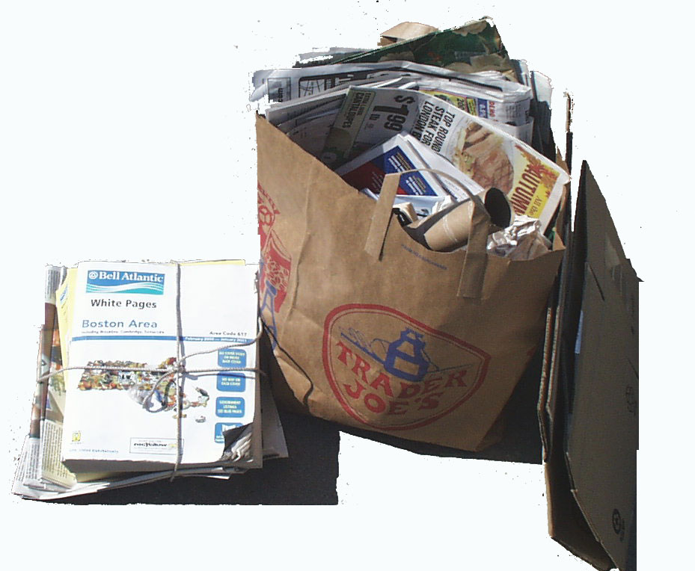 | 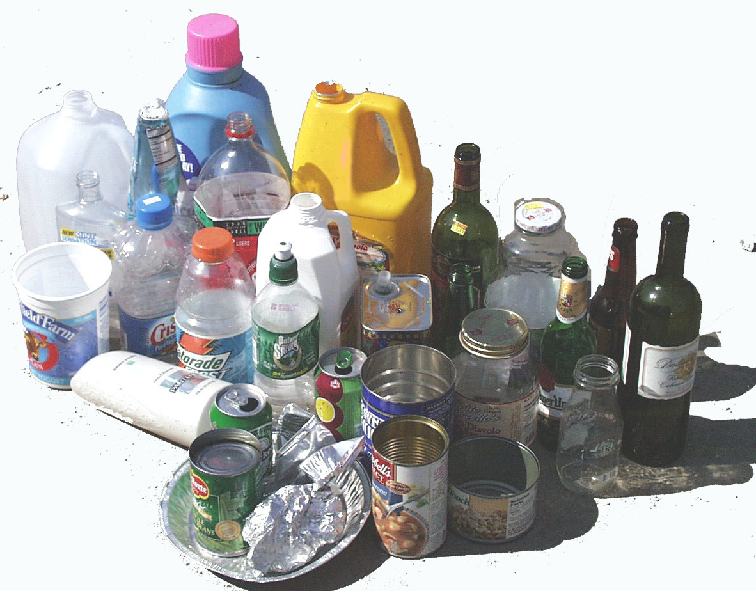  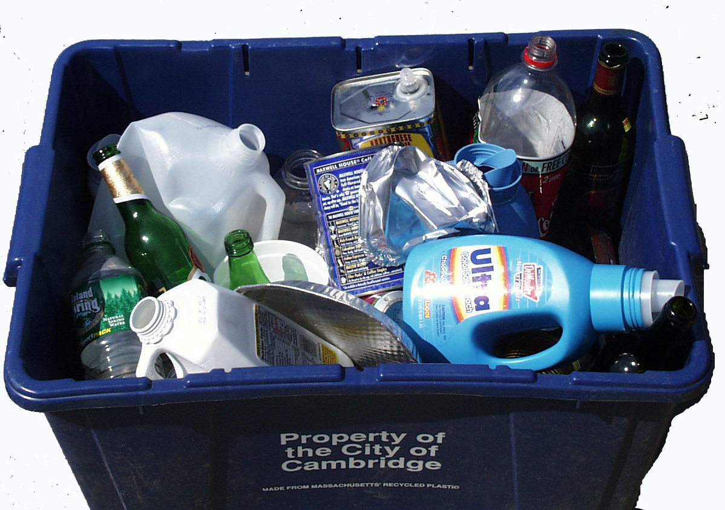
Printed on recycled paper using soy based inks  3  We can't recycle… pizza boxes, styrofoam, plastic bags, plastic toys, dishes & glassware, pots and pans, plant pots, or hangers | 3 Quick Rules:  - Do not mix papers with containers  - No plastic bags  - Put recycling at the curb by 7am on trash collection day

City of Waltham Recycling Focus Group Findings

Study Objective

Research International was contracted by the City of Waltham to conduct four focus groups with Waltham residents concerning the City’s recycling program. On Thursday, November 15, 2001, Research International conducted two of the four focus groups¹ which addressed the following issues:
- Motivations regarding recycling behavior
- Factors likely to influence higher participation levels in the recycling program
- Knowledge regarding the City’s recycling program
- Social expectations concerning recycling

The first focus group was comprised of Waltham residents who do participate in the City’s recycling program (referred to as “recyclers” in the memo) and the second group was conducted with residents who do not participate in the recycling program (referred to as “non-recyclers” in the memo). Residents’ demographics in each group were distributed between gender, age, income, and those living in single/multi-family dwellings. Of the eight participants who attended each group, four in the “recycling” group were ethnic minorities (2 American Indian, 2 Hispanic) and two in the “non-recycling” group were ethnic minorities (1 Asian and 1 Hispanic). When comparing participants’ education levels we found that more “recyclers” had pursued education beyond the high school level than had “non-recyclers.”

¹ Research International will conduct the last two focus groups in early 2002.
Key Findings

Identified below are key findings from the focus groups. Many of these findings can be further validated in the quantitative phase of the research and/or considered for inclusion in the new design of Waltham’s recycling program.

- Most residents of Waltham recycle to improve the environment.
- The frequency of collecting recyclables does influence most residents’ recycling behavior. The program’s more frequent weekly collection schedule led many recyclers to increase their recycling. Many non-recyclers do not recycle because they incorrectly think that recycling is collected bi-weekly which they perceive to be too infrequent for the amount of recyclables they have.
- Both recyclers and non-recyclers recommend that designing a bin that is higher, holds more, has a lid, and is on wheels or has sturdy handles would lead more Waltham residents to recycle. Based on our findings, the design of the recycling bin is the most significant barrier to participating in the City’s recycling program. We strongly recommend that Waltham further studies and considers redesigning the recycling bin.
- Overall, residents who recycle and those who do not are satisfied with the information Waltham provides to them about its recycling program.
- Both recyclers and non-recyclers are generally knowledgeable about materials that can/cannot be recycled. A few residents required clarification regarding the types/color of glass that can be recycled. As an example, Waltham should consider including more specific language about the types/color of glass that can be recycled in its program literature.
- Some recyclers state that residents would recycle more or even begin to recycle if the City informed the residents of specific products – both consumer and those used by the City – that were made from recycled materials.
- Similarly, recyclers and non-recyclers are knowledgeable about yard waste that can/cannot be recycled. A few residents are confused by the term “yard waste” as some interpreted it to mean waste from the yard that would include grills, etc. Waltham should further test this term in the quantitative study and possibly consider other terms that more concisely describe yard waste, e.g., yard clippings or organic material.
- Although neither recyclers nor non-recyclers feel outside pressure to recycle, a small number of non-recyclers feel a bit “guilty” about not recycling.

Motivation Concerning Recycling Behavior

Both residents who recycle and those who do not recycle state that Waltham residents recycle to improve the environment. Recyclers participate in the City’s recycling program to improve air quality and reduce landfill waste.

- “[Recycling] is good for the environment. It cuts down on trash.” (Recycler)
- “[Recycling] saves the environment, protects the water supply, and protects the air supply.” (Recycler)

A few recyclers also identify the potential financial savings that may result from recycling. For example, some participate because they believe that the City receives a financial pay-back either in the form of a tax break or as a cash payment from the recycling center and because they believe the products made from recycled material are less expensive.

Waltham’s weekly recycling pick-up schedule has led most recyclers to increase their recycling over the past year.

- “I recycle more this year because the City has weekly pick-ups.” (Recycler)

Although non-recyclers recognize the environmental benefits of recycling, most do not recycle because they perceive it to be “inconvenient.” Living situations such as residing in an apartment (especially above the first-floor) and lack of a good place to store the recycle bin are some perceived inconveniences of recycling. Also, most non-recyclers incorrectly believe that Waltham’s recycling is currently collected bi-weekly, and state that they do not recycle because of the large quantity of recyclables that collect over the two-week period.

- “I am on the second floor and I don’t really have the space.” (Non-recycler)
- “Pain in the neck. Cannot remember when pick-up is. No place to store things [and cans and bottles] attract bugs.” (Non-recycler)
- “It is very inconvenient because of [lack of] storage and sanitary problems.” (Non-recycler)

Factors Likely to Increase Recycling Behavior

Increasing the convenience of recycling may motivate people to recycle more or to start recycling. Both recyclers and non-recyclers agree that recycling would be more convenient if the design of the recycling bin is modified. In general, both groups recommend that the bins be made deeper to accommodate more items and to prevent items from falling out or blowing away. To prevent recyclables from smelling, attracting bugs, or from getting wet if stored outside, both groups recommend designing a cover for the bins. Some suggest placing wheels or sturdy handles on the bins to increase the ease of transporting a full bin to the curb.

- “Change design of bin.” (Recycler)
- “If bins were bigger and higher not like they are now.” (Recycler)
- “Bigger and closed containers.” (Non-recycler)
- “Large, closed containers distributed by the City to be left outside of the home.” (Non-recycler)

In addition to increasing the convenience of recycling, many recyclers believe that residents, including themselves, would be more motivated to recycle if they knew more about what was being made from residential recycled material. Also, some recyclers state that residents should be informed of the recycled products – from office supplies to materials used to build playgrounds – that are used by the City.

- “… there are many people out there who don’t know what they are recycling for. It would be nice if they would explain what they are making out of it.” (Recycler)
- “A list telling what products were made from the recycled products.” (Recycler)
- “If some of the recycled products started to show-up being used by the city such as plastic wood.” (Recycler)
- “More information on recycling, showing what recycled products are, and showing if the city is using any of these products.” (Recycler)

Both recyclers and non-recyclers with school age children state that recycling in the City would increase if the schools educate the children about the City’s recycling program and about the benefits of recycling.

- “More education at schools – instruct the kids.” (Recycler)
- “[They should] teach kids in school about it.” (Recycler)

Residents from both groups suggest that financial incentives to recyclers in the form of property tax reductions or cash payments would likely increase participation in Waltham’s recycling program.

- “Companies who recycle would be rewarded and get money and donate to school. And when recycling was new, could take it and get money for it. You can get paid for so many pounds. (Recycler)
- “[Waltham] should give back money based on the [quantity] you recycle.” (Recycler)
- “Economic reward and punishment will motivate residents to recycler.” (Non-Recycler)
- “If recycling would keep (property) taxes down.” (Non-recycler)

If Waltham does receive a financial incentive for recycling, residents identify that recycling would likely increase if the City informed the residents of how the recycling money is invested back into the community.

- “[Residents would recycle more if they could] see the results: how much money did Waltham receive for recycling and where did the money go.” (Recycler)

Information About the City of Waltham’s Recycling Program

Most Waltham residents are satisfied with the information the City of Waltham provides on its recycling program. Recyclers and non-recyclers recall reading information about the program in mailings and in the City’s newspaper or through seeing information on the City’s cable television station. Most recyclers recall receiving program information in the mail on an annual basis while many non-recyclers do not recall the frequency in which they receive such mailings.

- “The City does a pretty good job providing us information.” (Recycler)
- “Yes, I think it does provide enough information through the flyer.” (Recycler)
- “The City of Waltham has provided me with enough information about the importance of recycling and the way of recycling. I got the information from a letter sent to my home early this year.” (Non-recycler)
- “A card came in the mail telling you what day to put the trash recycling bin out and what to recycle and [you] can read it in the newspaper.” (Non-recycler)

Knowledge of the City of Waltham’s Recycling Program

Knowledge concerning the City’s recycling program was based on residents’ awareness of material and yard waste that could/could not be recycled as well as their awareness of the collection schedule for both materials and yard waste.

Material Recycling
Both recyclers and non-recyclers were asked to make a list of materials they believe could be recycled and those that could not be recycled. As shown in the table below, recyclers and non-recyclers are equally knowledgeable about the items that can be recycled. Residents most frequently identify paper, plastic, and glass bottles as items that can be recycled.

Materials That Can Be Recycled
 | Recyclers | Non-Recyclers
Paper | √ | √
Plastics | √ | √
Glass bottles | √ | √
Tin cans | √ | √
Aluminum cans | √ | √
Magazines | √ | √
Cardboard | √ | √
Appliances by appointment | √ | √

After identifying items that can be recycled under Waltham’s program, residents received a list of “official items” that can be recycled. Overall, residents (both recyclers and non-recyclers) were aware that all the items on the list could be recycled. A few residents were not aware that phone books and junk mail could be recycled. Similarly, a small number of residents needed clarification regarding the color of glass that could be recycled (e.g., whether blue glass could be recycled).
The table below presents the materials that recyclers and non-recyclers identify as “materials that cannot be recycled” in Waltham’s program. Both groups are aware that only certain types of plastic and glass can be recycled.

Materials That Cannot Be Recycled
 | Recyclers | Non-Recyclers
Tires | √ | √
Propane tanks | √
Certain types of plastic | √ | √
Certain types of glass | √ | √
Steel | √
Aerosol cans | √
Baby bottle nipples | √
Batteries |  | √
Oil |  | √
Chemicals/Pesticides |  | √
Paint |  | √

Knowledge of the program’s schedule for collecting recycled material greatly differs among those who recycle and those who do not. Not surprisingly, recyclers are aware that their recycled material is collected weekly while most non-recyclers incorrectly think that it is collected bi-weekly according to the color of the bin.

Yard Waste Recycling
Most participants who recycle material waste and reside in single family homes also recycle yard waste through Waltham’s program. However, we find that many participants who do not recycle materials and live in single family homes recycle yard waste. These participants find recycling yard waste more convenient than recycling material waste.

It appears that non-recyclers understand the life cycle process concerning recycling yard waste – waste decomposes into the ground and enriches soil – better than they understand the life cycle process of recycling material waste – material is often melted to be re-used as another product. Educating the residents of the products that are made from recycled material (both consumer products and those used by the City) would help educate residents of the life cycle process of material waste.
Both recyclers and non-recyclers are knowledgeable about yard waste that can/cannot be recycled in the program. Although most residents are aware that branches can be recycled, all are not aware of the exact branch size that can be recycled.

Yard Waste That Can Be Recycled
 | Recyclers | Non-Recyclers
Leaves | √ | √
Grass | √ | √
Branches | √ | √
Vegetable garden greens |  | √
Flowers | √ | √
Wood |  | √
Bushes |  | √
Organic matter |  | √

Similarly, recyclers and non-recyclers are knowledgeable about the yard waste that cannot be recycled in Waltham’s program. A small number of residents from both the recycling and non-recycling groups misinterpret that the term “yard waste” also includes outside waste from the house or backyard (i.e., grills, shingles, etc.). The City may wish to further analyze residents’ interpretation of the term “yard waste” when conducting the quantitative portion of the study.

Yard Waste That Cannot Be Recycled
 | Recyclers | Non-Recyclers
Tree stumps |  | √
Gravel | √ | √
Dirt |  | √
Shingles |  | √
Animal waste | √ | √
Rotten wood |  | √
Gas grill |  | √
Lumber | √
Bricks | √

Although most residents are aware that yard waste is collected bi-weekly, many are not aware of how many months of the year it is collected. Residents from the “non-recycling” group more often correctly estimate that yard waste is collected between 6 and 8 months of the year compared to residents from the “recycling” group who estimate that it is only collected in the fall.

Experience with Hauler

Recyclers are most familiar with the hauler that collects the City’s recycling. In general, most are satisfied with the hauler’s service, however, one recycler did state that the hauler threw material (i.e., plastic nipples from baby bottles and plastic hangers) that could not be recycled onto her yard on collection day.

Social Awareness of Recycling

In general neither recyclers nor non-recyclers state that they feel outside pressure to recycle. Recyclers do seem to expect others to recycle, but they do not communicate the benefits of recycling to neighbors or other residents who do not recycle.

- “[I’m] shocked at the people who don’t [recycle] and there seems to be a lot out there.” (Recycler)

A small number of non-recyclers feel somewhat guilty about not recycling.

- “I feel a bit guilty about not recycling. It’s not a good thing not to do.” (Non-recycler)
- “I feel obligated as a resident of Waltham, I should do it.” (Non-recycler)

More recyclers than non-recyclers take notice of neighbors’ recycling behavior. A few recyclers notice differences in neighbors’ recycling behavior. For example, one recycler takes notice of larger families on her street who have small quantities of recyclables at the curb – leading her to believe that these families do not recycle as much as they can. In contrast, a few recyclers and non-recyclers believe that small to no quantities of recyclables at the curb may mean that their neighbor eats more “fresh” than canned foods.

- “I figure that some of the people don’t use a lot of canned goods, healthy people, they are using all natural goods.” (Recycler)

City of Waltham Recycling Focus Group Findings
February 2002

Study Objective

Research International completed the final two of four focus groups with Waltham residents concerning the City’s recycling program on February 5, 2002. The final two focus groups assessed those residents’ (who currently recycle) interest in the City’s proposed recycling pilot program. The pilot program’s design was influenced by findings from the first two focus groups in November, 2001 and by subsequent telephone surveys with residents.

Specific topics discussed during the most recent groups were:
- Impressions of recycling decal to place on recycling containers
- Evaluations of three mock-up recycling decals
- Feedback on commitment to refer to recycling decal
- Interest in being educated about:
- By-products made from City’s recycled material
- Amount of annual waste City diverts from landfill as a result of recycling
- Amount of money City saves annually from recycling
- Identification of preferred medium to communicate results of City’s recycling program to community

Women participated in the 6:00 PM group and men participated in the 8:00 PM group. Any gender differences concerning the topics discussed will be noted in the findings. Both groups were diverse in both age and ethnicity.
Key Findings

- Women and men favor the recycling decal and believe it would motivate residents to recycle more.
- Women are more likely to place the decal on the recycling container where many men are likely to place it on another location (i.e., cupboard or refrigerator). Waltham should consider providing households with two decals to increase the likelihood that residents will refer to it.
- Decal 3 was the most favored recycling decal as 7 participants identified it as their favorite. Participants liked its graphics which made it easy for them to quickly learn about recycling. Decal 3 is best suited for the widest audience which includes non-English speaking residents and children.
- The value of Decal 3 can be increased by including plastic containers (1 thru 7) can be recycled, City’s recycling hotline number, City’s web site address.
- Decal 2 was the runner-up as it was most favored by 4 participants. These participants liked its layout and the effective incorporation of both text and small pictures to communicate the recycling message.
- Decal 1 was the “loser” among participants. Most found it boring, not creative, and uninformative.
- As part of the new program, the City will contact residents to request their commitment to refer to the decal. If contacted by phone, participants would commit to refer to the recycling decal when they had a question about the program. However, many participants questioned the value of such a call and recommended that the call be more informative. For example, the purpose of the call should be to confirm that resident received decal, answer any questions about the program, communicate program results, and provide information about how to obtain an additional container.
- The new program proposes to publish the names of those residents who commit to the decal in the City paper. Female participants are strongly opposed to publishing the names of residents. Men agree that the publication of names could actually negatively impact program participation.
- Participants were enthusiastic about receiving all information about the program’s success. Information about products made from the City’s recyclables is best suited for school-age children (elementary through high school). Adults, particularly property owners, are most interested in learning of the money Waltham saves from recycling.
- Participants are most interested in learning about the on-going progress of the program. As a result, participants recommend that Waltham should design signs to place outside City Hall and on other City grounds to enable residents to easily track the progress during their daily routine around the City. This signage should be updated monthly so that residents can see their actual contributions.
Focus Group Findings

A. Placing Recycling Decals on Recycling Containers

Both women and men favored the idea of receiving a recycling decal that would indicate the material to recycle under Waltham’s program. Both groups believed that providing such information on a proposed recycling decal would motivate residents to recycle more. The decal was perceived to provide significant educational value – especially for younger residents (college age and younger) who may be motivated to begin recycling if such a decal was provided.

“The decal is a good idea. People would be more aware of what to put in and more would get recycled.” (Female)

The decal design was also an important factor in discussing its likely impact on recycling behavior. Participants agreed that the decal must be large, colorful, and easy-to-read to attract people’s attention and enable them to quickly learn from its message.

“Decal is helpful if large enough and colorful.” (Male)

Differences did exist in terms of where female and male respondents would place their decal. Women were much more likely to place their decal where intended – on the recycling container. Some men raised concern about the decal getting dirty if placed on the container and suggested that they would likely place it on the refrigerator or in another area in their kitchen.

Recommendation: The “decal” is an effective medium to communicate the material that can be recycled under the City’s program. The ability to actually secure the decal on the container or on another location of choice is likely to increase the likelihood that residents will refer to the information throughout the year.

As residents keep their container in different locations (i.e., kitchen, porch, garage, etc.) provide residents with two recycling decals – one to secure on their container and another to place in a location of choice.

B. Recycling Decal Evaluation

Decal 3
Decal 3, meeting participants’ desire for “color” and ease of reading, was the overall favorite among men and women. (Four women and three men identified Decal 3 as their favorite.) The decal’s graphics -- showing both the materials to recycle and how to prepare them for curbside recycling – was perceived to be most educational. Participants thought that the decal’s graphically descriptive nature would communicate the recycling message to a wider audience which included non-English speaking residents as well as children.

“Most visual for all ages.” (Female)
“It’s good, tells me how to do it the right way.” (Female)
“Catches your eye, the photos give it interest.” (Female)
“Like the visuals, like different items pictured together.” (Male)
“Pictures keep it simple even if you can’t understand English.” (Male)
“Clear, bright, informative, easy to read.” (Male)

In addition to the decal’s graphics, many participants found specific text to be quite informative such as:
- The list of what can’t be recycled
- The three quick recycling rules

After reviewing Decal 3, many also learned that pizza boxes could not be recycled and that paper products could be recycled with newspapers.

Interested to make Decal 3 as informative as possible, participants suggested to include the following information:
- Plastic containers numbered “1 thru 7” can be recycled
- City’s recycling hotline number
- City’s web site address

The few participants who did not like Decal 3 thought it was too busy – making it unlikely that they personally would refer to it. However, after hearing others’ perceptions toward Decal 3, these participants often changed their opinion as they recognized the value of Decal 3’s design to the whole community.

Decal 2
Decal 2 was most favored by 4 participants (3 women and 1 man). Those favoring Decal 2 liked its layout and the perceived effective incorporation of both text and small pictures to communicate the message. Some also liked the use of the color green which they associated with the environment.

“Well organized and good color used.” (Female)
“Like little pictures.” (Male)

Although not the clear favorite, many found specific content on Decal 2 to be of value:
- A few men liked the “Need an extra bin?” text and accompanied phone number
- Both men and women liked the identification that plastic containers numbered 1 through 7 could be recycled
Decal 1
Decal 1 was the unanimous “loser” among women as none identified it as their favorite. However, 2 men identified it as their favorite. Women were most critical of Decal 1 – describing it as boring, not creative, and uninformative. Some suggested that it looked like a low-budget, mass-produced flier they receive in the mail. Many also alluded that they would likely “recycle” the decal rather than posting it on their container.

“(Information) won’t stay in your memory.” (Female)
“People are lazy, want to learn most in least time.” (Female)
“Very plain, not eye-catching.” (Female)

The two men who most favored Decal 1 found it simple and easy to read.

Recommendation: Decal 3 is the clear winner as it can most effectively communicate the City’s recycling message to the widest audience in the community. The size of the decal is important and should not be produced much smaller than the mock-up used in the focus group.

The educational value of the decal can be enhanced by including information such as: the recycling hotline number, message that “1 thru 7” plastic containers can be recycled, and City’s web site address.

C. Commitment to Recycling

Telephone Commitment
The new recycling program proposes to contact each Waltham household and request their commitment to refer to the decal. Participants agreed that if called, they would commit to refer to the recycling decal. The groups were divided in terms of whether such a commitment would actually increase residents’ recycling behavior. Some noted that “committing” is simply easier than “not committing” in an effort to quickly end the phone call.

“Depending on the time of the call, I’ll usually say anything to get off the phone.” (Male)
“You will get a lot of “Sure, yes, bye.” “(Female)

Men suggested that residents would be more likely to follow-through with their commitment if the call was more informative than simply asking for a commitment. Additional information to include in the phone call includes:
- Verification that household received decal
- Answer questions residents has
- Provide benefits of City’s program (items made from recyclables and benefits of recycling to the City)
- Inform residents on how to get another recycling container

A few women suggested that the City should call residents a few times a year to remind them of the recycling program.

Publish Names
One proposed way to help build support for the program was to ask permission to publish the names of residents in the City paper who committed to refer to their recycling decal. Opinions concerning this varied greatly between women and men. Women strongly opposed the publishing of names for personal security reasons.

“People don’t want their names published. People are private… horrible idea, public safety and privacy.” (Female)

Initially, men were neutral on the idea and were not certain it would motivate residents to recycle more. In contrast to women, men did not object to having their name published in the paper. However, after discussing this with the group, most men opposed the publishing of names as they thought it could actually have a negative impact on recycling participation.

“Seems kind of funny. Would it put some people off (non-recyclers), “you are such a good boy” (said of recyclers)” (Male)
“It will get people mad, if they recycle and are not called and there name is not in the paper.” (Male)

Some men recommended that publishing results of the City’s recycling program (i.e., amount recycled per year, cost savings to City) would be more effective than publishing names of committed households.

Recommendation: The pilot program will likely be more effective if Waltham households are contacted by phone shortly after the decals are mailed. The phone call should be multi-purpose and informative: (1) confirm receipt of decals; (2) ask for commitment to place decals on container and on another location of choice; (3) answer any questions about the program; (4) share program successes (dollar savings, waste diverted); (5) inquire if household needs additional recycling containers.

Do not pursue publication of names in City paper for privacy issues and to avoid potential ill-feelings toward the program.

D. Information About Recycling Program

Successes of Recycling Program
All participants were enthusiastic about the idea of Waltham providing residents with information about:
- Products made from the City’s recyclables
- Amount of City’s annual waste diverted from landfills
- Amount of money residents’ recycling annually saves the City

Participants recognized that all of the information described above should be communicated to residents as a specific message is likely to resonate more with particular individuals. For example, the participants indicated that children would be more interested to learn about product’s made from the City’s recyclables than to learn about the actual dollar savings to the City.

Participants perceived children as a key audience to reach about the City’s recycling program as children were most likely to communicate the message to their parents. Many suggested that the City’s schools educate children about the recycling program by providing program information or by assigning a school project on recycling.

In general, participants were interested in actual statistics about the program – annual waste diverted from landfill and annual dollar amount City saved by recycling. Participants who were homeowners were most interested in the bottom line – actual dollar savings generated from material recycled by Waltham.

“The more education, the better. Different information will work for different people.“ (Male)
“Everything comes down to money“ (Male)
“Absolutely all for knowing how much we’d save, show me the money.” (Female)

Communicating Results to Residents
Participants recognized the importance of identifying an effective medium to deliver information about the City’s recycling program. In general, both women and men agreed that such results should be posted outside and in multiple City locations for people to easily see during their daily routine. For example, most women favored printing results on a billboard and men suggested posting results on a sign in front of City Hall and on other City grounds. This message should be updated monthly to communicate the on-going progress. Examples of how Waltham can communicate its recycling progress to residents:

- Sign with graphic of thermometer outside City Hall which would be filled-in to show money saved or quantity of waste diverted
- Physically display progress by using objects such as recycling containers or BFI trucks to translate tonnage of waste diverted
- Post results (dollar savings or waste diverted) on BFI truck for residents to see around town
- Compare program results with other local city

Some participants also suggested communicating results via City paper and the City’s cable access channel.

Recommendation: The City must develop multiple messages to communicate the program’s progress. First, the City should provide teachers with material to distribute to students regarding products made from material recycled in Waltham. Second, the City should develop multiple messages to post outside on public grounds. For example, a sign with a thermometer – indicating monthly quantity of waste diverted from landfill – should be placed on the grounds of City Hall for pedestrians and motorists to see. The City should also post this information on its web site.

Once these three mediums are implemented, Waltham may wish to consider publishing such statistics in the local paper. When publishing this information, the City should also inform residents of the locations of its outdoor signage so that residents can take notice of them when in the area.

Waltham Residential Recycling Telephone Survey

Hello. My name is ___________. I am calling on behalf of the City of Waltham. We are conducting a survey that looks at curbside recycling and yard waste collection. The information from this survey will be used to improve the delivery of these programs. We have randomly selected households to call in the City, of which yours is one. Could I please speak to the member of your household who is primarily responsible for recycling? repeat introduction if another person comes to the phone. The survey will take less than 10 minutes to complete. Would you be willing to participate?

If respondent replies that he/she does not have time to complete the survey, ask if there is a more convenient time when you might call back . If the respondent does not wish to complete the survey at another time, ask if he/she would then be willing to complete a brief survey that will take no longer than half-a-minute. Explain that this brief survey will allow us to determine differences between those who complete the survey, and those who don’t.

Recycling Behaviors

1 I’d like to begin by asking you a few questions regarding recycling. On a scale where “1” is “not at all” and “6” is “all the time,” how frequently does your household participate in the curbside recycling program?
not all the
at all time dk na

participate in the curbside recycling program. 1 2 3 4 5 6 7 8

2 I am now going to read you a list of statements. For each statement, I would like you to give me a number between 1 and 6, where “1” is “strongly disagree” and “6” is “strongly agree.”
strongly strongly
disagree agree dk na

- I feel that I am knowledgeable regarding what can be recycled. 1 2 3 4 5 6 7 8
- The information that was provided by the city made it easy to
know what could be recycled 1 2 3 4 5 6 7 8
- I am satisfied with the range of materials that can be recycled 1 2 3 4 5 6 7 8
- I would prefer a larger recycling container 1 2 3 4 5 6 7 8
- Collecting recyclables creates odors 1 2 3 4 5 6 7 8
- Collecting recyclables attracts pests, such as flies 1 2 3 4 5 6 7 8
- I would prefer a recycling container that could be rolled to the
curb 1 2 3 4 5 6 7 8
- The recycling collection schedule is easy to follow 1 2 3 4 5 6 7 8
- It is convenient for our household to recycle 1 2 3 4 5 6 7 8
- It was easy to find a convenient location to store the container 1 2 3 4 5 6 7 8
- It is easy to get the recycling container to the curb 1 2 3 4 5 6 7 8
- I would be motivated to recycle more if the city provided
information on the types of products that are made from the
materials I can recycle 1 2 3 4 5 6 7 8
- Participating in the curbside recycling program
is good for the environment 1 2 3 4 5 6 7 8
- My friends expect our household to participate in the
curbside recycling program 1 2 3 4 5 6 7 8
- My family expects our household to participate in the
curbside recycling program 1 2 3 4 5 6 7 8
- Having a decal on the side of the recycling container that
indicated what can be recycled would make it easier to know
what is recyclable 1 2 3 4 5 6 7 8

3 Please name as many items as possible that can go in the recycling container. Do not read list. Check off only those that are mentioned. If the respondent just mentions a category (e.g., paper) ask him/her to specify what types of paper can be recycled.

Glass
glass food containers dk na
glass beverage containers

Metal Cans and Foil
metal food cans
aluminum pie plates and trays
beverage cans (deposit/non-deposit)
Paper
newspapers/inserts
magazines & catalogues
junk mail
white and colored office paper
telephone books
cereal/cracker/shoe boxes
books
cardboard boxes

Plastic
soda bottles
detergent bottles
milk, juice or water jugs
other plastic containers with a
1,2,3,4,5,6,or 7 on the bottom………

Non-List Items Mentioned
____________________________

____________________________

____________________________

4 Approximately what percentage of each of the following materials does your household recycle? For example, if your household recycled about half of all newspapers you would answer 50%.
percentage not don’t
applicable know
- Glass food containers _____% na dk
- Glass beverage containers _____% na dk
- Metal food cans such as soup, spaghetti sauce, and vegetable cans _____% na dk
- Aluminum pie plates and trays _____% na dk
- Beverage cans (both deposit and non-deposit) _____% na dk
- Newspapers/inserts _____% na dk
- Magazines and catalogues _____% na dk
- Books…………………………………………………………………….._____% na dk
- Junk mail _____% na dk
- White and colored office paper _____% na dk
- Telephone books _____% na dk
- Cereal/cracker/shoe boxes _____% na dk
- Phone Books _____% na dk
- Cardboard boxes…………………………………………………………._____% na dk
- Plastic soda bottles _____% na dk
- Plastic detergent bottles _____% na dk
- Plastic milk, juice or water jugs _____% na dk
- Other plastic containers with a 1, 2, 3, 4, 5, 6 or 7 on the bottom……….._____% na dk

weekly biweekly dk
5 Is curbside recycling in your neighborhood provided weekly or
every other week? 1 2 3

yes no dk
6 Do you remember receiving information from the city
this year regarding curbside recycling? 1 2 3

If the respondent answered “yes” to Q6, ask Q7. If they answered “no”, skip to Q9.

7 Do you still have this information? 1 2 3

If the respondent answered “yes” to Q7, ask Q8. If they answered “no”, skip to Q9.

not at all the
all time dk na
8 On a scale of 1 to 6, where 1 is “not at all” and “6” is “all the time,”
how often do you refer to this information when you have
questions about what can be recycled? 1 2 3 4 5 6 7 8

open throw dk
9 In general, when you receive an envelope with the City seal on it,
do you open it and read it or treat it as junk mail and throw it away? 1 2 3

10 Are there any problems or concerns that you have with the present recycling collection services or information materials that were provided?
__________________________________________________________________________________________
__________________________________________________________________________________________

Yard Waste

I’d now like to ask about your household’s experience with the curbside collection of yard waste.

11 Please name all of the yard waste items that you are aware of that can collected at the curbside. Do not read list. Check off only those that are mentioned. If the respondent just mentions a category (e.g., yard waste) ask him/her to specify what types of yard waste can be put at curbside.
Yard Waste
grass clippings
leaves
weeds
brush
branches (under 2” in diameter)

Non-List Items Mentioned
____________________________

____________________________

____________________________

yes no dk
12 Is yard waste recycling in your neighborhood provided weekly or
every other week? 1 2 3

Classification Section

Finally, just a few more questions for classification purposes.

13 Gender (Don’t Ask) male female

14 Which of the following age categories applies to you? Please stop me when I reach your category.

18-30 1 71-80.................. 6
31-40 2 81-90.................. 7
41-50 3 91-100.................. 8
51-60 4 refusal ................... 9
61-70 5

15 What type of dwelling is your home? Read options

a single-detached house 1 a suite within a house 5
a duplex or triplex (2 or 3 units attached) 2 a mobile home 6
a row house or townhouse (3 or more units) 3 other (specify) 7
an apartment building with 6 or more units 4 (don’t know) 8

16 Do you rent or own your home? rent own

17 Including yourself, please indicate the total number of people living in your household. _______

18 What is the highest level of education you have completed? Please stop me when I reach your category.

some public school 1 some university 5
graduated high school 2 graduated university 6
some college or technical 3 post-graduate studies 7
graduated college or technical 4 refusal 8

Thank you for your time and cooperation in completing this survey.

Strategy Revisions

February 20, 2002

Eileen and Jan:
I have had a chance to carefully review the focus group tapes, Research International's report and the participants' notes. Based upon this review, I have the following suggestions:
Decals:
Participants had a clear preference for the third decal which they perceived to have several advantages:
- First, it was more visually interesting and as a consequence more likely to be noticed and attended to by residents;
- Second, by using photographs it conveyed more information than the other decals. The use of photographs not only increases the likelihood that residents will be able to quickly identify which items are recyclable, but also lessens the challenges faced by residents who cannot read English. Since lack of knowledge regarding what is recyclable is a significant problem in Waltham, the provision of a decal that effectively combats this problem should be central to the development of the final decal; and
- Third, this decal made it more convenient for residents to quickly identify what is recyclable by either studying the photograph and/or reviewing the associated text;
- Based on the above, I would recommend that the City produce a decal that is based largely upon this decal.
- To decrease contamination, the portion of the decal that deals with what is not recyclable should also utilize pictures and text. To clearly distinguish these items from what is recyclable, “not recyclable” items should be “set out” with a different colored background and as far away as possible from the “recyclable” items on the decal;
- The final decal should also indicate that plastic containers 1-7 can be recycled and provide the City’s recycling hotline number and web address.
- The focus groups also clearly identified that many residents at onetime or another end up losing their recycling container. For example, four of the eight participants in the women’s focus group had lost theirs. Unless these households elect to use another container or contact the City for a replacement, they will be unable to participate in curbside recycling. Since most residents do not keep materials sent by the City it would useful to provide information directly on the decal as to where they can obtain a new container (this information can also be provided via the telephone call which is discussed below). While it might seem counterintuitive to provide information on how to obtain a replacement container on a decal that is attached to a lost or stolen container, it is expected that residents will refer to this information on a neighbor’s container.
- Participants also suggested that two decals could be sent to each home -- one of which could be placed on the recycling container and the other on the fridge or in some other convenient location. Providing two decals may make it easier for a broader range of households to know what is recyclable as some householders do not keep their recycling containers in a location that is easily referenced (e.g., the container is kept outside or in the garage and the household is using some intermediate location to store their recyclables before placing them in the container). If two decals are to be used, it will be important to obtain commitments regarding both of them (e.g. place one on the container and the other on the fridge or come other convenient location).
Commitment:
Participants were generally positive regarding making a commitment to review the decal when it arrives in the mail and subsequently when they have questions regarding what is recyclable. It is important that every attempt be made for the phone call to occur prior to the decal being delivered. It is clear from another jurisdiction that many households simply throw out materials without review them if the do not receive a prior phone call. To decrease the likelihood of this occurring, the calls should precede delivery of the materials.
- Several focus group participants noted that the phone calls should be more informative. While it may be possible to provide more information in the phone call (e.g., regarding availability of recycling containers or how much the City saves as a results of recycling) the primary purpose of the call is to gain a commitment to review the decal and place it on the recycling container. Since this pilot is meant to model strategies that might be used across Waltham it is important that the calls be kept brief to enable the calls to be done efficiently. If this information can be provided very quickly it could be integrated into the calls (e.g., a couple of sentences), otherwise the calls should focus solely on gaining the above commitments.
- Focus group participants were opposed to having names published in the newspaper. Despite this opposition, pilot residents should be asked if their names can appear in the newspaper. In Sonoma County focus group participants raised similar concerns. However, when this approach was used in a pilot, 89% agreed to review the decal when it arrived and place it on their container and 65% agreed to have their name published in the newspaper. The literature regarding the effect of public commitments, and the results from Sonoma County, is compelling and should guide the use of public commitments in Waltham rather than the information obtained from the focus groups.
Feedback:
Focus group participants provided a number of useful suggestions regarding providing feedback on the money saved and waste diverted as a result of recycling. These suggestions should be carefully considered as part of a community-wide rollout following the pilot. For the pilot itself, feedback to residents regarding waste diversion and financial savings can be cost-effectively provided via the mail.
Please let me know if there is any additional information that you need as you prepare the communication materials.
Best, Doug
Doug McKenzie-Mohr, Ph.D.
McKenzie-Mohr Associates

Throughout the survey “dk” and “na” stand for “don’t know” and “not applicable,” respectively.

