The School Recycling Incentive Program
Increasing Recycling Participation Using Community-Based Social Marketing

Introduction
What strategies work to increase recycling in public school systems? It’s an important and challenging question for municipal recycling program managers. Successive generations of adults will be more likely to see recycling as “the right thing to do” if it is a routine method of managing waste in all sectors of life from childhood on up.
Furthermore, research shows that the adults of today are motivated to recycle by actual pressure they receive from family and friends to do so. In focus groups conducted in 2001 with Boston-area residents, many partial recyclers said they were non-recyclers until their children increased their consciousness and reminded them to recycle. Children accustomed to recycling in school may be more likely to expect that recycling will also occur at home.
However, school systems often find it very difficult to give priority to launching and maintaining recycling programs. Recycling appears unrelated to their primary goals. Further, they are beset by budget woes, high stakes standardized testing and, no doubt, ongoing requests from organizations that wish their social change agendas to be incorporated into the schools’ mission.

The Strategy: Providing Monetary and Non-Monetary Incentives
Incentives, whether financial or otherwise (e.g. recognition) can provide the motivation for organizations to begin an activity that they otherwise would not perform, or to perform more effectively an activity that they have already undertaken. In early 2000, the Department of Public Works (DPW) in Cambridge, Massachusetts launched the School Recycling Incentive Program (SCRIP). From 2000-2003, SCRIP provided cash grants to individual schools based on the amount of material they recycled. Paper, cardboard, lunch room styrofoam and bottle and can recycling qualified for grant payments. Furthermore, the DPW has provided schools with comparative recycling statistics for each school in the system on an ongoing basis. The comparative statistics engender a sense of competition, which also serves as an incentive. Finally, the City presents annual awards to schools that have made outstanding recycling efforts.
The DPW has further strengthened the incentive program by combining it with other behavior change tools. These include:
- effective communication through personal contact with principals, custodians, teachers and staff;
- gaining custodians’ commitment to the program by involving them in reporting the quantities recycled;
- strategically placed prompts to remind people to recycle;
- technical assistance on program start-ups;
- convenient recycling services and delivery of recycling containers when needed; and
- resources that allow teachers to link in-school recycling programs to their educational mission.

A SCRIP fact sheet developed by the Cambridge DPW to promote the program within the school system can be found in Appendix A.

Benefits
Mixed paper recycling programs had been implemented in all fourteen Cambridge public schools in the mid-1990’s. One year after SCRIP began in 2000, the pounds of paper recycled per student per week had increased 71% over pre-SCRIP levels. Two years after the program had been launched, this same measure of recycling had increased by 92% over pre-SCRIP levels. Three years into the program, a 148% increase over pre-SCRIP paper recycling levels had been achieved. The caveat is that the effect of changes in the amount of paper being generated per student in the schools vs. changes in the percentage of paper being diverted from the waste stream is unknown.
Pre-SCRIP tonnages for recyclables other than paper (cardboard, bottles and cans, lunchroom styrofoam) are not available for comparison to post-SCRIP quantities. Collection programs for some of these materials began before SCRIP was instituted; other programs began after. The evidence does suggest, however, that recyclables other than paper do figure in SCRIP’s success. For example, while the pounds of paper collected per student per week increased by 56% in calendar year 2002 compared to 2001, the overall recyclables tonnage collected from the school system increased by 75% during this two year period. This increase in overall tonnage is even more impressive considering that enrollment was declining during this time.

Launching the Program
The DPW initiated the SCRIP program by first introducing the concept to the Mayor’s liaison to the school department. The Mayor chairs the School Committee in Cambridge. The Mayor’s liaison provided input on the program design, secured the Mayor’s approval and provided introductions to the school department’s facilities manager and the president of the principals’ association. These two individuals helped to further refine the concept. The program was then presented to School Department administrators at the Superintendent’s monthly meeting of principals and senior staff. Importantly, at this meeting, the facilities manager provided principals with written clarification that emptying classroom recycling bins and keeping the paper separate for recycling was a task that fell within the custodians’ job description. This point had previously been unclear, with the result that some principals had been reluctant to ask custodians to do it.

Cash Grants as Incentive
The City used Municipal Recycling Incentive Program (MRIP) funds to provide cash grants to the schools in the amount of $17 per ton recycled. $17/ton was chosen as a subtle reminder of the significant benefits of recycling, due to the fact that 17 trees are saved per ton of paper recycled. Paper, cardboard, lunchroom styrofoam and bottle and can recycling qualified for grant payments. In the two years between February 2000 and January 2002, the school system, which had an average enrollment of 7,500 students, earned $4,000 per year on average. Interestingly, due to a fiscal glitch at the school department, none of the grant money was transferred to the individual schools during this time. Nonetheless, by January, 2002, the tonnage recycled had increased 92% over pre-SCRIP levels. In the one year period between February 2002 and January 2003, the schools earned $5,400, even though by the end of this period, enrollment had declined to 6,900.
Depending on the size of the school and their recycling rate, schools might receive anywhere from $150 to $700 per year. The average annual award is $380. Although a few hundred dollars may not seem significant, principals recognize that any funding helps them meet their school’s needs. Schools have used the money for auditorium risers, math tutors, and tote bags, bookmarks and books for students.
Due to the cancellation of MRIP, the DPW was forced to suspend cash grants to the schools after the 2002-2003 school year. However, every school has continued to report how much they’re recycling to the DPW on a weekly basis. In the space of a few years, weekly reporting has become a habit, simply part of the way things are done. It is not yet clear whether the schools will divert as much material from the waste stream as they did when the monetary incentive was offered.

Monitoring the Tonnage
In the first year of the program, between February 2000 and January 2001, a DPW recycling staff person visited each of the City’s fourteen schools on their recycling collection day and noted how may containers of material had been set out for collection, what was in them, and how full they were.
After January 2001, schools were asked to report the amount they recycled by phoning, faxing, or emailing the DPW recycling staff on a weekly basis. In most cases the senior custodian at the school faxes a pre-printed form on which he can easily note the number of containers set out, their contents and fullness. This form is displayed in Appendix B.
Communicating in person with the custodians was essential in the transition to self-reporting. Recycling staff met with each custodian, went over the self-reporting form and let the custodian know that that they were depending on him to fax it each week. They also let the custodians know that recycling staff would be spot checking the quantities set out to ensure that the reporting standards used were consistent from school to school. In fact, the staff used the spot checking opportunity to ensure not only that reporting was consistent, but also accurate. There have been no discrepancies between the reported and actual amounts. Initially, the recycling staff phoned each custodian when their reporting form was received, in order to thank them and affirm their efforts.
It did take some schools longer than others to make self-reporting routine. However, principals at these schools rectified the problems once they learned that the lack of reporting meant that their school was not getting credit for the recycling they were doing. Instructing custodians to continue reporting throughout the summer has minimized the number of schools that have to be reminded to begin reporting at the beginning of the school year.
There is some evidence that giving the custodians the responsibility for reporting has increased their ownership of the recycling programs in their schools. Before self-reporting began, classroom recycling containers would routinely go missing each summer when custodians cleared out rooms in order to strip and wax the floors. Now, custodians conscientiously place the containers back in classrooms after the floors are done.

Competition as Incentive
Several times per year, each school receives feedback on the tonnage they’ve recycled and the revenue they’ve earned. The feedback is presented in charts that allow each school to compare its performance to that of the other schools in the system. A sample chart is displayed in Appendix C. The point of comparison is the pounds of paper recycled per student per week. This parameter allows schools of different sizes to compare performance. Further, by focusing on paper, it removes other factors that would skew a comparison. For example, one of the elementary schools serves as the base for preparing school lunches for all the others, meaning that #10 cans and cardboard boxes are generated at that school in far greater quantities than at any of the others.
Other than providing comparative feedback and making annual recycling awards to outstanding schools, the DPW did not take any explicit action to foster competition among the schools on recycling. However, anecdotal evidence suggests that competition has been a powerful motivator nonetheless. Principals have called the DPW recycling staff to say, “I’m embarrassed, and I want to get off the bottom of the list. What do I need to do?”
Interestingly, providing comparative feedback has resulted in mixed or negative reactions from schools in several other Massachusetts municipalities. In Wellesley, it proved very effective in finally getting the schools mobilized to upgrade their recycling programs. Recycling tonnage from the schools tripled over a period of two years. However, a new superintendent asked that the school recycling “report card” be discontinued, as she felt it created controversy. In Newton, attempts to provide the schools with comparative recycling information met with anger. It is possible that comparative feedback presented in the context of providing monetary grants is more likely to be accepted than comparative feedback on its own.

Recognition as Incentive
The Mayor, Public Works Commissioner and the Cambridge Recycling Advisory Committee annually recognize schools in three categories:
- the school with the highest recycling tonnage per student;
- the school with the most improved recycling tonnage per student; and
- the teacher, group of teachers, program or administrator with the most innovative use of recycling curricula.
Furthermore, in schools where students are involved in recycling collection or promotion, they are presented with certificates of achievement when the student body assembles for graduation rehearsal at the end of the school year. The DPW recycling staff also arranges a field trip for these students to a recycables processing facility or remanufacturer. Not only is the trip a reward for their efforts, but it enhances the students’ understanding that recycling makes a difference. Research indicates that the more people see recycling as effective, the more likely they are to participate, or to participate fully.

Technical Assistance
In working with schools to improve their paper recycling programs, the recycling staff found that it was important to stay involved until the school had a smoothly running system in place for picking up paper from classroom recycling bins and keeping it separate from the trash. Schools use a wide range of workable schemes for this purpose, involving student groups or custodians. Staying involved also meant visiting the school at the beginning of each school year to make sure the system was revived, until it became truly institutionalized. An effective message for schools just launching a program, or struggling to improve one, was, “It’s simple, and you have options.”
In addition, the recycling staff actively coached each school on the next steps for increasing its recycling tonnage. For example, a school with a good paper recycling program might be encouraged to have a cardboard dumpster installed, making it easier for them to capture all of their cardboard for recycling.

Prompts
Prompts are a specific type of information designed to remind or help us to do something we are already inclined to do. Prompts are most effective when they are close in space and time to the targeted behavior. In Cambridge public schools, curbside or deskside recycling bins are used in each classroom for paper collection. A decal, displayed in Appendix D, is placed on the inside of each recycling bin, near the top edge, to remind students and teachers what types of paper can be recycled. Placing it on the inside of the bin makes it more visible than on the outside.

Convenience
The Cambridge DPW has traditionally managed and paid for all waste handling services for the schools. In the case of cardboard, for example, the DPW contracts for cardboard recycling services. The recycling staff coordinates with the contractor and the school in arranging for a dumpster to be installed and for pick ups to occur. The DPW also supplies toters and classroom recycling bins to the schools, delivering and replacing them as needed. In order to ease the task of keeping paper separate from trash during end-of-year clean outs, the DPW calls or emails each school to offer extra toters. During this time of year, the DPW might deliver as many as 70 toters to the schools for temporary use. Making a sustainable behavior such as recycling more convenient than the alternative, non-sustainable behavior enhances motivation to participate.

Personal Contact
Research on persuasion indicates that our contact with other people is a major influence upon our attitudes and behavior. Personal contact with school officials and personnel is an integral part of the SCRIP strategy. Personal contact smoothed the transfer of the monitoring and reporting functions from the recycling staff to the senior custodians. Technical assistance features on-site visits. Program planning involves those individuals whom the program is going to affect. For example, getting the kitchen supervisor involved in the placement of a cardboard dumpster increases their ownership of the program. In addition, the recycling staff meets once per year with each principal, to discuss the city’s recycling goals and how the school’s recycling programs are going. Further, the staff meets annually with each senior custodian and kitchen supervisor. The message is, “You’re doing a great job! What else can the DPW do to help you?”

Linking Education and Recycling
In order to make recycling more relevant to the schools’ educational mission, the recycling staff makes MCAS-relevant recycling curricula, hands-on educational opportunities and professional development options available to teachers. The Cambridge recycling staff is trained to deliver the classroom and assembly presentations and teacher training that were formerly provided through the state-sponsored Recycling Education Assistance Program for Public Schools (REAPS).

Resources Needed
As of early 2003, all fourteen public schools in the City of Cambridge system had comprehensive programs for the recovery of cardboard, mixed paper, lunchroom styrofoam, #10 cans, other cans and bottles from the kitchen, fluorescent light bulbs, TVs and computers. (Schools have not received SCRIP payments for light bulbs, TVs or computers.) Implementation of some of these programs began before SCRIP was instituted, but the motivation provided by the SCRIP program hastened the implementation of others.
The amount of DPW staff time currently needed to maintain the SCRIP program is less than the time required while recycling programs were still being put in place. Currently, maintaining the program involves the following tasks:
- Setting up forms for data entry at the beginning of the year;
- Data entry;
- Providing feedback to the schools several times per year;
- Processing payments to the schools (while MRIP funds were available);
- Spot checking quantities recycled;
- Replacing broken toters;
- Calling or emailing each school to offer extra toters for clean outs;
- Delivering and picking up temporary toters;
- Meeting annually with principals, senior custodians and kitchen supervisors;
- Organizing end of year recognition for students groups involved in recycling; and
- Organizing the annual school recycling award ceremony.

Recycling staff spends an average of 15 hours per week maintaining the SCRIP program. At $17 per ton, the school system earned an average of $4,000 per year in each of the first two years of the program, with an average enrollment of 7,500. In year three, the schools earned $5,400, even though by the end of this period, enrollment had declined to 6,900.
In the absence of a state-sponsored MRIP program, municipalities wishing to fund an incentive program such as SCRIP may wish to explore the possibility of securing corporate donations for this purpose.

Questions?
Contact:
Rick Leandro
Recycling Program Manager
City of Cambridge DPW
617-349-4836
rleandro@cambridgema.gov

Randi Mail
Recycling Director
City of Cambridge DPW
617-349-4866
rmail@cambridgema.gov

Appendix A
SCRIP Promotional Piece

CITY OF CAMBRIDGE
SCHOOL RECYCLING INCENTIVE PROGRAM (SCRIP)
Contact: Rick Leandro, Recycling Program Manager, Dept of Public Works
Phone: 617.349.4836 Fax: 617.349.4814 rleandro@cambridgema.gov

WHAT ARE THE GOALS?
Ultimately, recycling efforts in the Cambridge Public Schools will help the City reach goals outlined in the Climate Protection Plan and the Solid Waste Master Plan. By 2010 the City must increase its recycling rate to between 43% and 53%. As of June 2003 Cambridge’s recycling rate was 36%. Schools make a large impact on, and contribution to, the City’s recycling rate. The School Recycling Incentive Program aims to:

- Recognize and award schools that maintain sustainable recycling programs, and increase & maintain high recycling recovery rates.

- Recognize and award teachers who teach students about the importance of recycling and reduction of solid waste. FREE assistance is available to teachers.

- Provide teachers with FREE MCAS-relevant recycling curricula, hands-on educational opportunities linked to in-school recycling programs and professional development options.

- Provide an incentive to each school to increase the amount of material that it recycles.

HOW DOES THE PROGRAM WORK?
- Recycling recovery rates will be reported by each school to the Department of Public Works and tracked and publicized Citywide.

- The Mayor, Public Works Commissioner and the Recycling Advisory Committee will award schools annually in three categories:
- The school with the highest recycling tonnage per student.
- The school with the most improved recycling tonnage per student.
- The teacher, group of teachers, program, or administrator with the most innovative use of recycling curricula.

HOW OFTEN WILL AWARDS BE GIVEN?
- The Mayor will give awards in the above categories at an annual citywide ceremony.

- Students involved in the collection, reporting, or outreach of your schools recycling program efforts will be awarded with Certificates of Achievement at the end of the school year.

HOW IS EACH SCHOOL’S RECYCLING MEASURED?
- Each school’s senior custodian or designee has the responsibility of reporting once a week to Cambridge Recycling the numbers of containers set out and how full they are. This can be faxed using a simple form provided by Cambridge Recycling, e-mailed, or phoned in to Rick Leandro’s voice mail (617-349-4836). Cambridge Recycling will spot-check the self-reporting information to ensure accuracy and consistency of reporting. Schools began Self-Reporting in November 2000 of the numbers of containers (95-gal toters, 18 gallon curbside bins) of papers, cardboard, and bottles & cans collected weekly at the curb.

- The number of bags and weights of cafeteria styrofoam collected from each school is reported to the recycling staff monthly by the City of Boston’s STRIVE Program, our styrofoam recycler.

- Some schools have dumpsters for their cardboard. Save That Stuff, our cardboard recycling contractor, provides this information to Cambridge Recycling.

- Please note that in order to ensure pickup & credit of curbside recycling, the containers must be put out no later than 7am on collection day!

HOW OFTEN DO SCHOOLS RECEIVE INFORMATION ON THE TOTAL RECYCLING GENERATED PER STUDENT?
This information will be provided to each school at least quarterly. The DPW Recycling Program will make every effort to provide the information in several different formats including raw numbers, a Recycling Report of the resources saved by school recycling, an update on the Cambridge Recycling web site and a link from the School Department’s web site. There will also be a chart showing how your school is doing in comparison to other Cambridge Public Schools.

HOW IS THE PROGRAM WORKING?
Between February 1, 2000, the start date of SCRIP, and January 31, 2003, the Cambridge Public Schools have recycled a total of 719.35 Tons of recyclables. During this time, the Cambridge Public Schools earned $12,495.62 in grant money from the Cambridge Recycling Program.

HOW CAN A SCHOOL MAXIMIZE ITS RECYCLING?
The following tips will help your school recycle as much as it can:

- The tracking of your schools recycling program is based on the weight of the material recycled by your school.
- Paper adds the most weight to a recycling container.
- Flattened cardboard also has a lot of weight per unit of space.
- Start by recycling as much paper and cardboard as possible.
- Add bottle & can recycling once other programs are going well.
- Fine-tune your cafeteria styrofoam recycling (i.e. signage, reeducate staff & students)!

- To maximize paper recycling
- Make sure each classroom and office area has both a trashcan and a recycling bin. This way, valuable recyclable paper won’t get mixed with trash.
- Need trash cans? Call Jim Rita at x-6855.
- Need recycling bins? Call Recycling Program Manager, Rick Leandro at x-4836.

- Determine how paper will be conveyed from classrooms and office areas to the recycling barrels.
- Is there a grade level, student group, or student government who want to do it? Great!
- If not, the custodians are responsible for removing paper from classrooms and keeping it separate for recycling.
- Do your custodians need tips on how to collect the paper without spending extra time? Rick Leandro can help.

- Ready to start recycling bottles & cans or increase your cardboard recycling?
- Rick Leandro can help you set up a customized program based on your school environment.

HOW CAN EDUCATIONAL ACTIVITIES BE LINKED TO SCHOOL RECYCLING?
- Curricula are available for teachers that include lesson plans and activities for grades k-8.

- The Cambridge Recycling Program offers the REAPS services FREE OF CHARGE. These services were formally offered through the State. The City funded Recycling Education Assistance Program for Public Schools (REAPS), includes classroom presentations, assembly presentations, and teacher training for which teachers can receive PDP’s.

- Rick Leandro can coordinate field trips to recycling facilities free of charge!

- The Cambridge Recycling Program will distribute a brochure describing all of the FREE services available to teachers and schools.

HOW CAN SCHOOLS BE RECOGNIZED FOR THEIR RECYCLING EFFORTS?
- Peers and administrators will receive quarterly reports of your school’s progress.

- Successful school recycling efforts can be promoted to PTOs, School Councils, the Mayor, City Manager, Cambridge City Councilors, School Committee, and in the news media.

- Three school-related recycling awards will be given at the City’s annual Recycling Awards Ceremony sponsored by the Cambridge Recycling Advisory Committee:
- School with the highest per student recycling rate.
- School with the most improved per student recycling rate.
- Teaching award for most innovative use of recycling curricula.

Appendix B
Self Reporting Form

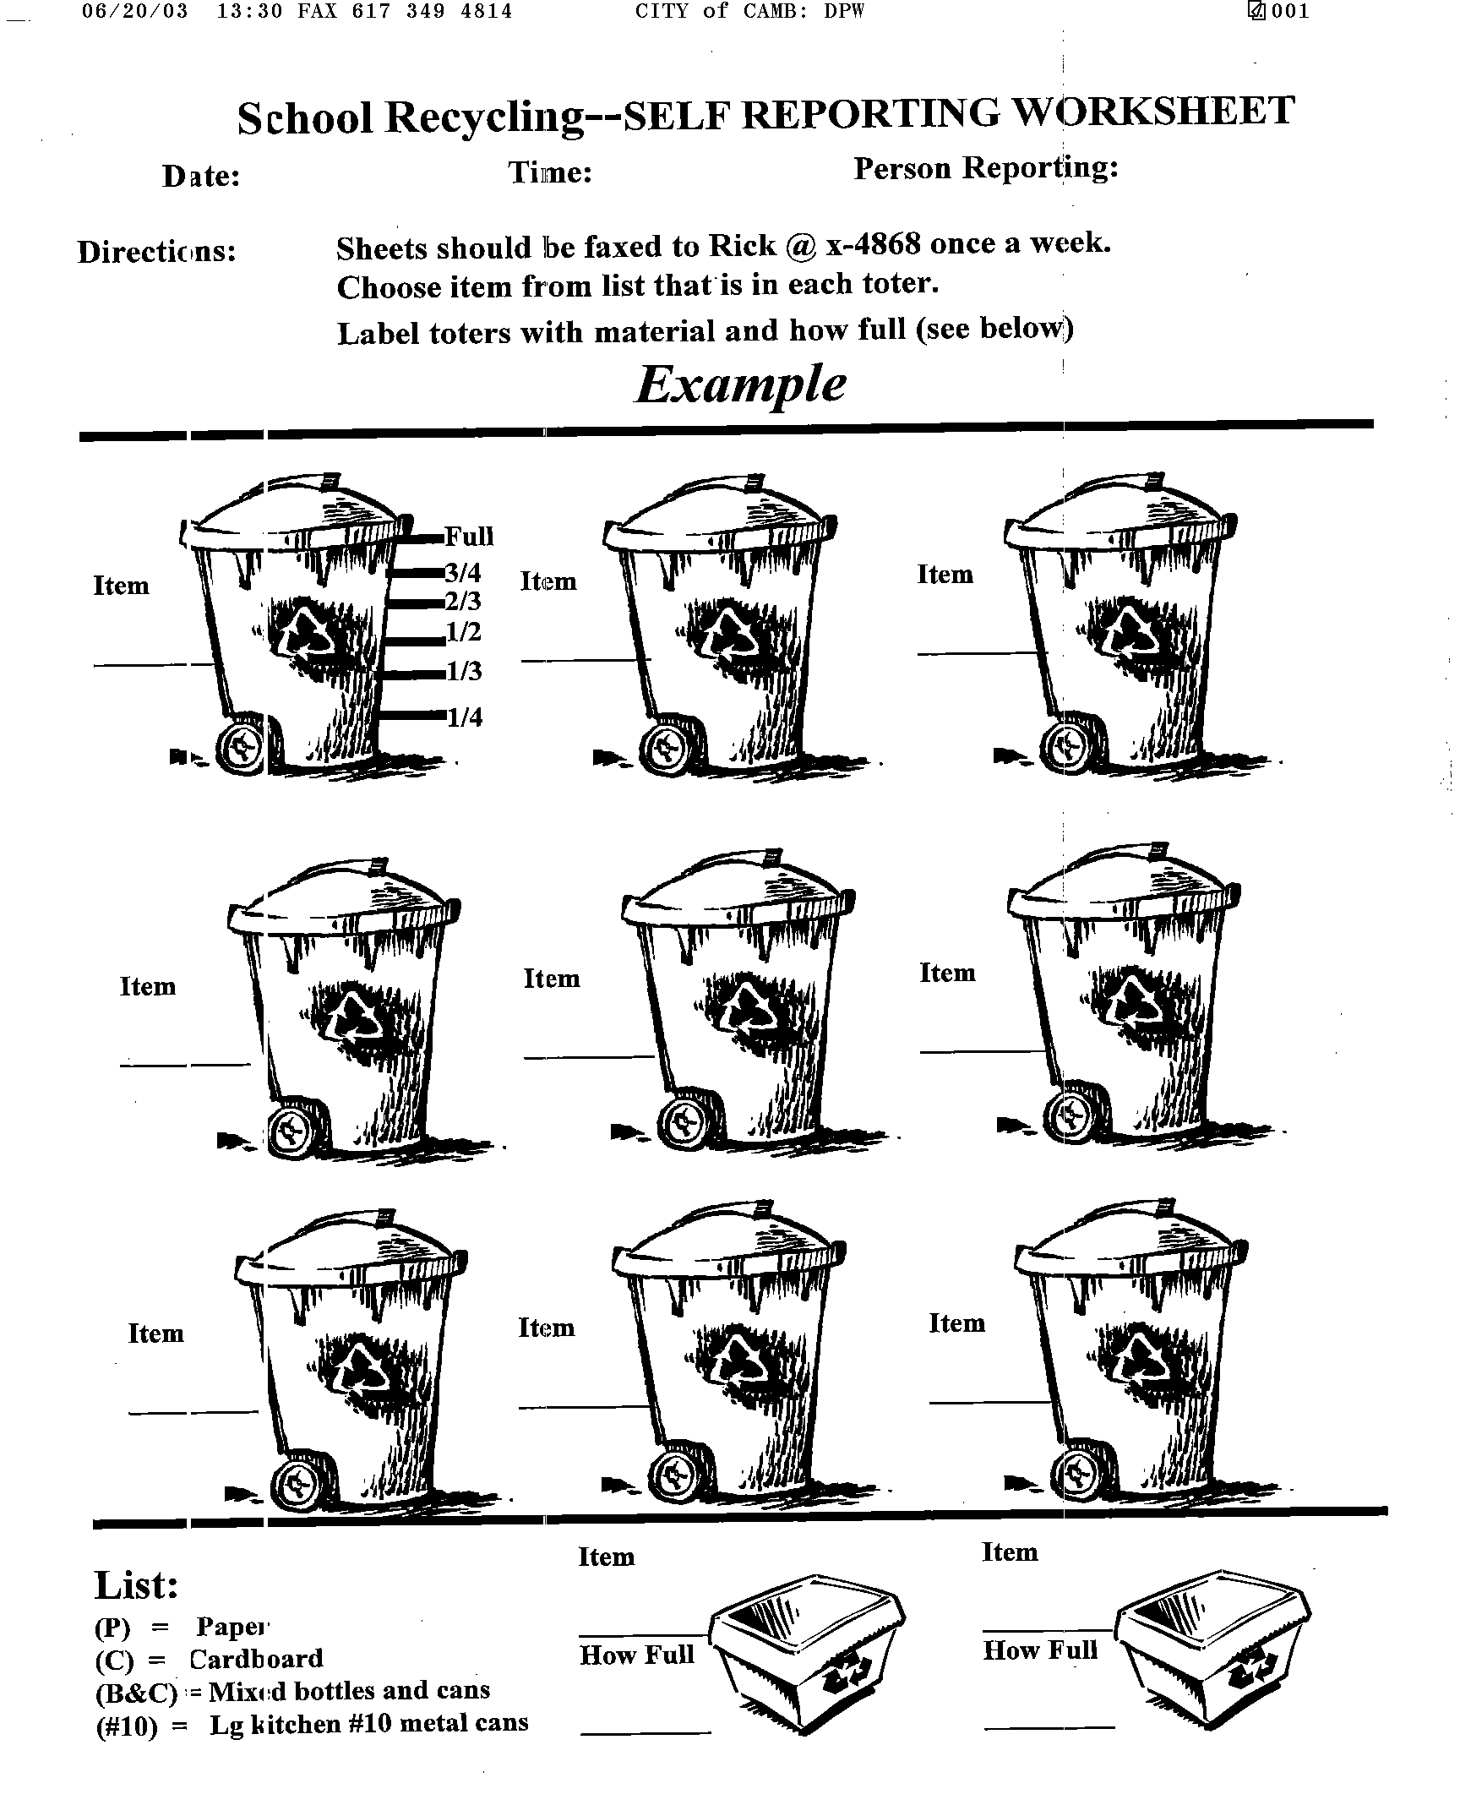
Appendix C
Feedback to Schools
Appendix D
Recycling Bin Decal

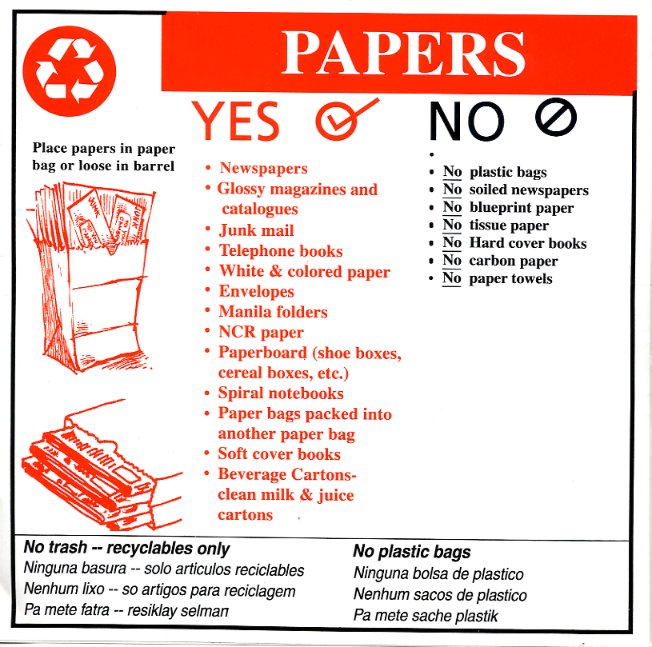

Endnotes ? Aceti, J. (2002). Recycling: Why People Participate; Why They Don’t. [Report prepared for the Massachusetts Department of Environmental Protection]. Boston, MA.
Rendon Group (2001, January). Focus Group Findings [Report prepared for the Department of Environmental Protection]. Boston, MA.
McKenzie-Mohr, D. & Smith, W. (1999). Fostering Sustainable Behavior: An Introduction to Community-Based Social Marketing. New Society Publishers: British Columbia, Canada. p.103.
Aceti, J. (2002). Recycling: Why People Participate; Why They Don’t. [Report prepared for the Massachusetts Department of Environmental Protection]. Boston, MA.
McKenzie-Mohr, D. & Smith, W. (1999). Fostering Sustainable Behavior: An Introduction to Community-Based Social Marketing. New Society Publishers: British Columbia, Canada. p.118.
McKenzie-Mohr, D. & Smith, W. (1999). Fostering Sustainable Behavior: An Introduction to Community-Based Social Marketing. New Society Publishers: British Columbia, Canada. p.61.
McKenzie-Mohr, D. & Smith, W. (1999). Fostering Sustainable Behavior: An Introduction to Community-Based Social Marketing. New Society Publishers: British Columbia, Canada. p.95. This document was prepared by: Aceti Associates 19 Allen St. #2 Arlington, MA 02474 Ph: 781-646-4593 Fax: 914-931-2038 www.acetiassociates.com printed on recycled paper

