Focus Group Research:

How to Conduct It &
How to Contract For It

A Community-Based Social Marketing Tool for Increasing Participation in Recycling and Waste Reduction

This project is funded by a grant from the
Massachusetts Department of Environmental Protection.

Printed on recycled paper

November 20, 2002

TABLE OF CONTENTS

SECTION 1: THE CONTEXT: COMMUNITY-BASED SOCIAL MARKETING 3
Step 1: Literature Review 3
Step 2: Focus Group Research 3
Step 3: Phone Survey Research 4
Using Focus Group Research for Strategy Refinement 4

SECTION 2: IN-HOUSE VS. CONTRACTED FOCUS GROUP RESEARCH 4

SECTION 3: CONTRACTING FOR FOCUS GROUP RESEARCH 6
Model Bid Specification 6
Costs of Contracting for Focus Group Research 12
Identifying Potential Contractors 12
SECTION 4: CONDUCTING FOCUS GROUP RESEARCH IN-HOUSE 13
Recruiting Focus Group Participants 13
Time of the Groups 14
Stipends 14
Choosing a Moderator 14
Encouraging Individual Participation 15
Other Tips for Facilitating Focus Groups Effectively 15
Discussion Guides 16
Structure 16
Formulating Effective Questions 17
Logistics 17
Drawing Conclusions from Focus Group Research 18

END NOTES 18

APPENDIX A SAMPLE FOCUS GROUP DISCUSSION GUIDES 20
Focus Groups to Evaluate Barriers and Motivations for Participation 21
Focus Groups to Evaluate Social Marketing Strategies 25

APPENDIX B – SAMPLE FOCUS GROUP REPORTS 31
Focus Groups to Evaluate Barriers and Motivations for Participation 32
Focus Groups to Evaluate Social Marketing Strategies 41

APPENDIX C – RECRUITMENT SCREENER 48

Note: This document was prepared by Aceti Associates of Arlington, MA. The document draws heavily from three sources: The Handbook for Focus Group Research by Thomas L. Greenbaum, Fostering Sustainable Behavior: An Introduction to Community-Based Social Marketing by Doug McKenzie-Mohr and several volumes of The Focus Group Kit that were authored by Richard A. Krueger. Readers wishing more information on focus group research are encouraged to utilize these resources.

Acknowledgement: Dr. Doug McKenzie-Mohr of McKenzie-Mohr Associates, New Brunswick, Canada, provided feedback on a draft of this report.

Section
1

The Context: Community-Based Social Marketing

The tools developed in this document are presented in the context of their use in community-based social marketing (CBSM). CBSM is an approach to fostering environmentally friendly behavior in which promoters identify the barriers and motivations associated with engaging in a particular activity. They then design a strategy to overcome the barriers and strengthen the motivations, using knowledge from the social sciences. The strategy is piloted to test its effectiveness and later evaluated when it is implemented on a broader scale. More information about CBSM can be found at http://www.state.ma.us/dep/recycle/recycle.htm Click on “Motivating People to Recycle.”

Developing a CBSM strategy to increase participation in your program begins with identifying the barriers that inhibit individuals in your community from engaging in the activity, and understanding what motivates people to take part. Focus group research is the second step of a three-step process that will enhance your understanding of how community residents view the behavior that you are promoting.

Step 1: Literature Review

Reviewing research carried out in other locales will provide you with information about potential barriers and motivations experienced by members of your community. Literature reviews have been conducted for a number of recycling and waste reduction activities. They can be found at http://www.state.ma.us/dep/recycle/recycle.htm Click on “Motivating People to Recycle” and look for the section entitled “Barrier/Motivation Inventories.” [Note: This web link is not active yet.] The community-based social marketing resources at the site will also provide you with guidance for conducting a literature review of your own, if necessary.

Step 2: Focus Group Research

A focus group consists of six to ten individuals who have been paid to discuss issues raised by a facilitator. You will want to use focus groups to understand how members of your community view barriers and motivations that have been identified in other locales as relevant to the activity in question. You will also want to note the words, phrases and concepts they use when speaking about the topic.

Focus group research does have limitations, however. The small number of participants makes generalizing the results to the larger community unwise, and, while interviewing participants in groups is cost-effective, members of a focus group can have a substantial effect on what opinions are expressed. Where possible, focus group research should be followed by a larger, representative telephone survey of residents in order to better understand the views of the community as a whole. Focus group research will help ensure that the survey will be well constructed and that questions contained in the survey will be readily understood by the respondents. However, even if financial or logistical constraints prevent you from conducting a telephone survey, focus groups will help enrich your understanding of the activity you wish to promote.

Step 3: Phone Survey Research

In addition to enhancing your understanding of community-wide views on the activity you are promoting, phone surveys can also be used to quickly assess residents’ initial reaction to a potential CBSM strategy for increasing participation. Finally, in situations where many barriers and motivations influence people’s participation in an activity, phone surveys can help you identify the most important, so that scarce program resources can be most effectively targeted to increase participation.
A sample specification that can be used in contracting for phone survey research services is located at http://www.state.ma.us/dep/recycle/recycle.htm Click on “Motivating People to Recycle” and look for the section entitled “Research Tools.” [Note: This web link is not active yet.]
Using Focus Group Research for Strategy Refinement

Focus groups are also used to obtain reactions to a proposed strategy, once it is developed. When focus groups are used in this way, participants may be asked to talk about the appeal and clarity of draft promotional materials and about how well a strategy is likely to be accepted in the community. The strategy is then further refined, based on the input received from focus group participants.

Section
2

IN-HOUSE VS. CONTRACTED FOCUS GROUP RESEARCH

You can use municipal staff and resources to conduct focus group research in-house, or contract with a market research firm to conduct the research for you. Each approach has its own advantages.

The Benefits of Conducting Research In-house:

Cost savings. Contracting for focus group research will cost in the area of $5,000 per group. The research can be conducted in-house with a much lower outlay of funds.
Expertise. You can discuss your programs more knowledgeably with focus group participants than any researcher can. Further, this knowledge enables you to hear the nuances of the discussion and therefore get more information from the groups than an outside moderator.
Time Savings. Conducting focus group research in-house allows you to avoid the time needed to 1) go through the procurement process; 2) brief the focus group moderator on the activity that you are trying to promote and 3) coordinate with the moderator on the preparation of the discussion guide.

The Benefits of Contracting for Focus Group Research

Research Expertise. An outside moderator doesn’t have same degree of knowledge about the topic, but has special expertise in conducting research. Expertise in research methodologies is considered to be more important than technical expertise in the research topic for obtaining quality results from focus group research.
Experience in Learning the Essentials. Experienced research consultants know how to gather enough information about a particular topic so that they can be effective facilitators in focus groups.
“Outsider” Status. Most research consultants feel that they are more effective in focus groups when the participants realize that they are not experts in the topic area but facilitators hired to stimulate conversation. Their outsider status allows them to ask questions that would be unacceptable from an “expert.” Further, with a moderator who is a “non-expert,” the participants normally work harder to explain their views. They don’t feel a need to impress the moderator by using fancy language and terminology.
Objectivity. The subtleties of how we say things may matter more than what we say in conveying our leanings on a topic. Since the outside researcher has no stake in a group’s outcome, it may be easier for him/her to avoid displaying unconscious bias in asking questions or reacting to answers. Furthermore, using an outside researcher lessens the possibility that preconceived beliefs will impact the analysis of the group members’ comments. (See “Drawing Conclusions from Focus Group Research” in Section 4.)
Credibility. Decision makers may feel that focus groups conducted in-house are intended to prove a point rather than to objectively seek community input on a topic. Therefore, involvement of a professional moderator can make the research results more believable than they would be if internal staff carried out the research.
Professionalism. A market research firm will focus on the assignment and not be distracted by the day-to-day “firefighting” that is common for program managers with multiple responsibilities. As a result, the research is likely to be completed more quickly and with more attention to detail than would be possible in-house.

Section 3 provides a model bid specification that you can modify to fit your needs if you choose to contract with a market research firm to conduct focus group research for you. Section 4 provides a set of instructions for setting up and conducting focus groups yourself, if you choose to do your research in-house. Whether you intend to contract for focus group research or do it in-house, reading both Sections 3 and 4 will lead to a better understanding of how focus groups work.

Section
3

CONTRACTING FOR FOCUS GROUP RESEARCH

The model bid specification presented here was used in the City of Waltham to contract for focus group research services. The shaded text describes a variety of options to consider as you modify the specification to meet your own needs. Shaded text also outlines steps that you will want to take to ensure that the focus group research is carried out as effectively as possible.

CITY OF WALTHAM, MASSACHUETTS
DEPARTMENT OF PUBLIC WORKS

Specifications for Focus Group Research

BACKGROUND

A 1999 survey of Waltham residents indicated that residents strongly supported increasing the frequency of curbside collection from every other week to weekly collection, even though they were informed during the survey that it would cost taxpayers substantially more. Accordingly, in the fall of 2000 the City made this change, increasing its collection costs by $250,000 per year in the process. Tonnage increased dramatically during the first few months of weekly curbside collection, but has since subsided to the same levels observed during every-other-week collection. Waltham made a strong financial commitment to waste diversion. Now it is important that the city increase its recycling rate. A variety of information intensive initiatives have been tried over the last year including newspaper articles and paid ads, a city-wide postcard, and flyers distributed to school children, in utility bills and in recycling bins. Given the lack of success of these initiatives, the City’s administration believes it is particularly important to uncover the barriers and motivations associated with participation in the curbside program in order to guide future promotional efforts. Therefore, the City is interested in designing a strategy to increase participation using community-based social marketing (CBSM) techniques.

A variety of tools are used in the process of planning a program using CBSM techniques. Literature reviews, focus groups, and phone surveys are used to uncover the barriers and motivations associated with various waste reduction activities. Once the barriers and motivations are identified, a strategy is developed to overcome the barriers and strengthen the motivations. The strategy utilizes behavior change tools such as: commitment techniques, prompts, community norms, persuasive communication, incentives, modeling and social diffusion. Focus groups, and small-scale pilots are then used to refine and test behavior change strategies. Baseline and follow up measurements are used to evaluate the pilots. More information about CBSM can be found at www.cbsm.com.

SCOPE OF WORK

The City of Waltham seeks to contract with a market research firm to do the following:

- Conduct four focus groups consisting of City of Waltham residents. The first two focus groups will explore the barriers and motivations associated with curbside recycling, and are to be conducted during the week of November 12-16, 2001. The second two focus groups will be used to gain reactions to a proposed strategy, and are to be conducted during the week of January 30 – February 6, 2002.

2. Recruit focus group participants. Each focus group should contain 8-10 participants. Each set of focus groups will consist of one group of recyclers and one group of non-recyclers. The City wishes to screen out residents who live in buildings served by large wheeled recycling containers. A list of addresses falling in this category will be provided to the contractor. Within each group, a range of age, income and educational levels is desired, as well as a distribution across race, ethnicity, language and Waltham neighborhoods. Participants representing various language groups must be fully bilingual. All participants must be literate, as they will be asked to write as well as verbalize responses.

HOW MANY FOCUS GROUPS DO YOU NEED?
If you are seeking to maximize participation in a program that is already in existence, it is a good idea to hold separate sessions for participants and non-participants if finances allow. Without intending to, participants can sometimes sound judgmental. Non-participants will be more comfortable voicing their opinions in their own group. If the participant/non-participant split is not needed, it is still a good idea to hold two groups, one of men and one of women. Because men tend to be more comfortable holding the floor in a group setting, women will tend to express their opinions more fully in their own group. Ideally, four focus groups would be held to identify barriers and motivations and four more to respond to a proposed strategy. In each case, the four attendee categories would be: male program participants, female program participants, male non-participants and female non-participants. Holding eight focus groups will rarely be possible financially. If a choice has to be made, it is best to separate the participants and non-participants, and ask the facilitator to be especially careful that the women in the group are given the time to express their views fully. If only one focus group can be held, the facilitator will also have to work extra hard to communicate that there are no “right” or “wrong” answers, just opinions, ideas and perspectives.

Once you have identified barriers and motivations, the results may lead you to focus your social marketing strategy solely on obtaining a higher level of participation from current participants, or solely on motivating non-participants to begin participating in your program. (For example, the City of Waltham chose to pursue a strategy designed to motivate current recyclers to recycle more material.) Therefore, the focus group split that you request for the strategy feedback sessions may be different than you originally specified. Your market research contractor may request a modest additional payment if they think it is going to take more phone calls to recruit the new selection of individuals you have requested. For example, recruiting two groups of non-recyclers is likely to take more time than recruiting one group of recyclers and one group of non-recyclers. People are reluctant to admit that they don’t recycle.

RECRUITING A REPRESENTATIVE SAMPLE OF FOCUS GROUP MEMBERS
The more barriers that you remove to participating in the focus groups, the more likely it is that the group members will be representative of the whole community. You may want to ask potential contractors to provide you with pricing to:
- Arrange transportation
- Arrange childcare
- Translate written responses requested during the focus group session, if potential members are more comfortable writing in their first language than in English.

- Pay focus group members a stipend for their participation.

- Provide a facility in which to hold the focus group meetings.

- Moderate the focus groups and provide a note taker.

THE FOCUS GROUP MODERATOR
The quality of the focus group moderator is one of the three most important factors affecting the quality of the focus group research (along with the quality of the discussion guide and the correct recruiting of participants). Be sure that proposals received from market research firms specify who the focus group moderator will be, and carefully check that person’s references as well as the references of the firm as a whole. Reviewing the moderator’s resume also helps evaluate the person’s credentials. The costs of the most expensive and least expensive moderators do vary. Consider paying a premium if your reference check confirms that the moderator is highly skilled. These key characteristics of effective moderators may be helpful in formulating reference questions:

Superior Listening Ability. We all know people who have a reputation for listening carefully and understanding what others have to say. The ability to pay close attention and take in the meaning of others’ remarks is a characteristic of an effective moderator. A good moderator also knows how to restate the comments of a participant when necessary, in order to ensure that the content of the comments is clear.

Excellent Short-Term Memory. The moderator must be able remember comments that participants make at different times during the session, so that inconsistencies can be clarified. In order to ensure the fullest participation, the moderator must also be able to keep careful track of who has spoken, and who has not.

High Energy Level. When the tenor of a group gets very laid back and lifeless, participants will be less likely to make the effort needed to generate thoughtful responses. The best moderators find a way to infect the group with their energy and enthusiasm so that the participants are engaged throughout the session.

Personable. “The most effective moderators are those who can develop an instant rapport with participants, who then become actively involved in the discussion to please the moderator. Participants who don’t establish rapport with the moderator are much less likely to ‘open up’ during the discussion, and the output from the group is not as good.”

Above-Average Intelligence. No one can plan for every contingency that may occur in a focus group session. Moderators must be able to think on their feet to process the information that the group is generating and make on-the-spot decisions about how to handle group dynamics, adjust the length of time allowed for responses, etc.

Topic Experience. While not essential, it is almost always an advantage when a moderator has some prior experience with the topic at hand. If, however, the moderator is too much of an expert, this can limit his or her objectivity in directing the discussion.

Good Communication. The best focus group moderators have good verbal and written communication skills. These communication skills are important to the process of writing the discussion guide, asking questions of the participants during the session and preparing a report on the research.

- Provide beverages for focus groups members.

FOOD FOR PARTICIPANTS
In some cases, food is provided for participants, especially if the session is conducted early in the evening. This is not necessary, and can actually prove to be a distraction. It will also increase your costs. Be sure to specify exactly what you expect to be provided to attendees so that potential vendors do not make inappropriate assumptions.

- Audiotape the focus groups meetings. An audio check must be done to ensure that each focus group participant can be heard clearly on the tape. No transcript is required.

OBSERVING THE FOCUS GROUP SESSIONS
Clients are encouraged to observe the focus group sessions, and doing so will enrich your understanding of the views and perceptions of focus group members. It will also allow you to observe first hand whether there are any problems with the discussion guide that was developed for the sessions. For example, during the first set of focus groups in Waltham, it became clear that the number of questions included in the discussion guide made it difficult to solicit written and verbal responses from each participant and still end the session on time. These first-hand observations allowed for more productive interaction between Waltham project staff and the focus group moderator during the development of the discussion guide for the second set of focus groups.

COMMUNICATING WITH THE MODERATOR DURING THE SESSIONS
Many focus group research facilities have rooms with one way mirrors that will allow you to observe unnoticed. Make plans in advance that the moderator will leave the group several times in order to confer with you while participants are writing responses to questions. If you have concerns or questions about how the session is progressing, this gives you the opportunity to discuss them with the moderator without distracting the participants. It is not advisable for the moderator to spend more than 30-45 seconds away from the group, so plan to discuss only essentials.

- A discussion guide dealing with potential barriers and motivations associated with curbside recycling in Waltham will be provided for use with the first two focus groups. A discussion guide designed to solicit feedback on the City’s proposed strategy for increasing participation will be developed for use with the second two focus groups. The focus group moderator will be responsible for reviewing the discussion guides with the project consultant in order to ensure clarity on the areas in which the City of Waltham requires input from the focus group members.

THE DISCUSSION GUIDE (Also referred to as the “Moderator Guide.”)
The discussion guide is a detailed agenda for the focus group session. It contains a set of carefully worded and sequenced questions, along with the time allocation per question. It also describes the session format. For each question, for example, the format may involve participants writing down their responses, then verbalizing their responses individually, then engaging in a free flowing discussion.

You will want to specify whether you will be providing the contractor with a discussion guide. If you wish the contractor to develop the discussion guide you will need to provide them with information about your research objectives and a general list of topics that you want addressed. Once the moderator has developed a draft of the guide, you will want to review it and suggest changes if you feel that guide can be made more consistent with your research objectives. Sample discussion guides are provided in Appendix A of this document.

9. Provide the following reports and materials to the project consultant: 1) Good quality audiotapes of each focus group meeting; 2) Original written responses made by focus group participants as a result of instructions to write a response to a question before answering verbally; 3) A log of verbal participant responses as recorded by the note taker; 4) A summary of the participants’ responses, indicating the main themes. All reports must be printed on 30% post-consumer recycled paper and available electronically.

FOCUS GROUP REPORTS
Samples of the reports provided by the market research firm that conducted the Waltham focus groups are included in Appendix B.

10. The tasks relevant to the first two focus groups are to be completed between October 26, 2001 and November 23, 2001. The tasks relevant to the second two focus groups are to be completed between January 16, 2002 and February 13, 2002.

SCHEDULE
It will take the contractor about two weeks to recruit focus group members. During this time you can review and finalize the discussion guide with them. The sessions are conducted in the third week and the report is prepared during the fourth week.

Prior to bid submission, requests for clarification regarding the Scope of Work should be addressed to Aceti Associates. Aceti Associates will also serve as the liaison to the market research firm that is contracted by the City of Waltham to carry out the scope of work described above.

CONTACT INFORMATION
For Questions On: | Contact | Contact Information
1)Bid Submission Process  2) Payment | Eileen Zubrowski  Waltham Recycling Coordinator | 119 School St.  Waltham, MA 02451  Ph: 781-314-3391  Fax: 781-314-3032  ezubrowski@city.waltham.ma.us
- Clarifications on Scope of Work  - Project Coordination  - Discussion Guides | Aceti Associates  Project Consultant | 19 Allen St. #2  Arlington, MA 02474  781-646-4593  j.aceti@worldnet.att.net

QUOTE SUBMISSION:

- Quotes must be submitted by 5pm on October 19, 2001 to Eileen Zubrowski at the address or fax number above.
- A contract will be awarded by October 26, 2001.
- Potential vendors must provide a one page description of the background/experience of the staff that will be conducting the focus group research.
- Potential vendors must provide three references for focus group research they have done, with contact names and phone numbers. References must be able to comment on the performance of the individual who will be moderating the focus group sessions, as well as on the performance of the vendor as a whole.

PRICE SUMMARY FORM

All costs associated with the services set forth in the scope of work must be included in the total price. Prices must remain firm throughout the entire period during which work is being done.

Total price $________________

_________________________________________
(repeat sum in words)

Name of company representative

Signature of company representative

Phone Number of company representative

Email Address of company representative

Name of company

Address of Company

Fax Number
Costs of Contracting for Focus Group Research
Contracting for focus group research will cost around $10,000 for each set of two groups. For this price, the contractor will recruit focus group members, work with you to refine the discussion guide, provide a meeting space, facilitate the session and prepare a report on the findings. It is helpful to note that most firms charge almost as much for one focus group as for two. This is because groups are normally conducted in the evening at 6 and 8 o’clock, with each session lasting about 90 minutes. Once a moderator has allocated part of the evening for the research, the additional time involved in conducting a second group is relatively small. Moreover, most focus group facilities do not normally charge significantly more for use of the facility for one group than for two, since they generally can’t use the room for another client that same evening.

Since budget constraints are often significant for municipalities, it may be worth discussing the feasibility of several cost saving ideas with potential vendors as you develop your specifications. Focus group research facilities traditionally provide a meal for clients observing the focus groups, at a cost of $15-30 per person per evening. Explore whether the facility would lower its costs if meals for client observers were not required.

Providing a room in a municipal building in which to conduct the focus groups sessions could save you $300-600 per group. If there were no focus group research facilities located in your community, this idea would also make it more convenient for residents to attend the sessions. Either you or the market research firm would need to be able to provide the equipment to make good quality audiotapes of the sessions.

Identifying Potential Contractors
Focus group research services can be procured from market research firms on state contract. Here are three contracts that list pre-qualified firms. Some firms have specific competencies, and pricing can differ quite a bit. Soliciting quotes, references and information on background and experience is recommended. The instructions for locating the vendor list for the second and third contracts are analogous to the instructions given for the first contract. (The instructions are subject to change.)

- Department of Public Health contract dph-30002. Contract end date is 6/30/2005.
1. Go to www.comm-pass.com
2. Scroll to very bottom of page and click on "Search" in the next to last box on the right.
3. Type dph-30002 in the Contract Reference No. box
4. Click on search
5. Click on Multi-departmental media services RFR.
6. Scroll down and click on Award Notice The firms that conduct market research are indicated with an FR (Formative Research and Evaluation)
- Department of Environmental Protection contract RFR FY98-B (Solid Waste and Recycling Consulting Services). Contract end date is 10/20/03. Consult with Brooke Nash (617-292-5984) for further guidance on firms that provide market research services.
- Operational Services Division’s Master Service Agreement for Management Consultants, Program Coordinators and Planners. Bid Reference No. ST2H191. This bid is not expected to be awarded until late 2002. Once it has been awarded, the Bid Reference Number will become the Contract Reference Number.

Section
4

CONDUCTING FOCUS GROUP RESEARCH IN-HOUSE

If you choose to conduct focus groups in-house, it may be tempting to approach them as informal discussions. However, the quality of the output you will gain from your focus group research is directly affected by how carefully you prepare for the sessions. Specifically, the correct participants must be recruited, the moderator must be fully briefed (if it is someone who is not familiar with the topic at hand), and the discussion guide must be carefully prepared. The following sections will provide you with the guidance you need to prepare for your focus group sessions.

Recruiting Focus Group Participants

Once you’ve decided how many focus groups to conduct and who you want the participants to be (see the box entitled “How Many Focus Groups Do You Need?” in Section 3), you can contact potential participants by randomly choosing numbers from the phone book. Be sure to let residents know how their names were selected. The best times to reach people will be from 7:00-9:00pm on weekday evenings and during the day on Saturday. Remember that the more barriers you remove to participating, the more representative your focus groups will be of the community as a whole (see the second part of the Box entitled “How Many Focus Groups Do You Need?” in Section 3). The script (or “screener,” as it is called) used to recruit participants for the second set of focus groups in Waltham can be found in Appendix C.

It will take more time to recruit some types of individuals than others. For example, it may take more phone calls to recruit non-recyclers because many people are reluctant to admit that they don’t recycle. One way to cut down on the amount of time involved is to broaden your definition of a non-participant to include those who seldom or rarely participate.

Another strategy is to hire a market research firm to carry out the recruitment for you. In 1997, the City of Cambridge contracted for the recruitment of twelve non-recycling focus group participants at a cost of about $670. Fieldwork Boston, the focus group research facility that recruited the participants for the Waltham focus groups, indicated that the cost of recruiting 12 recyclers, evenly split between men and women, would be $90 per recruit, or $1,080 in total. A comparison of the Cambridge and Waltham costs does not support the assumption that it costs more to recruit non-recyclers than to recruit recyclers. However, the difference in the two costs may be more related to the price spread between companies than to the relative difficulty of recruiting different types of individuals. As another point of reference, the 1998 Handbook of Focus Group Research indicates that contracting for the recruitment of twelve “adult consumers of a commonly used product” will cost $550-900. Recruiting twelve “adult consumers of a relatively low incidence product (10% or less incidence)” is estimated to cost $1,000-1,400. These figures do not include the stipend that is paid to focus group participants (see below).

Because some people will not show up, always recruit two to three people more than needed. If everyone does show up, you can pay several people their stipend and send them home immediately. To avoid alienating people, explain that you “over-recruited” in case there were no-shows. Prepare a summary chart of participant characteristics (age, ethnicity, neighborhood, income, etc.) in advance. This information will help you can decide who to send home so that the remainder of the group best meets the recruitment criteria.

Avoid sending information to focus group members prior to the session about the activity you are trying to promote (handing information out afterward is fine). If participants have special access to information prior to the focus groups, they will no longer be representative of your community.

If you do not recruit the focus group members yourself, you may want to consider administering a brief “re-screener” as people enter the session room to ensure that they meet the criteria. The rescreener would consist of a few questions that address the key characteristics (i.e. “recycler” and “do not live in a building that uses toters”) that you are looking for. This can prevent the awkwardness of discovering that someone does not meet the criteria after the session has begun. In order to encourage authentic answers, the re-screener should be administered out of earshot of other participants entering the room.

Time of the Groups

Most focus groups are held at 6 and 8 o’clock in the evening. However, some groups, such as small business owners, for example, may prefer to attend at 7:30 in the morning rather than in the evening.

Stipends

A stipend of $40-$50 is generally paid to focus group participants immediately after the session is over (When focus group participants are volunteers, there is a strong likelihood that they are participating because they have a greater interest in the topic than others in the community.) However, as noted in the recruitment script provided in Appendix C, Fieldwork Boston offered a stipend of $75 to potential participants in the Waltham groups conducted by Research International. If you intend to pay a contractor to do the recruitment for you, it may be worth exploring with them whether increasing the stipend will decrease the recruitment costs.

While it is customary to pay cash stipends, municipal purchasing systems may not allow the disbursement of cash to individuals. A municipal check is the next best option if individual checks for each participant can be prepared in the interval between recruitment and the sessions themselves. If this is not possible, another option is to provide everyone with a gift check, such as those that can be purchased from American Express. Take a moment after the session to explain how to cash the checks.

Choosing a Moderator

Because there are advantages to using a moderator who is not an “expert” in the topic of interest, (see “The Benefits of Contracting for Focus Group Research,” in Section 2), it may be worthwhile to identify an individual other than the recycling/waste reduction program manager to facilitate the focus groups. The individual might be a municipal staff person or a community volunteer who would benefit professionally or personally from having the experience of moderating the focus groups. Keep in mind the key characteristics of an effective moderator as you are thinking about who you might involve in this role.

If you, as the program manager, are moderating the focus groups, be prepared for the possibility that participants may ask you to explain parts of the program that they find they are unsure about. Be ready to respond with a statement such as, “I would be happy to answer your questions as soon as the session is over. However, right now, it is important for me to gain a sense of what all of you think, believe and understand about the program. Does anyone else know what the answer to the question might be?”

Encouraging Individual Participation

Research shows that when asked to respond to a question in a group setting, people tend to look to the behavior of those around them to determine how they will respond. How can one improve the likelihood that people will express what they truly think during the focus group session? It is important that the facilitator establish a supportive but firm role with the participants. It is not uncommon to have one or two members of a focus group attempt to monopolize the conversation and in the process make other members feel that their comments are not valued. Your job is to facilitate in such a way that less assertive members, or individuals who might have differing views, feel comfortable in speaking up. Prior to conducting the focus group, you will need to be comfortable with statements such as, “I have received some very helpful feedback from you, now I would like to hear what others have to say,” and “I understand you feel strongly about this issue, but I also know that some people have very different views on this matter. Would anyone like to share them?” These statements reassure participants that even if there are some overbearing or overly talkative members, you are ensuring that the views of other members will be heard.

Another tool for helping participants voice their own opinions is to ask that everyone write down their responses to each question prior to sharing them with the group. This enhances participants’ commitment to their own answers. Their sense of commitment can be subtly reinforced by letting participants know at the beginning of the session that their written responses, as well as notes and an audiotape of the session will be used to prepare the focus group report. Soliciting a verbal response from each participant individually will also encourage people to speak their mind. Several minutes can be allocated for a more free flowing discussion once everyone has had an opportunity to express their own view on a topic.

Observations of the first set of focus groups in Waltham confirmed that written responses and individual queries to participants were very important. In the focus group of non-recyclers, initial comments about the inconvenience of recycling included statements of belief that recycling was picked up only every other week in Waltham. It appeared that none of the non-recyclers were aware that the City had increased the frequency of collection to once per week. However, after the facilitator asked participants to write down their answers to a specific question about the frequency of collection, several participants acknowledged that they knew that recyclables were picked up weekly. Also, when responses were solicited from each participant individually, more opinions were offered and the comments were more extensive than when the facilitator simply opened up the floor for discussion.

Other Tips for Conducting Focus Groups Effectively

Seek Clarification on Inconsistent Comments. Participants in focus groups may change their positions as the session progresses. Stay alert for inconsistent comments, and if the reason for the shift isn’t obvious, ask about it. You won’t have the chance when you’re listening to the tape of the session the next day. You might say something like, “Earlier you said……… and now you’ve indicated that………..These seem to me to be different from each other. Help me understand how you feel about this issue.”

Listen for Vague Comments. “Pay attention to our needs!” “We want quality service!” Buzz words or phrases like these can have different meanings for different people. Probe to find out more: “Could you give me an example?” “Please explain. I’m not sure I know what you mean.”

Avoid giving examples. It may be tempting to give examples to help participants understand the question you are asking. However, examples can limit the thinking of respondents and lead them to respond in a certain way.

Discussion Guides (Also referred to as the Moderator Guide)

Resist the idea that a one-page list of issues will be a sufficient tool for guiding focus group discussions. Time spent in careful preparation of a detailed agenda for the focus group sessions will be repaid in the quality of the information that you are able to elicit from focus group participants.

The discussion guides for each set of focus groups in Waltham are included in Appendix A as samples. The guide for the focus groups conducted on November 15, 2001 was designed to explore the barriers and motivations associated with participation in Waltham’s curbside recycling program. The number of questions in this guide did make it difficult to allow time for people to write their responses and to query each participant individually. This problem was remedied in the second guide (dated February 5, 2002), which was designed to gain feedback from participants on a proposed strategy for increasing participation in Waltham’s curbside recycling program. The second guide contains fewer questions. The approach here was to focus on key content and eliminate the warm up and summary sections (see the section on discussion guide structure below). Furthermore, while the November 15th focus groups each had eight participants, the number in each of the February 5th groups was reduced to six. Both changes allowed more time for writing and individual responses.

Structure
A discussion guide is generally composed of four sections:

Introduction. Here the moderator introduces him or herself to the participants, briefly explains the purpose of the session, mentions housekeeping details and sets the tone for the meeting. Finally, the moderator asks the participants to introduce themselves.

Warm Up. The warm up section uses general questions to begin discussion of the topic.

Example: If you recycle most or all of the time, what motivates you to do this? If you don't recycle or don’t recycle as much as you could, what has stopped you?

Key Content: The key content section uses specific questions to obtain insight on areas of central concern in the study.

These areas of concern may arise from focus group and survey research carried out in other locales, which provides you with information about potential barriers and motivations experienced by residents in your community. For example, many studies have shown that those with less knowledge about how and what to recycle tend to recycle less or not at all. Accordingly, detailed questions in the November 15th discussion guide probed group members’ knowledge about recycling.

Example: What types of items can and cannot be recycled in the City of Waltham’s curbside program?

A specific aspect of your own program may also be of central concern. For example, the City of Waltham needed to assess whether their efforts to publicize the switch from every other week to weekly recyclables collection had been successful or not.

Example: How frequently does the city pick up your papers, bottles and cans?

Finally, open-ended questions can provide an opportunity for focus group participants to provide you with feedback on issues of key interest.

Example: What do you believe is most likely to motivate people in the City of Waltham to recycle?

Summary. The summary section gives participants an opportunity to share any thoughts about the topic that were not previously elicited.

Example: Do you have any additional comments that you would like to share?

Formulating Effective Questions

You will want to create and maintain an informal atmosphere in focus group sessions. Therefore, your questions need to be ones that you would be comfortable asking in conversation. Try out each question as you write it. Is the question easy to ask, or do you stumble over the words? Conversational questions are also more likely to be effective because they are clear and brief. Clear questions are usually short, jargon-free and address a single idea. Lengthy questions can be confusing to respondents because it is harder for them to distinguish the core intent of the question. Another important feature of simple questions is that they are memorable. Participants may forget what the question is if it is too complex. “For example, don’t ask, ‘What are the ingredients that are associated with healthy living?’ Instead say, ‘Describe a healthy lifestyle.’” If possible, seek feedback on your draft questions from people who have similar knowledge of the research topic as your prospective focus group participants.

Logistics

Focus groups can be held in a conference room in a conveniently located municipal building for which evening access can be arranged. The focus group room should be sufficiently large so that the participants will not feel cramped during the session. It should also be large enough to allow the moderator to move around it easily, if he/she will be using an easel or referring to items. Rooms that are free of distracting noise are preferable. Avoid using long, narrow tables because they place too much distance between some of the participants. Square or round tables are best. Ensure that there are well-placed electrical plugs for recording equipment.

Since the moderator will be steering the conversation through the questions in the discussion guide, you will want to have someone act as a note taker. This may be a good role for the program manager, if another municipal staff person or a volunteer is moderating the sessions. The note taker should be seated so that he/she can see and hear each of the participants. If other municipal staff wish to observe the focus groups, they may be seated at an unobtrusive location in the room. Introducing the note taker and observers as “city (or town) staff” should be sufficient.

It is a good idea to tape record the sessions in case the session notes need clarifying later on. However, conscientious note taking is good insurance against tape recorder failure. Test the tape recorder in the conference area in which the focus group is to take place to ensure that all participants will be heard clearly.

Provide name cards for each participant (similar to the “tent”-like place cards used at fancy dinners). Use first names only, even if the participants have titles. This makes the environment much less formal. Ensure that the name on the card is the one by which the participant likes to be called, not necessarily the name on the screening questionnaire. People respond much better when addressed by their most commonly used name. Put the name on both sides of card so that the moderator can see it from all parts of the room.

Provide sharp pencils and a pad of paper for each participant. Providing water and/or soda may help participants stay more comfortable and alert during the session.

Plan ahead how you will handle late arrivals. If the number of attendees is much lower than you expected, it may be worthwhile having latecomers join in. Otherwise, the disruption caused may not justify the inclusion of latecomers.

Drawing Conclusions from Focus Group Research

When the focus groups are completed, you’ll want to summarize the comments that have been made. The challenge here is to avoid a common analytical mistake in focus group research, which is to enter the research with a preconceived bias and to listen for inputs from group participants that seem to confirm your belief. Here are some tips for keeping an open mind.

- Conduct the analysis as soon after the focus groups sessions as possible, while memories are still fresh.
- Use the session tapes along with your written notes as you draw conclusions.
- Tabulate the number of times that a specific comment was made, or agreed with, by members of the focus group. In general, pay close attention to comments that are made frequently.
- Bring preconceived notions to the surface by asking the following questions: “What was previously known and then confirmed or challenged by this study?” “What was suspected and then confirmed or challenged by this study?” What was new that wasn’t previously suspected?” “What implications do these results have for the program or service?”
- Involve your notetaker (or moderator) in the interpretation of the comments. Having another first hand perspective on the participants’ input will broaden your view.
- Try to develop (or seek from colleagues and other experts) several alternative explanations for the comments that participants have made rather than settling on the first one that comes to mind. Then, choose the explanation that seems to best fit the comments made.

APPENDIX A
DISCUSSION GUIDES
Focus Groups to Evaluate Barriers to Participation
in Curbside Recycling in the City of Waltham

Guide for Focus Groups
November 15, 2002

General Protocol

- a response is obtained from each participant on every question, and each person has an equal opportunity to share their views and perspectives;
- the discussion is focused on the topic/question at hand, and is commenced and completed on time (1.5 hour meeting duration);
- each participant has a pen/pencil and paper;
- the note-taker records the full range of responses for each focus question, enabling frequencies to be easily determined for the purposes of preparing the meeting summary;
- the note-taker and facilitator keep an eye out for gender and other potential demographic differences in response to the focus questions.

1.0 OPENING REMARKS AND INTRODUCTIONS (5 minutes)

Hello, my name is ____________. I am a consultant with a local firm, ______________ of Cambridge.

My job is to chair the meeting. My colleague, ________, will be taking notes during the meeting.

Before we start, I'd like to thank you all for coming and we look forward to hearing your ideas and perspectives during the meeting.

So why have we asked you here?

We’d like to get a sense of what residents know and think about recycling. We would also like to know what you believe the City of Waltham can do to make it easier to participate in curbside recycling.

Before we start, I'd like to bring a few things to your attention…

First, this meeting is one of several that are being conducted with City of Waltham residents on this topic.

Second, I'm not an employee of the City of Waltham, and am unlikely to be able to answer any questions you may have that go beyond this specific project. If you do have specific questions you'd like to ask the City, we will take your name and number after the meeting and have one of their representatives contact you in the next few days.

Third, we will be taking notes and tape recording the session. For most questions we will also be asking you to jot down your responses on the provided paper prior to sharing them with the group. You should know that anything you say or write will be treated in confidence. We will use our notes, your written responses and the recording to prepare our report on this meeting, and no names will be used. So, please feel free to speak frankly.

As you know, we chose you randomly to take part in tonight's meeting. This is to help us make sure we hear from typical people from the City of Waltham, not just from people who know or care a lot about recycling.

Finally, in just a minute, I'm going to ask you a series of questions. Be assured…there are no right or wrong answers…just your opinions, ideas and perspectives.

Introductions…

Please tell me your name, the number of people in your household, and the area you live in.

2.0 FOCUS QUESTIONS

If you recycle most or all of the time, what motivates you to do this? If you don't recycle or don’t recycle as much as you could, what has stopped you?
Give people a minute to write down their answers, and then ask each person to share their response. [10 minutes]

For those of you who do recycle, would you say that you recycle more, less or about the same than you did last year at this time? Why?

Give people a minute to write down their answers, and then ask each person to share their response. [5 minutes]

Is there anything that you can think of that would lead you to recycle more than you do now? What prevents you from recycling now?
Give people a minute to write down their answers, and then ask each person to share their response. [10 minutes]
3.0 KNOWLEDGE AND CONVENIENCE OF RECYCLING
Do you feel that you are knowledgeable regarding what can and cannot be recycled?
How did you learn about the City of Waltham’s recycling program? Do you think the City provides you with enough information regarding its recycling program?

Give people a minute to write down their answers, and then ask each person to share their response. [5 minutes]

What types of items can and cannot be recycled in the City of Waltham’s curbside program?
Ask that participants make separate lists of items that can and cannot be recycled on a new piece of paper that can be turned in. Give people a minute or two to write down their answers, and then ask each person to share their response. [20 minutes] Finish by providing people with the list of items that can and cannot be recycled.

After reviewing this list, are you surprised to learn of specific items that can or cannot be recycled?
Do you recall receiving materials from the City regarding what is recyclable? Have you kept those materials? What, if anything, would make it easier to know what items can be recycled?

How convenient is it to recycle? If you don’t find recycling convenient, what would make it more convenient?

Give people a minute to write down their answers, and then ask each person to share their response. [10 minutes]

How frequently does the city pick up your papers, bottles and cans? Have you had any problems with the hauler who collects your recyclables? What would you do if you wanted to have an old appliance, TV or computer picked up?

You may need to clarify who the hauler is though most participants will glean this from the wording of the question. Give people a minute to write down their answers, and then ask each person to share their response, through a show of hands or otherwise. [10 minutes]

4.0 YARD WASTE RECYCLING
Do you feel that you are knowledgeable regarding what yard waste is recyclable? What types of items can and cannot be recycled via the City of Waltham’s yard waste program? What, if anything, would make it easier to know what types of material can be recycled?

Ask that participants make separate lists of yard waste items that can and cannot be recycled on a new piece of paper that can be turned in. Give people a minute or two to write down their answers, and then ask each person to share their response. [10 minutes] Finish by providing people with the list of items that can and cannot be placed in the yard waste container.
After reviewing this list, are you surprised to learn of specific yard waste items that can or cannot be recycled?

Do you know when to put the yard waste at the curbside for pickup? When does the City pick up yard waste?

Give people a minute to write down their answers, and then ask each person to share their response through a show of hands or otherwise. [2 minutes]
5.0 GENERAL
What do you believe is most likely to motivate people in the City of Waltham to recycle?

Give people a minute to write down their answers, and then ask each person to share their response, by a show of hands or otherwise. [5 minutes]
Do friends, family, or colleagues expect your household to recycle? Whose opinion do you care about most when it comes to recycling?
(ASK RECYCLERS) Do you expect your neighbors or friends to recycle?

(ASK OF NON-RECYCLERS) Do you take notice of whether your neighbors or friends recycle?

Give people a minute to write down their answers, and then ask each person to share their response, by a show of hands or otherwise. [5 minutes]

What do you feel is the most effective way for the City of Waltham to encourage people to recycle as much as they possibly can?

Give people a minute to write down their answers, and then ask each person to share their response. [5 minutes]

Do you have any additional comments that you would like to share?
Ask each person if they have additional comments that they would like to share (5 minutes)
6.0 CLOSING REMARKS (1 minute)
On behalf of City of Waltham, I would thank to thank you for participating in this meeting. We appreciate your answers and perspectives. These will be very helpful in further development of the City of Waltham’s recycling program. Based in part on what we learn from these discussions, we will be testing a revised curbside recycling program in parts of the City of Waltham. If the pilot is successful in diverting more waste, we then plan to deliver the revised program to the remainder of the City. The City of Waltham is very interested in your opinions and perspectives on the topic of recycling. The feedback we receive from you will help us to develop the best possible recycling program.
Focus Groups to Evaluate Social Marketing Strategies

Guide for Focus Group
February 5, 2002
General Protocol

- a response is obtained from each participant on every question, and each person has an equal opportunity to share their views and perspectives;
- the discussion is focused on the topic/question at hand, and is commenced and completed on time (1.5 hour meeting duration);
- each participant has a pen/pencil and paper;
- the note-taker records the full range of responses for each focus question, enabling frequencies to be easily determined for the purposes of preparing the meeting summary;
- the note-taker and facilitator keep an eye out for gender and other potential demographic differences in response to the focus questions.

1.0 OPENING REMARKS AND INTRODUCTIONS (5 minutes)

Hello, my name is _________. I am a consultant with the firm, ______________ of Cambridge.

My job is to chair the meeting. My colleague, ________, will be taking notes during the meeting.

Before we start, I'd like to thank you all for coming and we look forward to hearing your ideas and perspectives during the meeting.

So why have we asked you here?

We’d like to get a sense of what residents think about several strategies we are considering to increase the amount of material recycled in the City of Waltham. Based in part on what we learn from these discussions, we will be testing a revised curbside recycling program in parts of the City. If the pilot is successful in diverting more waste, we then plan to deliver the revised program to the remainder of the City. The City of Waltham is very interested in your opinions and perspectives on our proposed strategies. The feedback we receive from you will help us to develop the best possible recycling program.

Before we start, I'd like to bring a few things to your attention…

First, this meeting is one of two that are being conducted with City of Waltham residents on this topic.

Second, I'm not an employee of the City of Waltham, and am unlikely to be able to answer any questions you may have that go beyond this specific project. If you do have specific questions you'd like to ask them, we will take your name and number after the meeting and have one of their representatives contact you in the next few days.

Third, we will be taking notes and tape recording the session. For most questions we will also be asking you to jot down your responses on the provided paper prior to sharing them with the group. You should know that anything you say or write will be treated in confidence. We will use our notes, your written responses and the recording to prepare our report on this meeting, and no names will be used. So, please feel free to speak frankly.

As you know, we chose you randomly to take part in tonight's meeting. This is to help us make sure we hear from typical people from the City of Waltham, not just from people who know or care a lot about recycling.

Finally, in just a minute, I'm going to ask you a series of questions. Be assured…there are no right or wrong answers…just your opinions, ideas and perspectives.

Introductions…

Please tell me your name, the number of people in your household, and the area you live in.

2.0 QUESTIONS

- One problem with the present curbside recycling collection program is that residents are not diverting as much material as they possibly could. We know from other research that we have done that many residents do not know all of the items that can be recycled and that many do not keep or refer to the Recycling Flyers that the City provides. As a result, one of the strategies that we are considering is attaching decals to the recycling containers that clearly indicate what is recyclable. What do each of you think of this idea?

Give people a minute or two to write down their answers, and then ask each person to share their response. [15 minutes]
Now that you have had a chance to hear everyone’s opinion, do you have anything else that you would like to add?

- I have brought to this meeting several mock-ups of decals that we are considering using. I’d like to show you several versions of the decal we are contemplating for the recycling containers and ask you to provide me with feedback on each.

[Note: The decal samples can be found at the end of this discussion guide.]

Show each of the recycling decals. Give people several minutes to write down their feedback on each decal, and then ask each person to share their response.

Once feedback from each person has been received, ask if there is anything else that they would like to share. [25 minutes]

- We are considering calling households to ask them to make a commitment to refer to the decal. This commitment would simply mean that a household pledges to refer to the decal when they first receive it in the mail, and to also refer to it whenever they are unsure of what can be recycled. By gaining this commitment we expect that residents will become more knowledgeable about what can be recycled. What do you think of this idea?
One possibility that we are considering is asking for permission to publish in the newspaper the names of households who make a commitment to increase their recycling by referring to the decal. By publishing their names in the newspaper we believe that we can build greater community support for recycling. What do you think about this idea?
Ask each question individually, give people several minutes to write down their response, and then ask each person to share their response. Once each person has shared his or her response ask for a general discussion. [20 minutes]

- We are considering providing residents with information about the types of products that are made from the recyclables collected by the City. By providing this information, it is expected that residents will have a fuller understanding of the benefits of curbside recycling. What do you think of the idea of providing this information to residents?
We are also considering providing residents with feedback on the amount of waste that is diverted each year from the landfill by recycling and on the amount of money that is saved by the City as a result of recycling. What do you think of the idea of providing this information to residents?
This information could be provided via radio or newspaper ads, billboards, direct mailings to households or a variety of other forms of communication. What do you think would be the most effective way to provide information on the products that are made from the recyclables we collect and on the amount of waste that is diverted by recycling?
For each question, give people a minute to write down their answers, and then ask each person to share their response. Once each person has shared his or her response ask for a general discussion. [25 minutes]

3.0 CLOSING REMARKS (1 minute)
On behalf of City of Waltham, I would thank to thank you for participating in this meeting. We appreciate your answers and perspectives. These will be very helpful in further development of the City of Waltham’s recycling program.

WEEKLY COLLECTION

Same Day as Trash

Place These Items in Bin

- Plastic Containers  thru 
- Glass Containers
- Metal/Aluminum Containers
- Milk & Juice Cartons

Place These Items in Paper Bag
(Next to or on top of bin)
- Newspapers/Inserts/Magazines
- Junk Mail/Phone Books
- Paperboard (Cereal/Shoe Boxes)
- White & Colored Paper

Need an extra bin? Need information?

Recycling Hot Line 781-314-3395

1
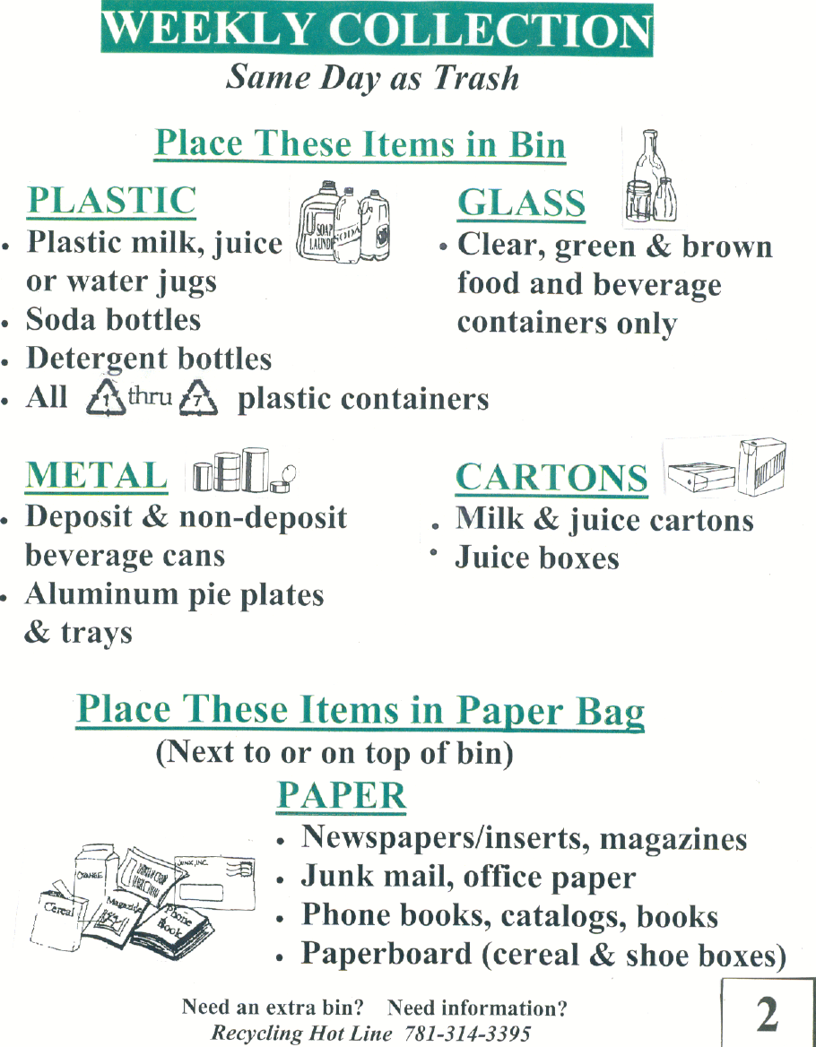

\  Papers  Containers  white and colored paper and envelopes  Clear & colored glass bottles and jars  Metal & Aluminum cans, foil, & trays  Stiff plastic containers  Flatten cardboard and cut down to no bigger than 3ft x 3ft  Papers in a brown bag or bundled with string  Remove caps, rinse & put loose in blue bin  newspapers  phone books  Junk mail  magazines  Paper bags  softcover and spiral notebooks  wrapping and packaging paper  Paperboard boxes and beverage cartons  cardboard  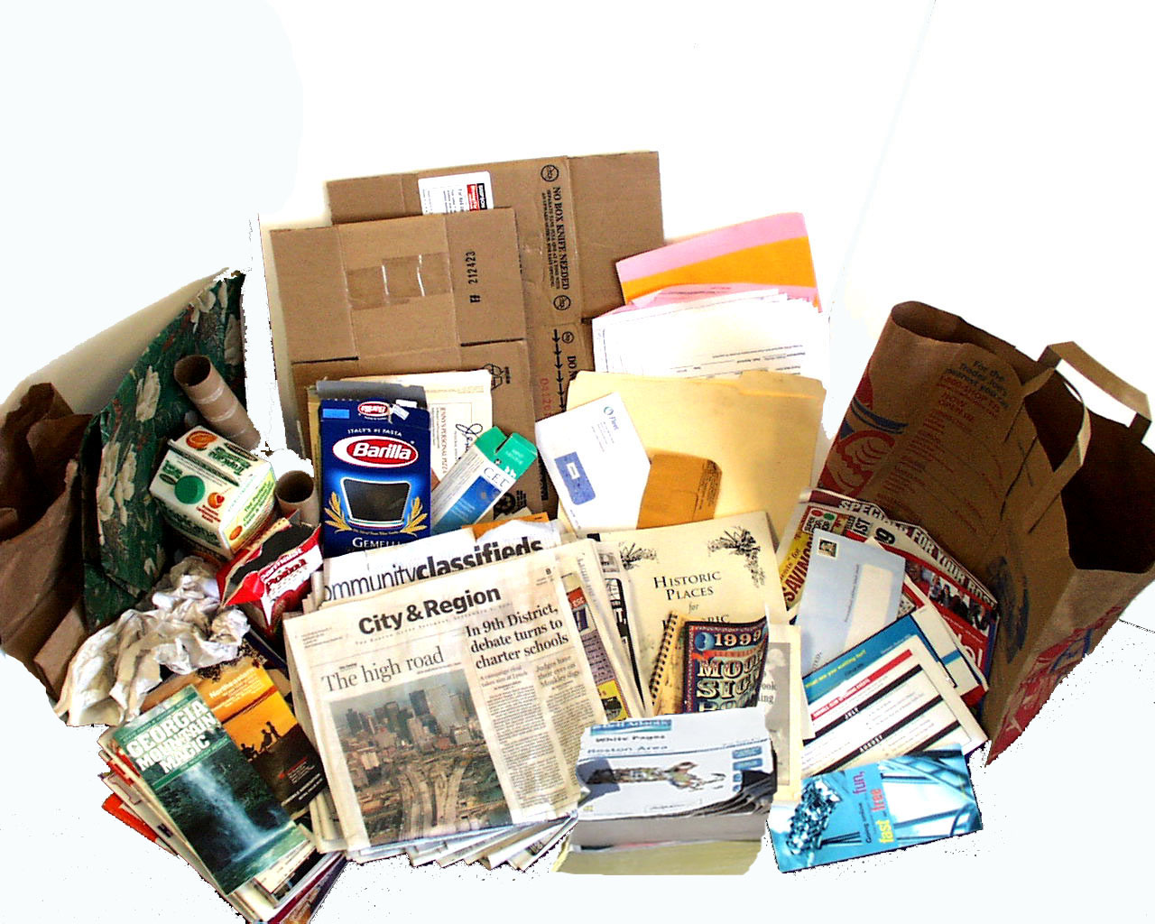  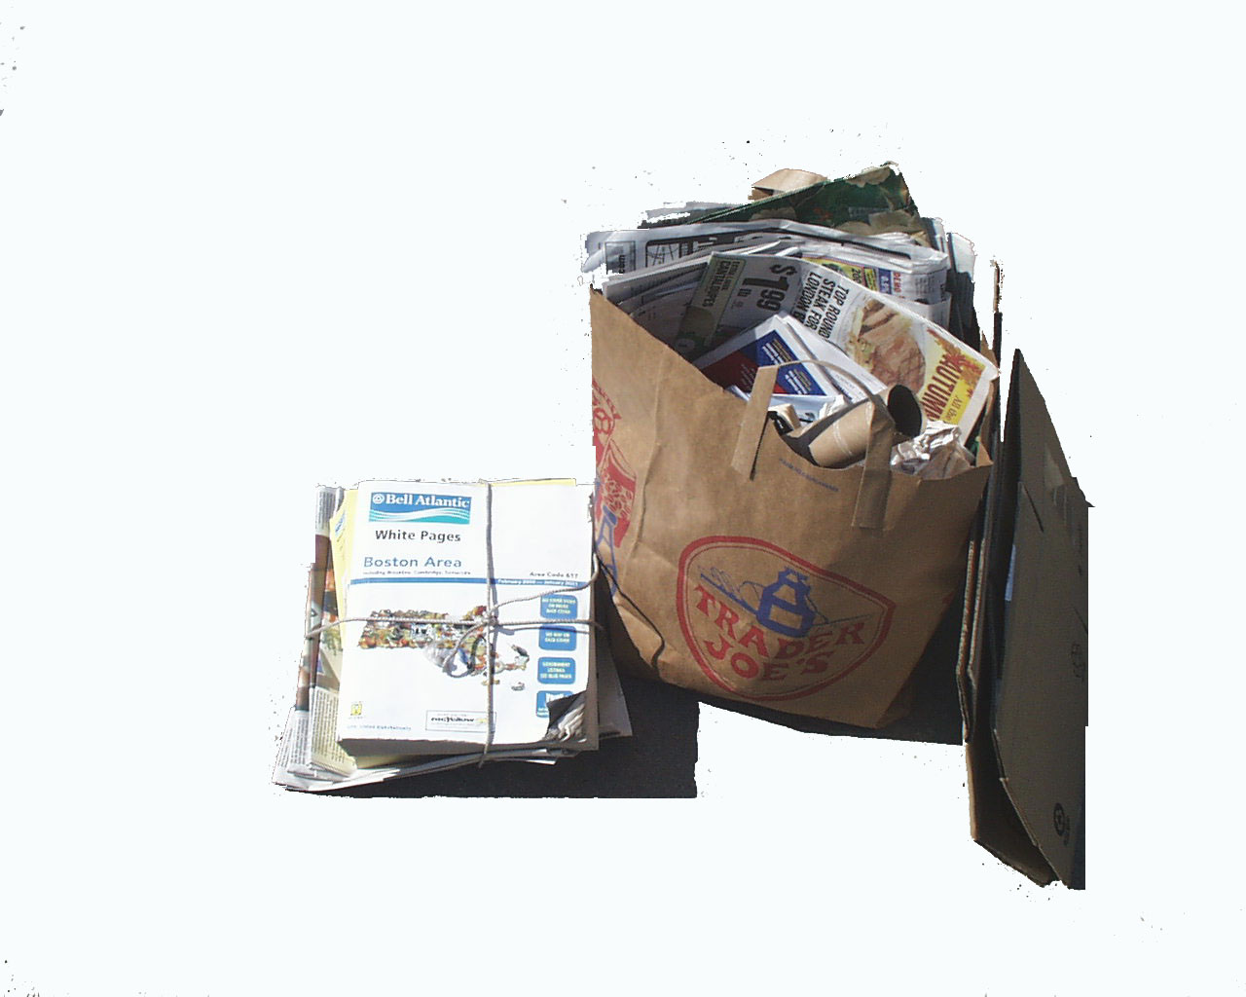 | 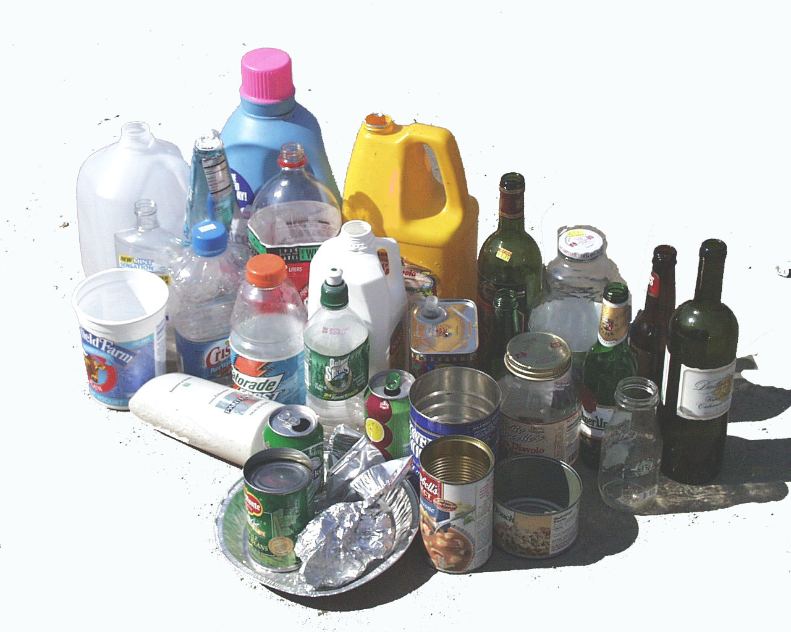  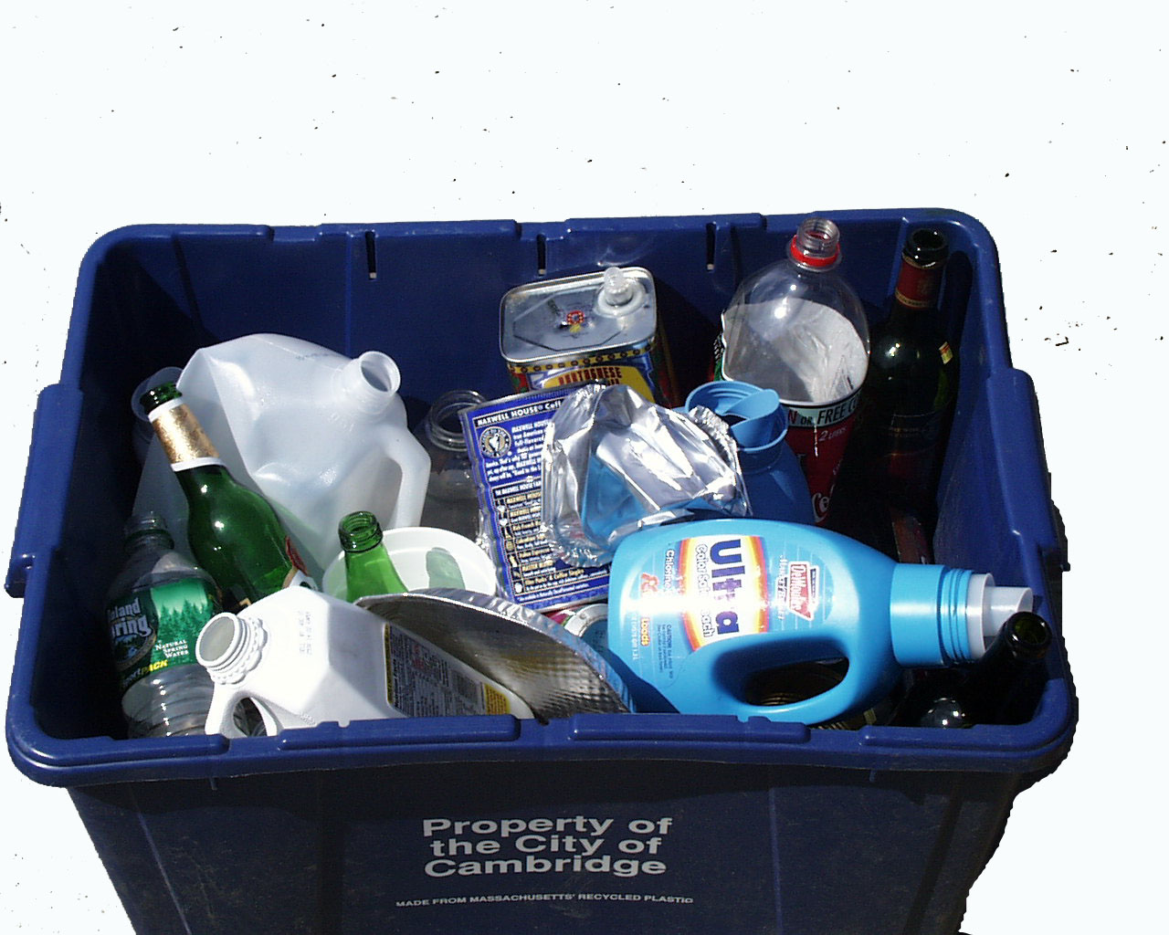
Printed on recycled paper using soy based inks  3  We can't recycle… pizza boxes, styrofoam, plastic bags, plastic toys, dishes & glassware, pots and pans, plant pots, or hangers | 3 Quick Rules:  - Do not mix papers with containers  - No plastic bags  - Put recycling at the curb by 7am on trash collection day

APPENDIX B
FOCUS GROUP REPORTS
City of Waltham Recycling Focus Group Findings
November, 2001

Study Objective

Research International was contracted by the City of Waltham to conduct four focus groups with Waltham residents concerning the City’s recycling program. On Thursday, November 15, 2001, Research International conducted two of the four focus groups¹ which addressed the following issues:
- Motivations regarding recycling behavior
- Factors likely to influence higher participation levels in the recycling program
- Knowledge regarding the City’s recycling program
- Social expectations concerning recycling

The first focus group was comprised of Waltham residents who do participate in the City’s recycling program (referred to as “recyclers” in the memo) and the second group was conducted with residents who do not participate in the recycling program (referred to as “non-recyclers” in the memo). Residents’ demographics in each group were distributed between gender, age, income, and those living in single/multi-family dwellings. Of the eight participants who attended each group, four in the “recycling” group were ethnic minorities (2 American Indian, 2 Hispanic) and two in the “non-recycling” group were ethnic minorities (1 Asian and 1 Hispanic). When comparing participants’ education levels we found that more “recyclers” had pursued education beyond the high school level than had “non-recyclers.”

¹ Research International will conduct the last two focus groups in early 2002.
Key Findings

Identified below are key findings from the focus groups. Many of these findings can be further validated in the quantitative phase of the research and/or considered for inclusion in the new design of Waltham’s recycling program.

- Most residents of Waltham recycle to improve the environment.
- The frequency of collecting recyclables does influence most residents’ recycling behavior. The program’s more frequent weekly collection schedule led many recyclers to increase their recycling. Many non-recyclers do not recycle because they incorrectly think that recycling is collected bi-weekly which they perceive to be too infrequent for the amount of recyclables they have.
- Both recyclers and non-recyclers recommend that designing a bin that is higher, holds more, has a lid, and is on wheels or has sturdy handles would lead more Waltham residents to recycle. Based on our findings, the design of the recycling bin is the most significant barrier to participating in the City’s recycling program. We strongly recommend that Waltham further studies and considers redesigning the recycling bin.
- Overall, residents who recycle and those who do not are satisfied with the information Waltham provides to them about its recycling program.
- Both recyclers and non-recyclers are generally knowledgeable about materials that can/cannot be recycled. A few residents required clarification regarding the types/color of glass that can be recycled. As an example, Waltham should consider including more specific language about the types/color of glass that can be recycled in its program literature.
- Some recyclers state that residents would recycle more or even begin to recycle if the City informed the residents of specific products – both consumer and those used by the City – that were made from recycled materials.
- Similarly, recyclers and non-recyclers are knowledgeable about yard waste that can/cannot be recycled. A few residents are confused by the term “yard waste” as some interpreted it to mean waste from the yard that would include grills, etc. Waltham should further test this term in the quantitative study and possibly consider other terms that more concisely describe yard waste, e.g., yard clippings or organic material.
- Although neither recyclers nor non-recyclers feel outside pressure to recycle, a small number of non-recyclers feel a bit “guilty” about not recycling.

Motivation Concerning Recycling Behavior

Both residents who recycle and those who do not recycle state that Waltham residents recycle to improve the environment. Recyclers participate in the City’s recycling program to improve air quality and reduce landfill waste.

- “[Recycling] is good for the environment. It cuts down on trash.” (Recycler)
- “[Recycling] saves the environment, protects the water supply, and protects the air supply.” (Recycler)

A few recyclers also identify the potential financial savings that may result from recycling. For example, some participate because they believe that the City receives a financial pay-back either in the form of a tax break or as a cash payment from the recycling center and because they believe the products made from recycled material are less expensive.

Waltham’s weekly recycling pick-up schedule has led most recyclers to increase their recycling over the past year.

- “I recycle more this year because the City has weekly pick-ups.” (Recycler)

Although non-recyclers recognize the environmental benefits of recycling, most do not recycle because they perceive it to be “inconvenient.” Living situations such as residing in an apartment (especially above the first-floor) and lack of a good place to store the recycle bin are some perceived inconveniences of recycling. Also, most non-recyclers incorrectly believe that Waltham’s recycling is currently collected bi-weekly, and state that they do not recycle because of the large quantity of recyclables that collect over the two-week period.

- “I am on the second floor and I don’t really have the space.” (Non-recycler)
- “Pain in the neck. Cannot remember when pick-up is. No place to store things [and cans and bottles] attract bugs.” (Non-recycler)
- “It is very inconvenient because of [lack of] storage and sanitary problems.” (Non-recycler)

Factors Likely to Increase Recycling Behavior

Increasing the convenience of recycling may motivate people to recycle more or to start recycling. Both recyclers and non-recyclers agree that recycling would be more convenient if the design of the recycling bin is modified. In general, both groups recommend that the bins be made deeper to accommodate more items and to prevent items from falling out or blowing away. To prevent recyclables from smelling, attracting bugs, or from getting wet if stored outside, both groups recommend designing a cover for the bins. Some suggest placing wheels or sturdy handles on the bins to increase the ease of transporting a full bin to the curb.

- “Change design of bin.” (Recycler)
- “If bins were bigger and higher not like they are now.” (Recycler)
- “Bigger and closed containers.” (Non-recycler)
- “Large, closed containers distributed by the City to be left outside of the home.” (Non-recycler)

In addition to increasing the convenience of recycling, many recyclers believe that residents, including themselves, would be more motivated to recycle if they knew more about what was being made from residential recycled material. Also, some recyclers state that residents should be informed of the recycled products – from office supplies to materials used to build playgrounds – that are used by the City.

- “… there are many people out there who don’t know what they are recycling for. It would be nice if they would explain what they are making out of it.” (Recycler)
- “A list telling what products were made from the recycled products.” (Recycler)
- “If some of the recycled products started to show-up being used by the city such as plastic wood.” (Recycler)
- “More information on recycling, showing what recycled products are, and showing if the city is using any of these products.” (Recycler)

Both recyclers and non-recyclers with school age children state that recycling in the City would increase if the schools educate the children about the City’s recycling program and about the benefits of recycling.

- “More education at schools – instruct the kids.” (Recycler)
- “[They should] teach kids in school about it.” (Recycler)

Residents from both groups suggest that financial incentives to recyclers in the form of property tax reductions or cash payments would likely increase participation in Waltham’s recycling program.

- “Companies who recycle would be rewarded and get money and donate to school. And when recycling was new, could take it and get money for it. You can get paid for so many pounds. (Recycler)
- “[Waltham] should give back money based on the [quantity] you recycle.” (Recycler)
- “Economic reward and punishment will motivate residents to recycler.” (Non-Recycler)
- “If recycling would keep (property) taxes down.” (Non-recycler)

If Waltham does receive a financial incentive for recycling, residents identify that recycling would likely increase if the City informed the residents of how the recycling money is invested back into the community.

- “[Residents would recycle more if they could] see the results: how much money did Waltham receive for recycling and where did the money go.” (Recycler)

Information About the City of Waltham’s Recycling Program

Most Waltham residents are satisfied with the information the City of Waltham provides on its recycling program. Recyclers and non-recyclers recall reading information about the program in mailings and in the City’s newspaper or through seeing information on the City’s cable television station. Most recyclers recall receiving program information in the mail on an annual basis while many non-recyclers do not recall the frequency in which they receive such mailings.

- “The City does a pretty good job providing us information.” (Recycler)
- “Yes, I think it does provide enough information through the flyer.” (Recycler)
- “The City of Waltham has provided me with enough information about the importance of recycling and the way of recycling. I got the information from a letter sent to my home early this year.” (Non-recycler)
- “A card came in the mail telling you what day to put the trash recycling bin out and what to recycle and [you] can read it in the newspaper.” (Non-recycler)

Knowledge of the City of Waltham’s Recycling Program

Knowledge concerning the City’s recycling program was based on residents’ awareness of material and yard waste that could/could not be recycled as well as their awareness of the collection schedule for both materials and yard waste.

Material Recycling
Both recyclers and non-recyclers were asked to make a list of materials they believe could be recycled and those that could not be recycled. As shown in the table below, recyclers and non-recyclers are equally knowledgeable about the items that can be recycled. Residents most frequently identify paper, plastic, and glass bottles as items that can be recycled.

Materials That Can Be Recycled
 | Recyclers | Non-Recyclers
Paper | √ | √
Plastics | √ | √
Glass bottles | √ | √
Tin cans | √ | √
Aluminum cans | √ | √
Magazines | √ | √
Cardboard | √ | √
Appliances by appointment | √ | √

After identifying items that can be recycled under Waltham’s program, residents received a list of “official items” that can be recycled. Overall, residents (both recyclers and non-recyclers) were aware that all the items on the list could be recycled. A few residents were not aware that phone books and junk mail could be recycled. Similarly, a small number of residents needed clarification regarding the color of glass that could be recycled (e.g., whether blue glass could be recycled).
The table below presents the materials that recyclers and non-recyclers identify as “materials that cannot be recycled” in Waltham’s program. Both groups are aware that only certain types of plastic and glass can be recycled.

Materials That Cannot Be Recycled
 | Recyclers | Non-Recyclers
Tires | √ | √
Propane tanks | √
Certain types of plastic | √ | √
Certain types of glass | √ | √
Steel | √
Aerosol cans | √
Baby bottle nipples | √
Batteries |  | √
Oil |  | √
Chemicals/Pesticides |  | √
Paint |  | √

Knowledge of the program’s schedule for collecting recycled material greatly differs among those who recycle and those who do not. Not surprisingly, recyclers are aware that their recycled material is collected weekly while most non-recyclers incorrectly think that it is collected bi-weekly according to the color of the bin.

Yard Waste Recycling
Most participants who recycle material waste and reside in single family homes also recycle yard waste through Waltham’s program. However, we find that many participants who do not recycle materials and live in single family homes recycle yard waste. These participants find recycling yard waste more convenient than recycling material waste.

It appears that non-recyclers understand the life cycle process concerning recycling yard waste – waste decomposes into the ground and enriches soil – better than they understand the life cycle process of recycling material waste – material is often melted to be re-used as another product. Educating the residents of the products that are made from recycled material (both consumer products and those used by the City) would help educate residents of the life cycle process of material waste.
Both recyclers and non-recyclers are knowledgeable about yard waste that can/cannot be recycled in the program. Although most residents are aware that branches can be recycled, all are not aware of the exact branch size that can be recycled.

Yard Waste That Can Be Recycled
 | Recyclers | Non-Recyclers
Leaves | √ | √
Grass | √ | √
Branches | √ | √
Vegetable garden greens |  | √
Flowers | √ | √
Wood |  | √
Bushes |  | √
Organic matter |  | √

Similarly, recyclers and non-recyclers are knowledgeable about the yard waste that cannot be recycled in Waltham’s program. A small number of residents from both the recycling and non-recycling groups misinterpret that the term “yard waste” also includes outside waste from the house or backyard (i.e., grills, shingles, etc.). The City may wish to further analyze residents’ interpretation of the term “yard waste” when conducting the quantitative portion of the study.

Yard Waste That Cannot Be Recycled
 | Recyclers | Non-Recyclers
Tree stumps |  | √
Gravel | √ | √
Dirt |  | √
Shingles |  | √
Animal waste | √ | √
Rotten wood |  | √
Gas grill |  | √
Lumber | √
Bricks | √

Although most residents are aware that yard waste is collected bi-weekly, many are not aware of how many months of the year it is collected. Residents from the “non-recycling” group more often correctly estimate that yard waste is collected between 6 and 8 months of the year compared to residents from the “recycling” group who estimate that it is only collected in the fall.

Experience with Hauler

Recyclers are most familiar with the hauler that collects the City’s recycling. In general, most are satisfied with the hauler’s service, however, one recycler did state that the hauler threw material (i.e., plastic nipples from baby bottles and plastic hangers) that could not be recycled onto her yard on collection day.

Social Awareness of Recycling

In general neither recyclers nor non-recyclers state that they feel outside pressure to recycle. Recyclers do seem to expect others to recycle, but they do not communicate the benefits of recycling to neighbors or other residents who do not recycle.

- “[I’m] shocked at the people who don’t [recycle] and there seems to be a lot out there.” (Recycler)

A small number of non-recyclers feel somewhat guilty about not recycling.

- “I feel a bit guilty about not recycling. It’s not a good thing not to do.” (Non-recycler)
- “I feel obligated as a resident of Waltham, I should do it.” (Non-recycler)

More recyclers than non-recyclers take notice of neighbors’ recycling behavior. A few recyclers notice differences in neighbors’ recycling behavior. For example, one recycler takes notice of larger families on her street who have small quantities of recyclables at the curb – leading her to believe that these families do not recycle as much as they can. In contrast, a few recyclers and non-recyclers believe that small to no quantities of recyclables at the curb may mean that their neighbor eats more “fresh” than canned foods.

- “I figure that some of the people don’t use a lot of canned goods, healthy people, they are using all natural goods.” (Recycler)

City of Waltham Recycling Focus Group Findings
February 2002

Study Objective

Research International completed the final two of four focus groups with Waltham residents concerning the City’s recycling program on February 5, 2002. The final two focus groups assessed those residents’ (who currently recycle) interest in the City’s proposed recycling pilot program. The pilot program’s design was influenced by findings from the first two focus groups in November, 2001 and by subsequent telephone surveys with residents.

Specific topics discussed during the most recent groups were:
- Impressions of recycling decal to place on recycling containers
- Evaluations of three mock-up recycling decals
- Feedback on commitment to refer to recycling decal
- Interest in being educated about:
- By-products made from City’s recycled material
- Amount of annual waste City diverts from landfill as a result of recycling
- Amount of money City saves annually from recycling
- Identification of preferred medium to communicate results of City’s recycling program to community

Women participated in the 6:00 PM group and men participated in the 8:00 PM group. Any gender differences concerning the topics discussed will be noted in the findings. Both groups were diverse in both age and ethnicity.

[Note: The decal samples can be found at the end of the February 5th focus group discussion guide in Appendix A. Each sample is identified by a number in the report below, which can be found at the bottom of the decal.]
Key Findings

- Women and men favor the recycling decal and believe it would motivate residents to recycle more.
- Women are more likely to place the decal on the recycling container where many men are likely to place it on another location (i.e., cupboard or refrigerator). Waltham should consider providing households with two decals to increase the likelihood that residents will refer to it.
- Decal 3 was the most favored recycling decal as 7 participants identified it as their favorite. Participants liked its graphics which made it easy for them to quickly learn about recycling. Decal 3 is best suited for the widest audience which includes non-English speaking residents and children.
- The value of Decal 3 can be increased by including plastic containers (1 thru 7) can be recycled, City’s recycling hotline number, City’s web site address.
- Decal 2 was the runner-up as it was most favored by 4 participants. These participants liked its layout and the effective incorporation of both text and small pictures to communicate the recycling message.
- Decal 1 was the “loser” among participants. Most found it boring, not creative, and uninformative.
- As part of the new program, the City will contact residents to request their commitment to refer to the decal. If contacted by phone, participants would commit to refer to the recycling decal when they had a question about the program. However, many participants questioned the value of such a call and recommended that the call be more informative. For example, the purpose of the call should be to confirm that resident received decal, answer any questions about the program, communicate program results, and provide information about how to obtain an additional container.
- The new program proposes to publish the names of those residents who commit to the decal in the City paper. Female participants are strongly opposed to publishing the names of residents. Men agree that the publication of names could actually negatively impact program participation.
- Participants were enthusiastic about receiving all information about the program’s success. Information about products made from the City’s recyclables is best suited for school-age children (elementary through high school). Adults, particularly property owners, are most interested in learning of the money Waltham saves from recycling.
- Participants are most interested in learning about the on-going progress of the program. As a result, participants recommend that Waltham should design signs to place outside City Hall and on other City grounds to enable residents to easily track the progress during their daily routine around the City. This signage should be updated monthly so that residents can see their actual contributions.
Focus Group Findings

A. Placing Recycling Decals on Recycling Containers

Both women and men favored the idea of receiving a recycling decal that would indicate the material to recycle under Waltham’s program. Both groups believed that providing such information on a proposed recycling decal would motivate residents to recycle more. The decal was perceived to provide significant educational value – especially for younger residents (college age and younger) who may be motivated to begin recycling if such a decal was provided.

“The decal is a good idea. People would be more aware of what to put in and more would get recycled.” (Female)

The decal design was also an important factor in discussing its likely impact on recycling behavior. Participants agreed that the decal must be large, colorful, and easy-to-read to attract people’s attention and enable them to quickly learn from its message.

“Decal is helpful if large enough and colorful.” (Male)

Differences did exist in terms of where female and male respondents would place their decal. Women were much more likely to place their decal where intended – on the recycling container. Some men raised concern about the decal getting dirty if placed on the container and suggested that they would likely place it on the refrigerator or in another area in their kitchen.

Recommendation: The “decal” is an effective medium to communicate the material that can be recycled under the City’s program. The ability to actually secure the decal on the container or on another location of choice is likely to increase the likelihood that residents will refer to the information throughout the year.

As residents keep their container in different locations (i.e., kitchen, porch, garage, etc.) provide residents with two recycling decals – one to secure on their container and another to place in a location of choice.

B. Recycling Decal Evaluation

Decal 3
Decal 3, meeting participants’ desire for “color” and ease of reading, was the overall favorite among men and women. (Four women and three men identified Decal 3 as their favorite.) The decal’s graphics -- showing both the materials to recycle and how to prepare them for curbside recycling – was perceived to be most educational. Participants thought that the decal’s graphically descriptive nature would communicate the recycling message to a wider audience which included non-English speaking residents as well as children.

“Most visual for all ages.” (Female)
“It’s good, tells me how to do it the right way.” (Female)
“Catches your eye, the photos give it interest.” (Female)
“Like the visuals, like different items pictured together.” (Male)
“Pictures keep it simple even if you can’t understand English.” (Male)
“Clear, bright, informative, easy to read.” (Male)

In addition to the decal’s graphics, many participants found specific text to be quite informative such as:
- The list of what can’t be recycled
- The three quick recycling rules

After reviewing Decal 3, many also learned that pizza boxes could not be recycled and that paper products could be recycled with newspapers.

Interested to make Decal 3 as informative as possible, participants suggested to include the following information:
- Plastic containers numbered “1 thru 7” can be recycled
- City’s recycling hotline number
- City’s web site address

The few participants who did not like Decal 3 thought it was too busy – making it unlikely that they personally would refer to it. However, after hearing others’ perceptions toward Decal 3, these participants often changed their opinion as they recognized the value of Decal 3’s design to the whole community.

Decal 2
Decal 2 was most favored by 4 participants (3 women and 1 man). Those favoring Decal 2 liked its layout and the perceived effective incorporation of both text and small pictures to communicate the message. Some also liked the use of the color green which they associated with the environment.

“Well organized and good color used.” (Female)
“Like little pictures.” (Male)

Although not the clear favorite, many found specific content on Decal 2 to be of value:
- A few men liked the “Need an extra bin?” text and accompanied phone number
- Both men and women liked the identification that plastic containers numbered 1 through 7 could be recycled

Decal 1
Decal 1 was the unanimous “loser” among women as none identified it as their favorite. However, 2 men identified it as their favorite. Women were most critical of Decal 1 – describing it as boring, not creative, and uninformative. Some suggested that it looked like a low-budget, mass-produced flier they receive in the mail. Many also alluded that they would likely “recycle” the decal rather than posting it on their container.

“(Information) won’t stay in your memory.” (Female)
“People are lazy, want to learn most in least time.” (Female)
“Very plain, not eye-catching.” (Female)

The two men who most favored Decal 1 found it simple and easy to read.

Recommendation: Decal 3 is the clear winner as it can most effectively communicate the City’s recycling message to the widest audience in the community. The size of the decal is important and should not be produced much smaller than the mock-up used in the focus group.

The educational value of the decal can be enhanced by including information such as: the recycling hotline number, message that “1 thru 7” plastic containers can be recycled, and City’s web site address.

C. Commitment to Recycling

Telephone Commitment
The new recycling program proposes to contact each Waltham household and request their commitment to refer to the decal. Participants agreed that if called, they would commit to refer to the recycling decal. The groups were divided in terms of whether such a commitment would actually increase residents’ recycling behavior. Some noted that “committing” is simply easier than “not committing” in an effort to quickly end the phone call.

“Depending on the time of the call, I’ll usually say anything to get off the phone.” (Male)
“You will get a lot of “Sure, yes, bye.” “(Female)

Men suggested that residents would be more likely to follow-through with their commitment if the call was more informative than simply asking for a commitment. Additional information to include in the phone call includes:
- Verification that household received decal
- Answer questions residents has
- Provide benefits of City’s program (items made from recyclables and benefits of recycling to the City)
- Inform residents on how to get another recycling container

A few women suggested that the City should call residents a few times a year to remind them of the recycling program.

Publish Names
One proposed way to help build support for the program was to ask permission to publish the names of residents in the City paper who committed to refer to their recycling decal. Opinions concerning this varied greatly between women and men. Women strongly opposed the publishing of names for personal security reasons.

“People don’t want their names published. People are private… horrible idea, public safety and privacy.” (Female)

Initially, men were neutral on the idea and were not certain it would motivate residents to recycle more. In contrast to women, men did not object to having their name published in the paper. However, after discussing this with the group, most men opposed the publishing of names as they thought it could actually have a negative impact on recycling participation.

“Seems kind of funny. Would it put some people off (non-recyclers), “you are such a good boy” (said of recyclers)” (Male)
“It will get people mad, if they recycle and are not called and there name is not in the paper.” (Male)

Some men recommended that publishing results of the City’s recycling program (i.e., amount recycled per year, cost savings to City) would be more effective than publishing names of committed households.

Recommendation: The pilot program will likely be more effective if Waltham households are contacted by phone shortly after the decals are mailed. The phone call should be multi-purpose and informative: (1) confirm receipt of decals; (2) ask for commitment to place decals on container and on another location of choice; (3) answer any questions about the program; (4) share program successes (dollar savings, waste diverted); (5) inquire if household needs additional recycling containers.

Do not pursue publication of names in City paper for privacy issues and to avoid potential ill-feelings toward the program.

D. Information About Recycling Program

Successes of Recycling Program
All participants were enthusiastic about the idea of Waltham providing residents with information about:
- Products made from the City’s recyclables
- Amount of City’s annual waste diverted from landfills
- Amount of money residents’ recycling annually saves the City

Participants recognized that all of the information described above should be communicated to residents as a specific message is likely to resonate more with particular individuals. For example, the participants indicated that children would be more interested to learn about product’s made from the City’s recyclables than to learn about the actual dollar savings to the City.

Participants perceived children as a key audience to reach about the City’s recycling program as children were most likely to communicate the message to their parents. Many suggested that the City’s schools educate children about the recycling program by providing program information or by assigning a school project on recycling.

In general, participants were interested in actual statistics about the program – annual waste diverted from landfill and annual dollar amount City saved by recycling. Participants who were homeowners were most interested in the bottom line – actual dollar savings generated from material recycled by Waltham.

“The more education, the better. Different information will work for different people.“ (Male)
“Everything comes down to money“ (Male)
“Absolutely all for knowing how much we’d save, show me the money.” (Female)

Communicating Results to Residents
Participants recognized the importance of identifying an effective medium to deliver information about the City’s recycling program. In general, both women and men agreed that such results should be posted outside and in multiple City locations for people to easily see during their daily routine. For example, most women favored printing results on a billboard and men suggested posting results on a sign in front of City Hall and on other City grounds. This message should be updated monthly to communicate the on-going progress. Examples of how Waltham can communicate its recycling progress to residents:

- Sign with graphic of thermometer outside City Hall which would be filled-in to show money saved or quantity of waste diverted
- Physically display progress by using objects such as recycling containers or BFI trucks to translate tonnage of waste diverted
- Post results (dollar savings or waste diverted) on BFI truck for residents to see around town
- Compare program results with other local city

Some participants also suggested communicating results via City paper and the City’s cable access channel.

Recommendation: The City must develop multiple messages to communicate the program’s progress. First, the City should provide teachers with material to distribute to students regarding products made from material recycled in Waltham. Second, the City should develop multiple messages to post outside on public grounds. For example, a sign with a thermometer – indicating monthly quantity of waste diverted from landfill – should be placed on the grounds of City Hall for pedestrians and motorists to see. The City should also post this information on its web site.

Once these three mediums are implemented, Waltham may wish to consider publishing such statistics in the local paper. When publishing this information, the City should also inform residents of the locations of its outdoor signage so that residents can take notice of them when in the area.

APPENDIX C

RECRUITMENT SCREENER

Waltham Recycling Screener

RESPONDENT NAME

Good morning/afternoon/evening, My name is _________ and I am calling on behalf of Research International Company, an independent market research firm. We are currently putting together a discussion group to talk about some issues related to your town. This is not a sales call of any sort. The group will last up to 2 hours and you will be paid $75 for your participation. I would like to ask you a few questions to determine how you might fit into our group.

Q1. In what city do you live? (RECRUIT ONLY WALTHAM RESIDENTS)

Q2. Do you live in a single family home, townhome, multifamily home, or apartment building?
(RECRUIT 50% SINGLE FAMILY HOME & 50% MULTIFAMILY HOME/APARTMENT)

- Single family home/townhome (SKIP TO Q4 - RECRUIT 4 PER GROUP)
- Multifamily home (2 or 3 family houses) (CONTINUE)
- Apartment building (CONTINUE)

Q3. What is your address? (REFER TO LIST OF ADDRESSES. TERMINATE IF ADDRESS MATCHES ONE ON LIST)

_______________________________________

Q4. Do you recycle?

- Yes (CONTINUE)
- No (terminate)

Q5. Would you say that you recycle more or less than your neighbors? (RECRUIT A MIX)

- More
- Less
- OTHER, same as (ONLY RECRUIT IF DIFFICULT TO FIND “MORE” AND “LESS”)

Q6-Q9 RECRUIT A MIX OF PARTICIPANTS

Q6. Into which of the following age range do you fall? READ LIST
(GOOD MIX)
- Under 18 (TERMINATE)
- 18-24
- 25-34
- 35-44
- 45-54
- 55-69
- Over 70
- (Refused) (TERMINATE)

Q7. Which best describes the highest level of education you completed? READ LIST
(GOOD MIX)
- High school graduate or vocational school
- Associates or professional degree
- College degree
- Graduate degree
- Other:_______________________
- (Refused)

Q8. Which of these categories includes your approximate annual income? READ LIST
(GOOD MIX)
- Under $20,000
- More than $20,000 but less than $35,000
- More than $35,000 but less than $50,000
- More than $50,000 but less than $100,000
- $100,000 or more
- (Refused)

Q9. Which ethnic group best describes you? READ LIST
(GOOD MIX)
- Caucasian
- African American
- Asian
- Hispanic
- American Indian
- Other, Specify
- (Refused)

Q10. How many languages can you speak either fluently or proficiently? READ LIST

- One (SKIP TO Q12)
- More than one (CONTINUE)

Q11. Which languages do you speak? (NOTE, PLEASE ENSURE THAT PARTICIPANT SPEAKS ENGLISH WELL.)

- English
- Spanish
- Other, Specify_______________

Q12. During the group you will be asked to write short responses on paper. Are you comfortable writing in English?

- Yes
- No (Terminate)

Q13. Gender: (Observed – recruit Females for 6PM group and Males for 8PM group)

- Male
- Female
INTERVIEWER: IF YOU ARE LOOKING FOR A PARTICULAR GENDER AND THE PERSON ON THE PHONE DOES NOT MATCH WHAT YOU ARE SEEKING, ASK: “WE WANT TO BE SURE WE TALK TO BOTH MEN AND WOMEN ABOUT THIS, AND RIGHT NOW WE ARE LOOKING FOR MORE [MEN/WOMEN]. IS THERE A [MAN/WOMAN] IN YOUR HOUSEHOLD THAT I MIGHT TALK TO?”

Q14. One final question. Please tell me what activities you like to do in your spare time? Why?

_______________________________________________________________________

_______________________________________________________________________

_______________________________________________________________________

INTERVIEWER: THIS QUESTION HAS NO RIGHT OR WRONG ANSWER, BUT SHOULD BE USED TO DETERMINE IF A RESPONDENT IS INARTICULATE, UNCOMMUNICATIVE, HAS A SPEECH IMPEDIMENT, HEARING PROBLEM OR IS GENERALLY UNWILLING TO THINK ABOUT THE TOPIC. TERMINATE ACCORDINGLY.

We are organizing a discussion group to be held on February 5 at (6:00 p.m./8:00 p.m.). The discussion will be held at _________________ and will take 2 hours. We are only interested in eliciting your valuable opinions with absolutely no further obligation. Please note that everything you say will be held in confidence, and you will be paid $75 for your participation. May I reserve a seat for you at this discussion group?

Thank you. Now, may I please verify your name, address and telephone number?

NAME: __________________________________________________________________

ADDRESS: _______________________________________________________________

CITY, STATE, ZIP: _________________________________________________________

PHONE: Day____ Evening ___ ( ) _________________________________

We will be sending you some information, including a map and some instructions on parking.

I also need to let you know that we will get going right on time at (6:00p.m./8:00pm) on February 5th, so please try to be there then. If you do get there after the discussion has started, we may not be able to include you.

We will call you back to remind you on the day that the group will be meeting. If we call you on date of group, during the day, would this be a good number to reach you at?
INTERVIEWER: IF NOT, GET DAYTIME NUMBER OR AGREE TO CALL WITH REMINDER THE NIGHT BEFORE.

If an emergency comes up and you are unable to attend, would you please call ______ to let us know?

END NOTES ? Mckenzie-Mohr, D. (2000). Fostering Sustainable Behavior Through Community-Based Social Marketing. Americian Psychologist, 55(5), 531-537.
McKenzie-Mohr, D. (1999). Fostering Sustainable Behavior: An Introduction to Community-Based Social Marketing. Gabriola Island, British Columbia: New Society Publishers. p27; Morgan, D.L. (1998). The Focus Group Guidebook. Thousand Oaks, CA: Sage Publications. Vol. 1 of Focus Group Kit. 6 Vols. p1.
McKenzie-Mohr, D. (1999) p30.
McKenzie-Mohr, D. (1999) p30-31.
McKenzie-Mohr, D. (1999) p122 & 125.
McKenzie-Mohr, D. (1999) p125
Greenbaum, T.L. (1998). The Handbook for Focus Group Research. (2nd Ed.) Thousand Oaks, CA: Sage Publications, p28-31.
Greenbaum, T.L. (1998) p28-31.
Gladwell, M. (2002). The Tipping Point: How Little Things Can Make a Big Difference. Boston: Little, Brown and Company. p79.
McKenzie-Mohr, D. (1999) p27.
Greenbaum, T.L. (1998) p81.
Greenbaum, T.L. (1998) p77-78.
Greenbaum, T.L. (1998) p50.
Greenbaum, T.L. (1998) p37.
Greenbaum, T.L. (1998) p 41.
Greenbaum, T.L. (1998) p34-35.
Greenbaum, T.L. (1998) p109.
Greenbaum, T.L. (1998) p109.
Greenbaum, T.L. (1998) p14 & 15.
McKenzie-Mohr, D. (1999) p27.
Buhsmer, Karla. (2002, September 30). Research International. Email Communication.
Greenbaum, T.L. (1998) p109.
McKenzie-Mohr, D. (1999) p30.
Greenbaum, T.L. (1998) p43.
Greenbaum, T.L. (1998) p36.
McKenzie-Mohr, D. (1999) p27
McKenzie-Mohr, D. (1999) p72.
McKenzie-Mohr, D. (1999) p28 & 29.
Greenbaum, T. L. (1998) p144.
Kueger, R. A. (1998). Analyzing and Reporting Focus Group Results. Thousand Oaks, CA: Sage Publications. Vol. 6 of Focus Group Kit. 6 Vols. p47.
Kueger, R. A. (1998). Analyzing and Reporting Focus Group Results. p47.
Krueger, R.A. (1998). Developing Questions for Focus Groups. Thousand Oaks, CA: Sage Publications. Vol 3 of Focus Group Kit. 6 Vols. p34.
Greenbaum, T.L. (1998) p37 &41.
Greenbaum, T.L. (1998) p37.
Krueger, R.A. (1998). Developing Questions for Focus Groups. p22.
Krueger, R.A. (1998). Developing Questions for Focus Groups. p22.
Greenbaum, T.L. (1998) p40.
Krueger, R.A. (1998). Developing Questions for Focus Groups. p3-5.
Krueger, R.A. (1998). Developing Questions for Focus Groups. p34.
Greenbaum, T.L. (1998) p42.
Morgan, D.L. (1998). Planning Focus Groups. Thousand Oaks, CA: Sage Publications. Vol. 2 of Focus Group Kit. 6 Vols. p124.
McKenzie-Mohr, D. (1999). p27 & 28.
Kueger, R. A. (1998). Analyzing and Reporting Focus Group Results. p48.
Greenbaum, T.L. (1998) p46.
Greenbaum, T.L. (1998) p47.
McKenzie-Mohr, D. (1999) p30.
Greenbaum, T.L. (1998). p15.
Kueger, R. A. (1998). Analyzing and Reporting Focus Group Results. p12.
McKenzie-Mohr, D. (1999). p30.
Kueger, R. A. (1998). Analyzing and Reporting Focus Group Results. p14.
Kueger, R. A. (1998). Analyzing and Reporting Focus Group Results. p16.
Kueger, R. A. (1998). Analyzing and Reporting Focus Group Results. p15.
Morgan, D.L. (1998). Planning Focus Groups. Thousand Oaks, CA: Sage Publications. Vol. 2 of Focus Group Kit. 6 Vols. p117-120.
Morgan, D.L. (1998). Planning Focus Groups. Thousand Oaks, CA: Sage Publications. Vol. 2 of Focus Group Kit. 6 Vols. p117-120.

