The Oakdale

Neighborhood

Recycling

Campaign

A Community Working Together to Promote Participation in Curbside Recycling

Prepared for the Massachusetts Department of Environmental Protection

Prepared by Aceti Associates and the Town of Dedham Recycling Staff

August 2004

Table of Contents
 | page
Appendix A: Door Hanger Production, Specifications, Design Principles, Artwork and Distribution……………………………………………………… | 23
Appendix B: Private Sector Sponsor Recruitment………………………… | 35
Appendix C: Door-to-Door Volunteer Recruitment………………………… | 40
Appendix D: Volunteer Training……………………………………………... | 44
Appendix E: Door-to-Door Outreach Materials……………………………. | 64
Appendix F: Door-to-Door Outreach Statistics…………………………….. | 85
Appendix G: Product Specifications………………………………………… | 87
Appendix H: Vendors………………………………………………………… | 90
Appendix I: Advertisement in the Dedham Times…………………………. | 91

If there are questions or comments on this report, please contact:

Jan Aceti
Aceti Associates
19 Allen St. #2
Arlington, MA 02474
Ph: 781-646-4593
Fax: 914-931-2038
jan@acetiassociates.com
www.acetiassociates.com

David Hirschler
Recycling Coordinator
Town Hall
26 Bryant St.
Dedham, MA 02026
Ph: 617-817-0477
dhirschler@town.dedham.ma.us

Appendix A

Door Hangers:

Production Specifications, Design Principles, Artwork and Distribution

Door Hanger Production Specification

The Town of Dedham seeks copying and die cutting services as specified below.

(Note: Copying produced a door hanger of sufficiently good quality, meaning that a more expensive printing process was not needed.)

Title: Door hanger

Quantity: 900

Description: 4 ¼” x 11” door hanger, double sided

Artwork: pdf file supplied via email by customer

Stock: 65# cover stock with 30% post-consumer content; Brite Hue, Ultra Fushia

Ink: Soy or Vegetable Ink, Black,

Proof: Via email or fax to Jan Aceti

Bindery: Die cut slit and opening for door knob

Ship to: Jan Aceti
19 Allen St. #2
Arlington, MA 02474

Ship Via: Best Way

Schedule: Jan needs to receive by July 2nd

Questions about the specifications may be directed to Jan Aceti via phone, fax or email.

Jan Aceti
Aceti Associates
19 Allen St. #2
Arlington, MA 02474
Ph: 781-646-4593
Fax: 1-914-931-2038
jan@acetiassociates.com

Door Hanger Design
Prior experience using door hangers to promote recycling participation had revealed that text-heavy messages lose people very quickly. Therefore, the following principles were used in the design of the door hangers for this pilot:

- Everything that could possibly be presented graphically was presented graphically.
- Double-sided door hangers were used to
  - provide more information without making the information too dense.
  - Allow a single message to be presented on each side. The progress towards the goal was typically shown on the front and the recycling tip on the back.
- The recycling tips were stated in short sentences as well as graphically to increase understanding.
- The door hangers were printed on different color paper every time so residents would be less likely to think they were getting the same message repeatedly.

Note: The original plan was that Dedham Co-operative Bank’s logo and contact information would go on the front of each door hanger, for maximum exposure. However, the Bank began receiving recycling inquiries after the door hangers were distributed, and asked us to move their information to the back.

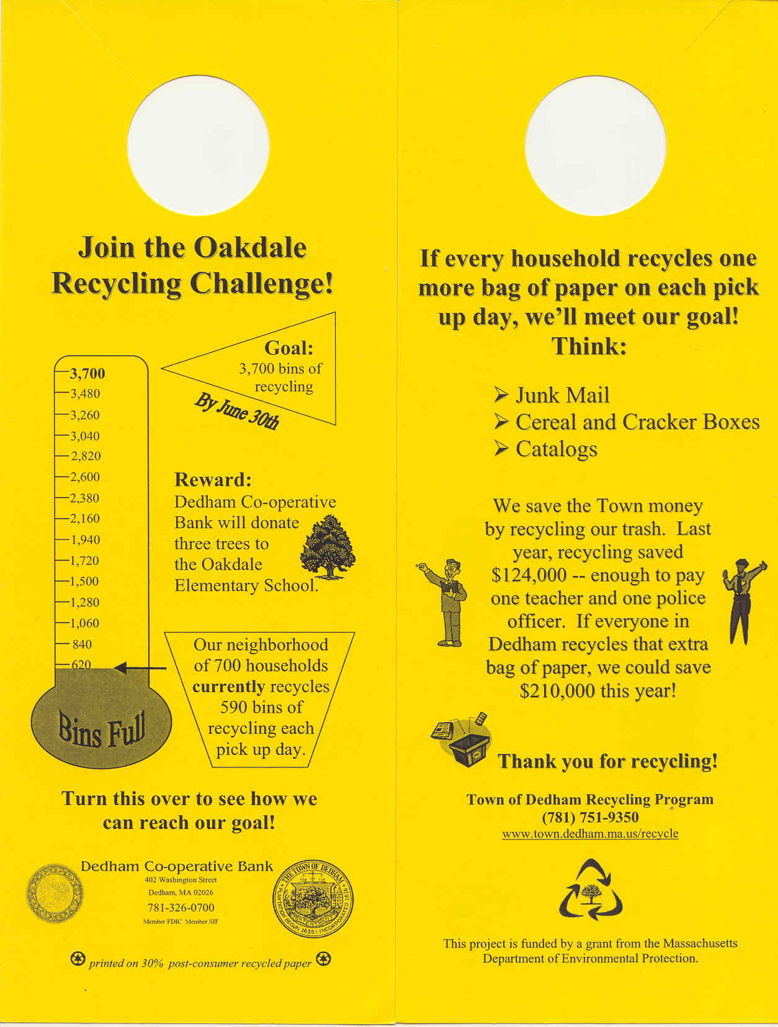
For the door hangers shown below, the front side is displayed on the left, the back on the right.
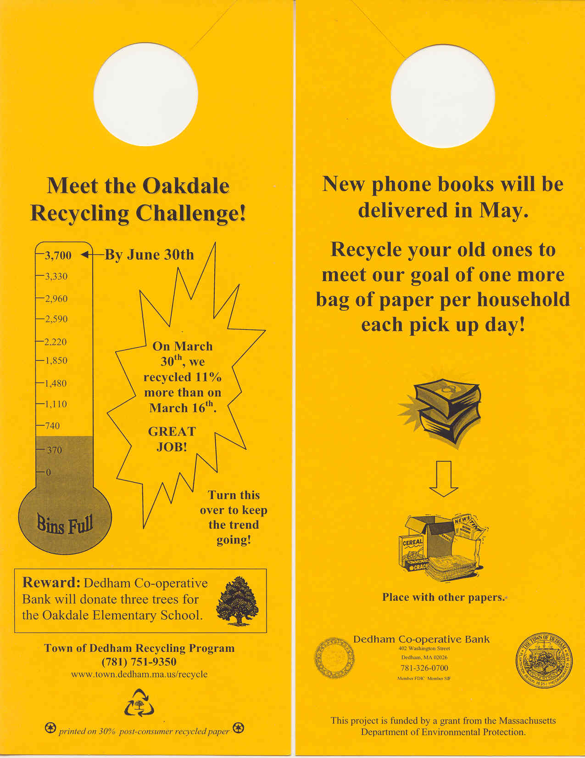

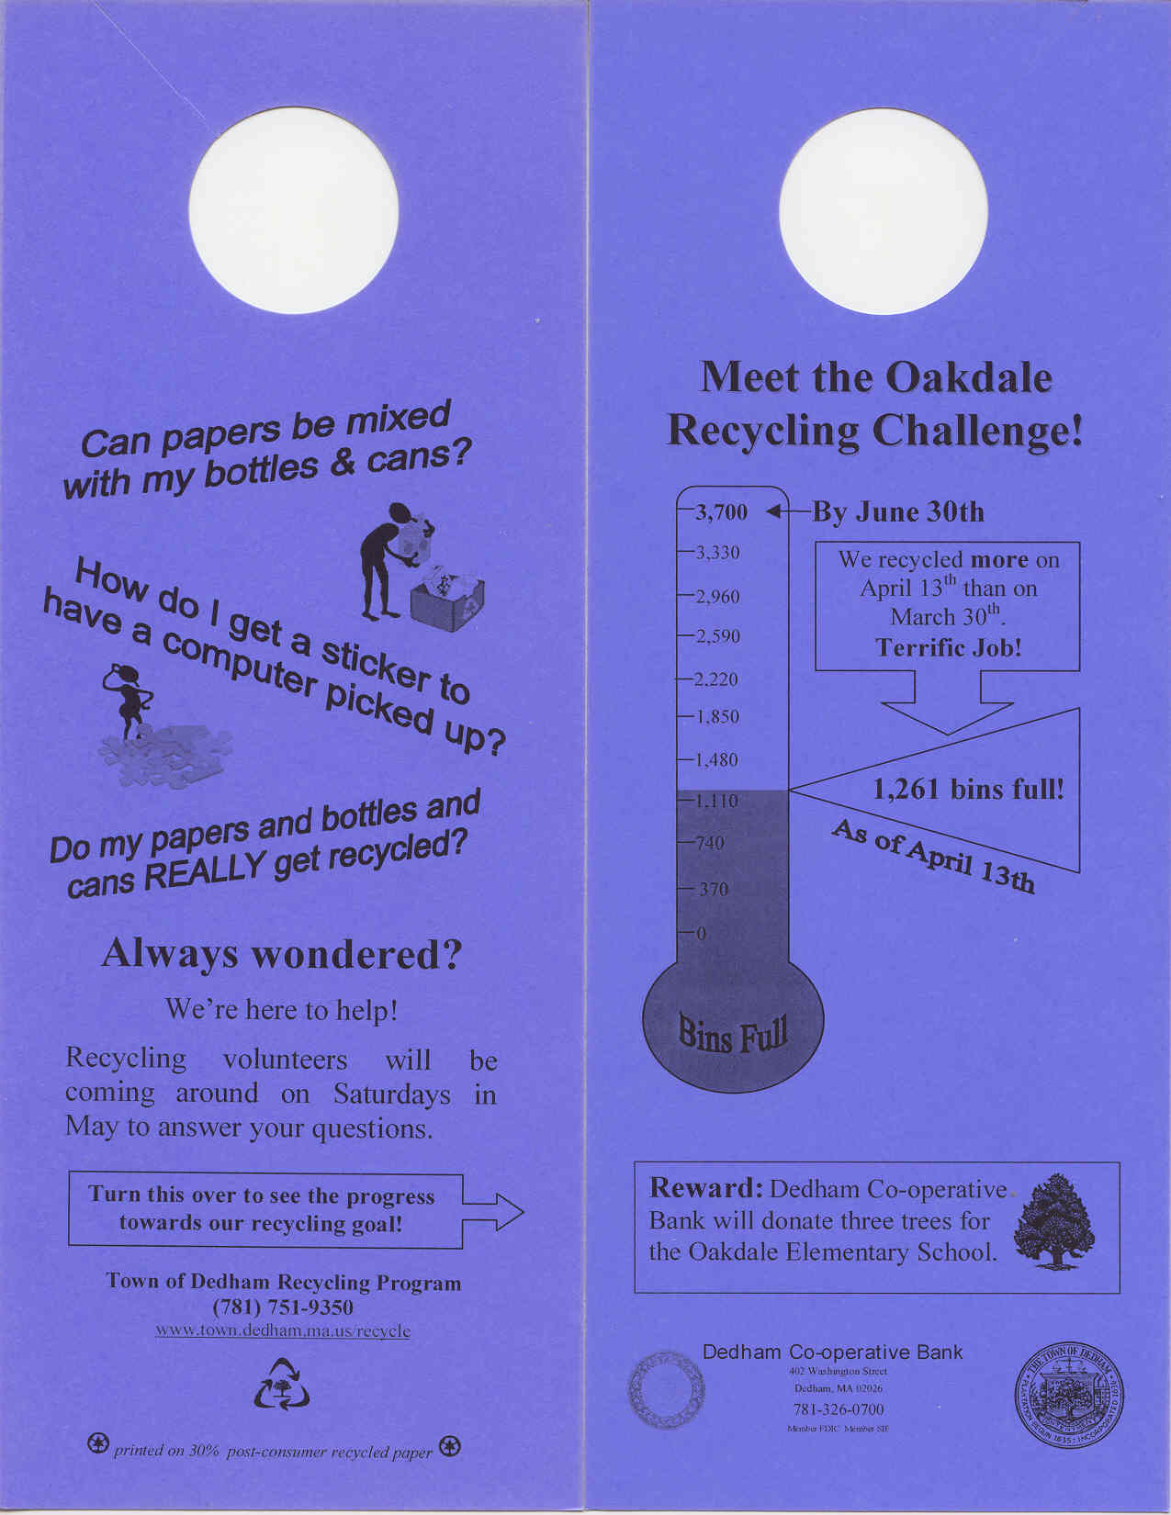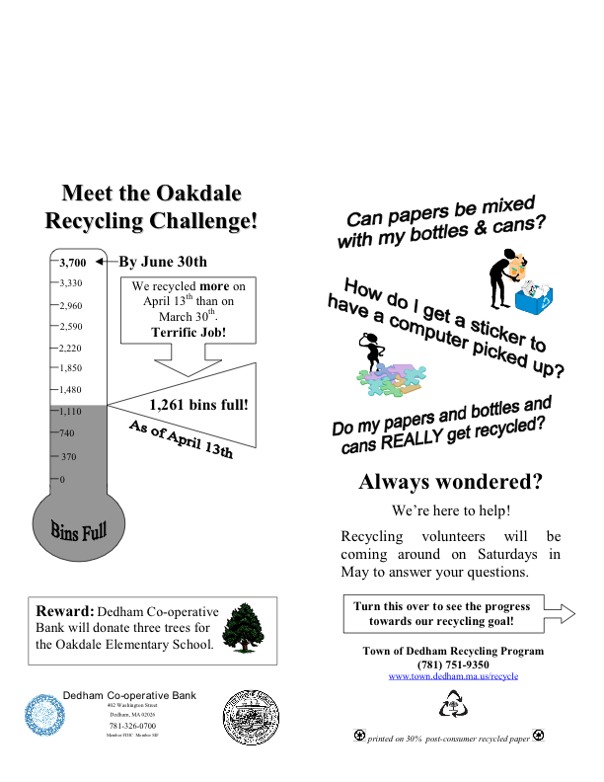
Front

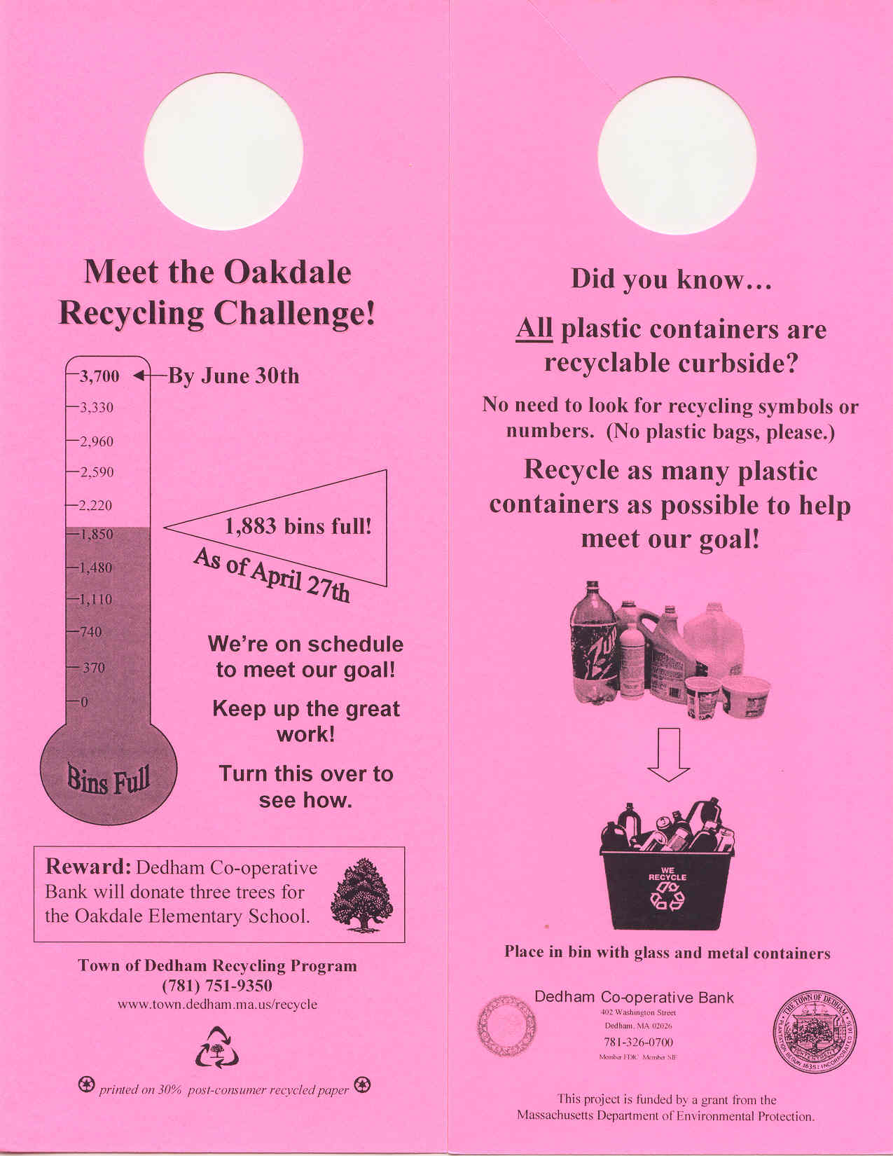

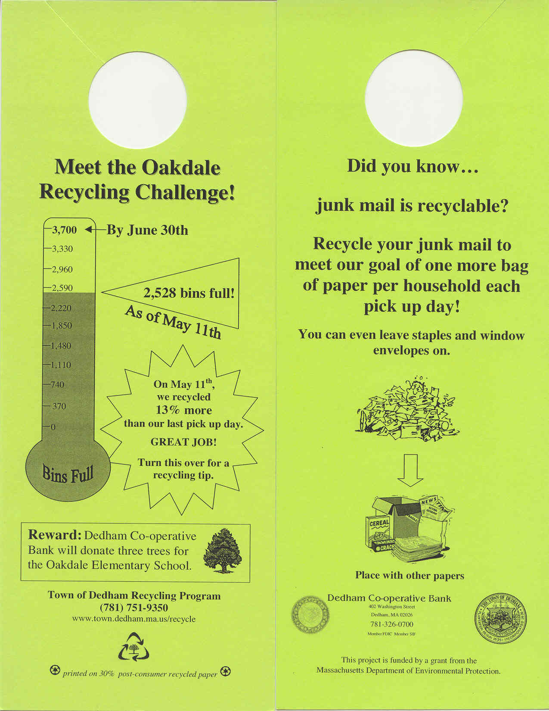

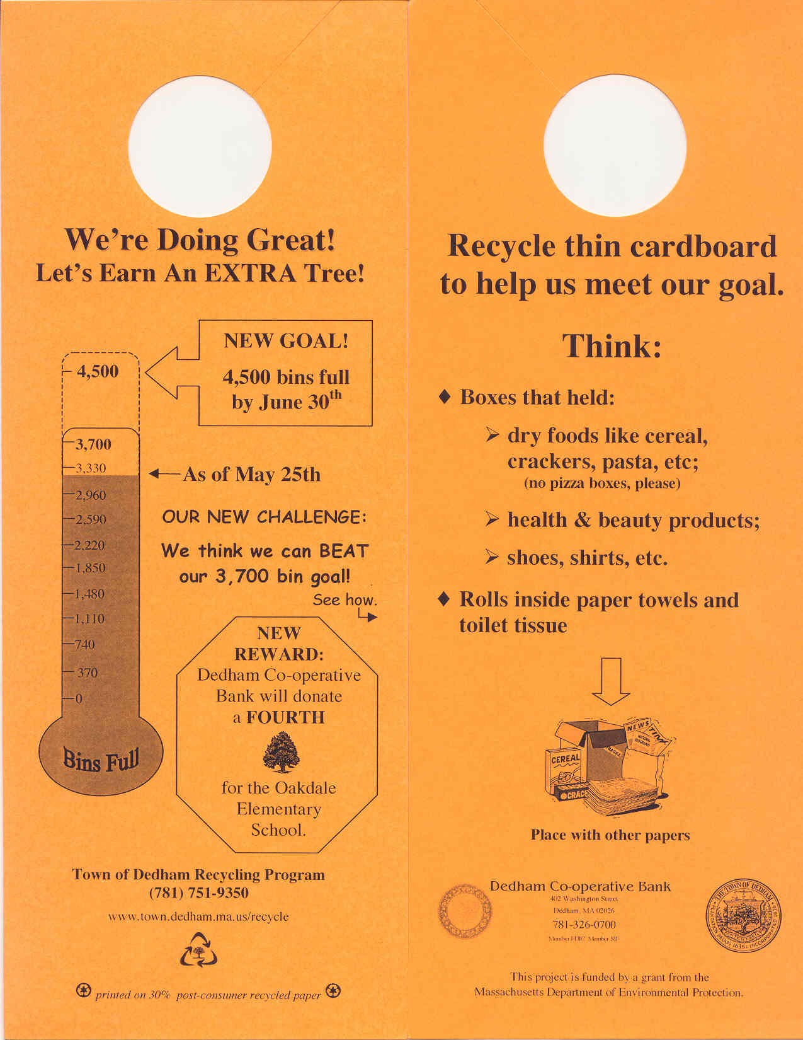

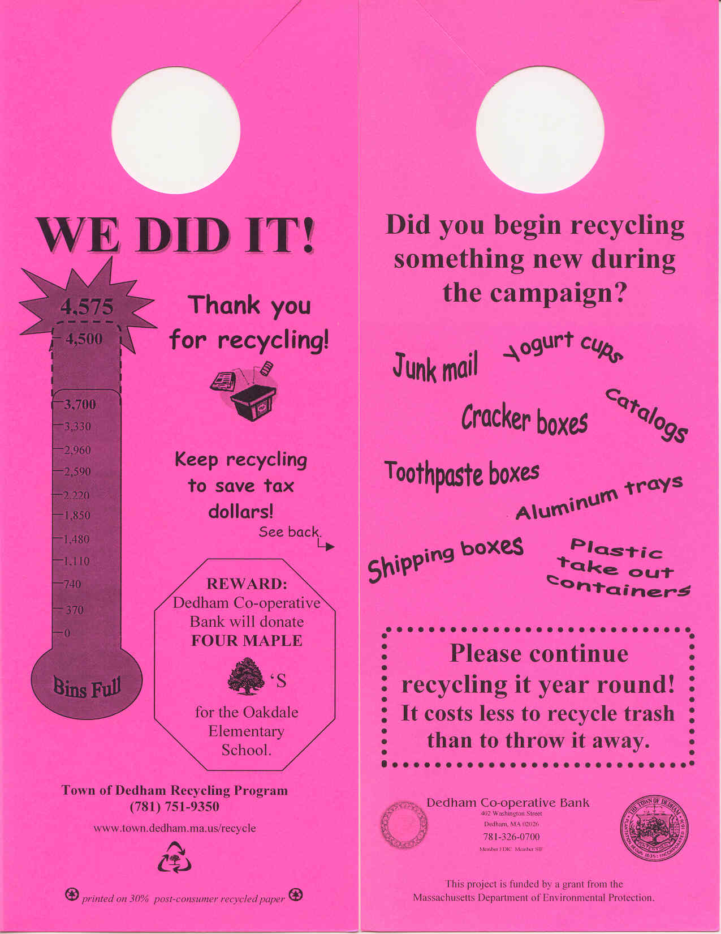

Door Hanger Distribution

Several approaches were tried before a workable system was found for distributing the door hangers. The first approach was to try to hire a door-to-door distribution company. Although nine firms were listed in the yellow pages under “Distributing Service – Circular, Sample, Etc.,” only one company responded to phone calls and does residential door-to-door distribution. This firm was unable to meet the desired specifications for distribution, which included attaching the door hangers with rubber bands to door knobs and handles, gates, fences, and railings in such a way that that the door hangers hung down, as opposed to being folded up or rolled up. Project staff felt that the manner in which the feedback was presented would itself convey a message to residents about the importance of the material, and distinguish it from commercial advertisements. Therefore, the goal was a neat and professional looking presentation, with the front of the door hanger visible to resident without detaching it. Furthermore, the distribution company was unable to adapt to rainy weather conditions (the door hangers were not weather-proof) by placing the door hangers in more protected locations such as door knobs and mail box hooks rather than on gates or railings.
The second approach was to hire Dedham High School students and Dedham adults to work with the project staff in distributing the door hangers. This approach had the added advantage that project staff and their helpers had more direct contact with residents. Residents’ questions and comments provided some clues about how they perceived the campaign. The door hangers were distributed in the afternoon, after the school day was over. The Town’s Youth Commission identified young people who were available to work. Pre-screening young people for a conscientious approach to work is important. Teaming each young person with an adult also helped ensure proper distribution. On one occasion, a mother and two twelve year old girls made an effective team.
Dedham High School has a community service requirement for graduation. We offered students the opportunity to distribute door hangers on a volunteer basis as a partial fulfillment of the community service hours required. One senior and one junior helped out on one distribution day, but overall, the response was less than we had hoped. An advisory committee member and another Dedham adult with a particular interest in recycling did contribute their time to the door hanger distribution effort, though.
Other information about the distribution process:
- Each of the four distributors was easily able to carry enough door hangers and rubber bands in a shoulder bag to complete their quarter of the route without having to replenish their supply.
- The distributors worked in two person teams, with each team member doing one side of each street.
- The route was divided into two roughly equal parts. Each team was assigned to complete one of these two parts, working towards each other from the ends of the route to the middle.
- If one team completed their assignment before the other team, the teams communicated via cell phone on how to divide up the remaining work.
- If there was a chance of rain during the day, door hangers were attached only to door handles, which were protected from the weather to some extent. If no rain was expected, door hangers were attached to the first available spot, which included gates, fences and railings as well as doors. Door hangers were not distributed on days when heavy rain was expected.
- Door hangers were always attached with a rubber band, as even a slight breeze can blow them off. The only exceptions were some cases in which the door hangers were inserted between a screen door and door frame.
- Door hangers were not put in mailboxes, as only mail carriers can legally put material in mailboxes.
- The Dedham police were notified prior to distributions so that they could respond appropriately if residents called with any concerns about the presence of workers going door to door in the neighborhood.

Appendix B:

Private Sector Sponsor Recruitment
February 15, 2004

Mr. Mark Whalen, President
Dedham Co-operative Bank
402 Washington St.
Dedham, MA, 02026

Dear Mr. Whalen:

You may have read recently in the Daily News Transcript that the Town has won a state grant to encourage increased recycling among Dedham residents. I am writing to offer Dedham Co-operative Bank an intensive promotional opportunity among 700 Dedham households to be targeted initially by the recycling outreach effort. The nature of this project also offers Dedham Co-op an outstanding opportunity to create a sense of community good will through its sponsorship. $800 is needed to support various aspects of the program, as outlined below.

Our plan for the outreach program is to distribute seven door hangers to 700 households in the Oakdale neighborhood between late March and the end of June. The door hangers will inform residents of ongoing progress towards a recycling goal, and will indicate that if the goal is met, Dedham Co-operative Bank will donate three trees to be planted at the Oakdale Elementary School. I have attached some sample artwork illustrating the door hanger format we have in mind. Several notices with the same information will also be sent home with Oakdale Elementary School students.

During the month of May, we will also send recycling volunteers door-to-door in the Oakdale neighborhood. The recycling volunteers will answer questions about how and what to recycle. They will also reiterate the Bank’s commitment to donate the trees if the recycling goal is met.

We plan to place a permanent sign made of recycled plastic lumber near the trees. The sign itself will be an appealing example of a product that is made from the milk, water and detergent bottles that residents put in their recycling bins. The sign will also remind neighborhood residents of Dedham Co-op’s donation. I have attached sample text for the sign, as well as sample photographs of a plastic lumber sign currently on the market.

Finally, we expect that once the project is complete at the end of June, the local papers will publicize the results, including the Bank’s involvement.

A donation from Dedham Co-operative Bank would support the purchase of the trees and sign. In addition to the satisfaction of being involved in a worthwhile project, I believe that our recycling outreach effort offers Dedham Co-op abundant opportunities for increased visibility among residents of the Oakdale neighborhood, and indeed, within the community as a whole. I hope that you will decide to become our program sponsor. Jan Aceti, the consultant working with us on this project, will follow this letter with a phone call to answer any questions you might have, and to ask for your participation.

Sincerely,

William G. Keegan, Jr.
Town Administrator
Trees Donated by
Draft Sign Text:
Dedham Co-operative Bank

in Recognition of the

Oakdale Neighborhood’s

Recycling Efforts

sign made from recycled plastic bottles

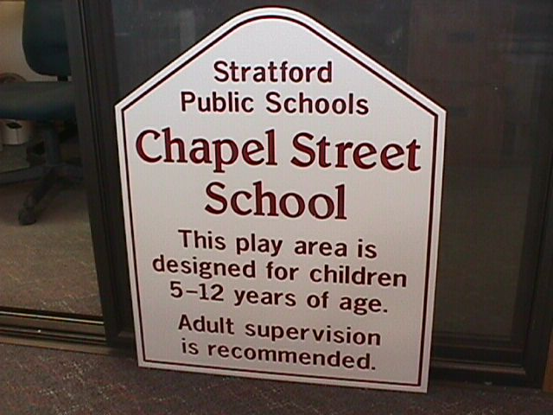
Close Up View of Sign; 24” x 18” size



Sign Mounted on Posts

Sign Manufactured by Plastic Lumber Company, Inc.
Akron, Ohio
www.plasticlumber.com

March 15, 2004

Mr. Mark Whalen, President
Dedham Co-operative Bank
402 Washington St.
Dedham, MA, 02026

Dear Mr. Whalen:

On behalf of the Town, I am writing to convey our sincere appreciation for your sponsorship of our upcoming recycling outreach program. I understand that in addition to donating the trees for the Oakdale Elementary School, and the sign to accompany them, you have also generously offered to donate t-shirts for our recycling volunteers. The Bank’s $1,200 contribution will not only enhance the quality of our outreach program, but also demonstrates to residents that recycling has broad support in our community. By working together, we can protect the environment, manage the residential refuse stream cost-effectively through recycling, and create visibility and good will for Dedham Co-operative Bank in particular, and for Town’s business sector in general.

Dedham Co-op is a valued local business in our community, and we thank you again for stepping forward to demonstrate your good corporate citizenship.

Sincerely,

William G. Keegan, Jr.
Town Administrator

Appendix C

Door-to-Door Volunteer Recruitment

Fundraising Opportunity for

the Oakdale PTO


The Town of Dedham’s Recycling Program offers the PTO the opportunity to:

- raise money for the organization;

- promote participation in the Town’s recycling program.

How will the PTO earn money?

You’ll earn money for the PTO by volunteering as a recycling outreach worker in the Oakdale Recycling Challenge. The Town will donate $20 to the PTO for each member who volunteers for a two hour shift. The Town invites PTO members to work up to 45 shifts, meaning that the PTO could earn up to $900.

What’s the Oakdale Recycling Challenge?

This spring, the Town is promoting recycling in a section of the Oakdale neighborhood. If the neighborhood recycles 3,700 bins full of paper, bottles and cans between late March and the end of June, Dedham Co-operative Bank will donate three new trees to be planted at the Oakdale Elementary School.

What will the recycling volunteers do?

As a recycling volunteer, you‘ll go door-to-door in Oakdale during the month of May, answering people’s questions about how, what and why to recycle. Recycling volunteers will also have a “photo album” with pictures showing where Dedham’s papers and bottles and cans go once they leave the curb and what new products are manufactured from them. Volunteers will provide Oakdale residents with information about how recycling benefits the Town financially and protects the environment. Finally, volunteers will ask householders to pledge to recycle as much as they can in order to help meet the neighborhood goal.

What is the time commitment required?

The commitment will include attending a two hour evening training session on Thursday, April 29th from 7-9pm. Then, we will go door-to-door during a two hour shift on each of three subsequent Saturdays: May 1, 8 and 15. On the first Saturday, the door-to-door visits will take place from 10am to 12pm. On the second Saturday, from 12pm to 2pm. On the final Saturday, the outreach will be carried out between 2pm and 4pm. If you can’t work all three Saturdays, join us for just one or two of the Saturdays. The Oakdale Recycling campaign offers you the opportunity to make a big difference with a small time commitment.


Why are the door-to-door visits at a different time each Saturday?

We expect to have to go back to some houses more than once because people won’t necessarily be home the first time. Many people have a standard time when they do errands, go to sports events, etc. on Saturday. By changing the time we do the outreach each Saturday, we hope to reach the greatest number of people.

What if the volunteers have questions or encounter problems?

There will be a staffed home base set up near the area where we will be canvassing. This will provide a place for you to check in at the beginning of the shift, stop in or call with questions if need be, and return at the end to let us know how it went and be rewarded for your efforts with refreshments and a heartfelt “thank you!”

Won’t people be put off by someone coming to their door?

We will do our utmost to make the door-to-door visits as comfortable as possible for everyone. The Oakdale Recycling Challenge will be publicized throughout the neigborhood in late March. Door hangers will be distributed to each household in the area three times before the door-to-door visits take place. The door hangers will update people on the progress being made towards the recycling goal. All of this publicity will help people see the door-to-door visits as part of a larger recycling campaign, rather than something that happens out of the blue. A door hanger distributed in late April will announce that volunteers will be coming around in May to answer questions about recycling. The Town will also send a letter announcing the upcoming visits to each household in the area. Finally, each volunteer will have a t-shirt to wear identifying them as a “DEDHAM RECYCLING VOLUNTEER Incidently, the t-shirts will be made of a mixture of recycled cotton, and “Ecospun,” which is made from recycled soda bottles! One Dedham resident said, “This sounds like going trick or treating with the kids at Halloween – a great chance to meet neighbors!”

What kind of training will be provided to volunteers?

Town staff will have done a number of door-to-door visits before the training session, so we’ll be able to demonstrate what a real visit will be like. We’ll go over the answers to common questions about recycling, provide you with some fun and fascinating facts to share with people, and give you a short list of topics to cover in your conversations with people. It’ll be fun, we promise!

Questions?

Call or email:

Jan Aceti, project coordinator Dave Hirschler
Aceti Associates Dedham Recycling Coordinator
781-646-4593 617-817-0477
jan@acetiassociates dhirschler@town.dedham.ma.us

This project is funded by a grant from the Massachusetts Department of Environment Protection.
2/18/04

This fact sheet, which we emailed to organizational representatives after contacting them by phone, did not result in any organizational partnerships. However, we include this fact sheet because we think it could be useful if the stipend were greater. We sent a similar sheet to individuals who were considering volunteering or as a reference to those who had already agreed to.

Appendix D:
Volunteer Training
Volunteer Training Session Agenda

- Sign in -- Jan & Dave – 7-7:15pm
- Get verbal commitment from each volunteer on their availability to go door-to-door
- Give them a name tag
- Give them a clipboard with all materials on it
- Topic list
- Address list
- Photos
- End products map
- Flyer
- Yd waste sticker
- Commitment card
- Copy of commitment card with notes
- Oakdale neighborhood map
- Recycled paper
- Corrugated medium
- FAQs
- List of Outlets for Non-curbside Recyclables
- Door Hangers delivered so far
- Get their t shirt size
- Find out if they will need shoulder bags
- Point them to refreshments

- Intro -- Dave – 7:15-7:30pm
- Welcome, thank you
- Introductions
- Overview of Strategy
- Goal
- Reward (indicate where trees will be planted)
- Door hanger feedback; door hangers provide context for visits
- Door-to-Door Visits
- Answer recycling questions
- Make sure people are up to date on materials accepted
- Ask them to pledge to recycle new items
- Inform people of financial benefits to town
- Take orders for bin deliveries as needed
- Provide some evidence that the stuff gets recycled rather than thrown away
- Brief Volunteers on Trial Visits Done by Dave and Jan
- Overview of Training
- Bathrooms are on the ground floor
- Game Show
- Demonstration of How to Conduct a Visit
- Handouts/Logistics for Visits
- Introduce Game Show
The “Symbol of Fortune” Game Show was a fun way of helping volunteers learn the answers to the most frequently asked recycling questions.

- Game Show - Kathleen and Dave 7:30 – 7:45pm

- Questions from Volunteers and Remaining FAQ - Dave – 7:45 - 7:55pm
- Point out FAQ sheet on their clipboard and encourage them to take it home and look it over.

- Demonstrations of several possible conversations with residents Jan to introduce-- Dave and Kathleen to demonstrate 8 – 8:20pm
- Have volunteers pull out commitment card and end products map because they may be hard to read on the screen
- Everything you are about to hear is written down somewhere, and we’ll point out where a bit later. So, no need to take notes. Just take it in.
- Questions about demonstrations?

- Door-to-Door Handouts/Logistics – Jan 8:20-8:40pm

- Provide t-shirts – Jan and Dave 8:45-8:55pm

VOLUNTEER TRAINING
INTRODUCTORY REMARKS

Introduction
Hi, I’m Dave Hirschler, Dedham’s Recycling Coordinator. I’d like to welcome you all and thank you for volunteering with the Oakdale Recycling Campaign. Let’s go around the room and introduce ourselves. If you could give your name and your street if you’re from Dedham; your name and your town if you’re not from Dedham. [After introductions] Just for your info, bathrooms on lower floor.

Campaign
The door-to-door visits you’ll be doing are the centerpiece of the Oakdale Recycling Campaign, but that’s not the whole campaign, and you’ll find it helpful to know a bit about the rest of the campaign, too, so I want to tell you about it quickly. Please feel free to ask questions as we go along.

Goal
The campaign’s goal is to increase recycling both by informing people about how easy recycling is and about recyclables that they may have not known before, and by motivating them to recycle to reach a neighborhood goal. This goal is for them to recycle 3700 bins of recyclables by the end of June, if the goal is met, the Dedham Cooperative bank will donate three trees to be planted at the Oakdale Elementary School. There are a few parts to the campaign, with the biggest two being you folks and doorhangers that have and will continue to go out to every house in the campaign area.

Map
On your clipboard, you’ll see a map of the Campaign area. If you pull that out, you’ll see that the trees will be planted towards the back of the school yard in a spot adjacent to Madison St. Dedham Co-op is also funding a sign, which will be made from recycled plastic lumber, will be visible from the street and will explain why the trees are there. The map also shows you the area we are covering with our door hangers and door-to-door visits. It is the area in blue, bounded by Walnut St. on the north, Fairbanks Road to the west, the railroad on the south and more or less by Cedar St. on the east.

Pilot
We’ve also gotten a lot of inquiries from Dedham residents and town officials and I’m sure some of you are wondering why we are only doing this campaign in the Oakdale area and would like to see a similar campaign carried out in other neighborhoods. This is a pilot project that we are testing out to see how well it works, if our pilot project here in Oakdale shows good results, we do hope to take the campaign to other neighborhoods in Dedham.

Doorhangers
You should also have three door hangers on your clipboard, a yellow one, a gold one and one in “ultra-grape.” Each household in the Oakdale Recycling Campaign area has received each of these three door hangers. The yellow one was the first one, and it introduced the campaign and the goal.

You’ll notice that on the yellow doorhanger we tried to let each household know what kind of change they could make to help meet the goal, for example to put out one more bag of paper each pick up day. We also let people know that it costs the Town less to recycle trash than to throw it away. Last year, the town saved the remarkable sum of $124,000 due to recycling, but we estimate we could save at least an additional $86,000, for a total of $210,000 each year if everyone in town put out that extra bag of paper. That’s a substantial amount of money.

We also sent home a copy of this first door hanger with every child who attends the Oakdale Elementary School.

Gold Doorhanger
On the second door hanger, the gold one, we showed the progress towards the goal, and on the back, asked people to recycle their old phone books when the new ones are delivered in May, in order to help meet the goal.

Doing well
I did want to let you know that we’re off to a good start with this campaign. We’re already seeing an increase in recycling in the section of Oakdale where we’re doing some promotion, even before the door-to-door visits.

Grape Doorhanger
The third door hanger, the grape one, was delivered this Tuesday. It lets people know that we’ll be coming around on Saturdays in May to answer their questions about recycling. The back of this door hanger shows people the ongoing progress towards the goal.

Continue distributions
We are going to continue to distribute doorhangers, similar to the gold doorhanger, letting people know how far along they are in getting to the goal, and giving them other tips on how to increase their recycling

Comfort
We want to make sure all of you feel as comfortable as possible knocking on peoples doors. So on top of the grape doorhanger, each household in this area has also received a letter from the Town, mailed earlier this week, informing them of the door-to-door visits that you’ll be making. We’ll also be giving each of you a Dedham Recycling Volunteer t-shirt at the end of this evening. Between the letter, the three door hangers that people have received, and the t-shirts we’ll be wearing, people should be pretty comfortable with who we are and why we’re knocking on their door.

Goals for Outreach Volunteers
When we go door-to-door, we want to do the following (we’re going to go through this in detail later, so no need to take notes or anything. I just want to give you an overview). We want to:
- answer any questions people have about recycling,
- make sure they are up to date on the materials accepted in Dedham’s recycling program,
- ask them to pledge to begin recycling items they hadn’t known were recyclable, or, if they are already recycling everything, to continue doing so,
- inform people of the financial benefits to the town when trash is recycled rather than thrown away
- deliver recycling bins to people if they need them, and
- give them some information about where Dedham’s recyclables go and what they get made into.

Trials
Now, Jan and I did some trial door-to-door visits on April 3rd. Between the two of us, we knocked on 65 doors in about two hours, or about 32 houses each. Someone answered the door about half the time. When someone answered the door, about 70% of the time, they were interested in talking. About 30% of the time, they just said they weren’t interested. But, even when they weren’t interested, they weren’t surprised by our visit. We had sent each of our trial households a letter and distributed a door hanger before we visited, and that seemed to do the trick in terms of letting people know we’d be coming by. And, most of the 70% who were interested in talking had their questions all ready for us and were eager to get them answered. More than half of the people who answered the door pledged to either recycle something new or to continue recycling everything they could. Based on this we expect to see an even bigger jump in recycling after the door-to-door visits than we’ve already gotten from just the initial doorhangers.

Stories
At one of the houses I went to a woman answered the door as her son stood behind her. She had a few questions about the program, but didn’t seem too interested in recycling. When I talked about the trees that were going to be planted at the Oakdale schools, the little boys eyes lit up and said that’s my school! At the end of the conversation, the mother still wasn’t fully convinced, but as she shut the door the boy scolded his mother and said “mom, you have to recycle!!”

That wasn’t the only scolding, some people mentioned that their biggest obstacle to recycling was getting the other people in the house to do it. But lot’s of people had questions ready and were really glad to hear that junkmail and all plastic containers and things could be recycled, because they didn’t know about it.

I’m not going to say everything was happy, interested people. My first house that I was supposed to visit had a big german shepard barking right in front. And a woman looked through the door and said no, she wasn’t interested. Now, I didn’t go up to the house, because I was not comfortable with the dog, and We don’t want any of you to feel that you have to go to a house with a dog or anything like that. So if that happens to you, just keep going.

Rest of Training
Ok, now I just want to tell you what we’ll be doing during the rest of this training. Up next is the recycling game show, “Symbol of Fortune,” in which our contestants (that’s you) will compete for exciting prizes by guessing the right answers to questions about Dedham’s recycling program. There is at least one volunteer here who was a member of a small advisory committee who helped us plan this pilot project. So as not to give your team an unfair advantage, we ask advisory committee members to refrain from answering game show questions if you know the answer as a result of your advisory committee attendance. Then, we’ll give you the opportunity to ask any other questions you have about the recycling program. After all, if you have a question, chances are someone you’ll talk to will be wondering about it, too. After that, we’ll do a couple of demonstrations for you of what a door-to-door visit will be like, based on our experience with the trial visits. After that, we’ll go over some logistics.

Ok, it’s time for Syyyyymbooool of Fortune with host Kathy Schortmannnnnnnnn.

“Symbol of Fortune” Game Show Format

- We will have divided attendees up into four groups of five as they are settling in.
- Dave announces the game show and introduces Kathleen. (Wild applause!)
- Short pause for everyone to experience the exciting audio and visual animations that Jan has added to the initial powerpoint slide.
- Kathleen welcomes everyone to the show
- Kathleen mentions that Vanna White is on vacation this week, but we’re lucky to have Dave Hirschler with us. Dave will be keeping score and handing out prizes to our contestants.
- Dave describes and displays prizes:
“All of our valued contestants will receive this novel and stylish ruler made from– remarkably -- denim scraps and recycled plastic. “Our winning team will receive miniature recycling bins made with 100% recycled plastic. Not only are these bins made from recycled plastic, but they also come from sunny Palm Beach County, Florida!! Our prizes come from “Symbol of Fortune” sponsor Signature Marketing of Simsbury, CT.”
- Kathleen describes the rules, below.
- You all have a sheet on which you can record the correct answers for future reference.
- Each group please choose a spokesperson and a notetaker
- Each group discusses the possible answers and decides which one they think is most likely. Majority and minority opinions are permissible if there is no consensus.
- If other questions surface during the group’s discussion, please write them down. There will be an opportunity to ask them after the game show is over.
- For bonus question, Kathleen mentions that the street is in the Oakdale area, but not necessarily in our campaign area.
- Kathleen announces winner. Dave hands out prizes
- Kathleen thanks everyone for participating.
- Dave thanks our host, “Kathleennnnnn Schortmannnnn!”
The “Symbol of Fortune” Game Show Slides

Training Presentation to Volunteers on Handouts/Procedures for a Visit

What I’d like to do now is go over each of the items on your clipboard so that it’s clear what they’re all for, and then talk about some logistics for the visits. First, please find a sheet called Topic List. It has some items highlighted in blue on it. This list is a summary of the items we’d like you to try to cover in your conversations with people. The full list is what Dave discussed with Kathy in the first demonstration that you saw. The items in blue are the shortened version of the conversation that you saw in the second demo, where the person you’re talking with isn’t really that interested.

I do want to talk through this list with you quickly and add a few more suggestions to what you’ve heard already from Dave and Kathy.

- After you introduce yourself,
- You’ll want to ask the person if they have any questions about recycling or if there is anything they find difficult. Try to include both phrases. Not only do we want to answer people’s questions about how to recycle cardboard, for example, but we also want to help people figure out how to make recycling easier for themselves. People who perceive recycling as inconvenient tend not to recycle as much.

For example, you heard Dave mention that a common difficulty people brought up was not having space to store their recyclables for two weeks between pick ups. In addition to the solutions that Dave described, you may have some ideas of your own. Offering suggestions based on your own experience is a great idea if you can.

If someone mentioned that they did not have time to recycle, you could ask if they get the newspaper. If so, just recycling that would make a big difference. If they don’t get the paper, just recycling junk mail and catalogs would also make a big difference. And, if someone is concerned about the difficulty of washing out hard to clean bottles and cans, like peanut butter jars, or cat food cans, we’d rather they throw those away and recycle the containers that don’t need much washing, rather than not recycle any bottles and cans at all.

- Pledge Card

We found that after answering people’s questions, the thing that held people’s attention the most was to bring out the pledge card that you saw and to say something like, “You know, they’ve added items to the recycling program over the years. Can I go over these with you in case any of them are new to you?”

Now, if you could take out the pledge card again. You also have a copy of the pledge card with lots of little notes on it.

We found that as we went through the items on the pledge card, we could bring in information about each material that we wanted to mention to people. That’s what all these little notes are. For example, once again, we want to make sure that people don’t think recycling is harder than it really is. There are still a lot of beliefs floating around from the early days of recycling, like that you have to remove windows from envelopes, or take the labels off cans. So, as you noticed, Dave made a point of dispelling these myths as he went through the list of items.

People are also more likely to recycle if they understand that it really does make a difference. And every so often I still hear someone say, “You know, I read somewhere that all that stuff people put in their bins really just gets thrown away.” So we also take the opportunity of going through the list of recyclables to sneak in a little information about where some of the materials go and what they get made into. Some of the notes pertain to this.

You may not have time to mention all of the little notes on this sheet. It may also be hard to remember them all, at least at first. If you’re feeling like you’re not going to be able to fit everything in, focus on the ones I’ve highlighted in blue. I do want to point out the one about the plastics, which I think is a little misleading. It implies that the container has to have a number on it. In fact, any plastic container can go in, as long as it’s not a plastic bag. What we really want to communicate to people is that plastics recycling is much more convenient than it used to be because people don’t have to look anymore to see if it has a number. If it’s a plastic container, in it goes.

You’ll also see a note mentioning that cereal and cracker boxes go to Bay State Paper Co. right next door in Hyde Park and are made into corrugated medium, which is the squiggly part inside a piece of cardboard. We’ve given all of you a piece of corrugated medium to take out and show people. When people can see and touch things, it makes information come alive, it’s more likely they’ll remember it.

As you mention each of the items on the pledge card, it’ll be easiest if you check off the items that people tell you are new to them; that they didn’t know were recyclable. Then, mention the goal: If we recycle 3,700 bins full by the end of June, Dedham Co-op will donate three new trees to the Oakdale School. If some paper items were new to them, you might want to mention that the equivalent of one additional bag of paper per pick up day will be enough to achieve the goal. Ask if they would add the new items to their recycling or if they’ll continue to recycle all they can to help meet the goal.

Then, as you heard in the demo, you’ll want to mention that the Dedham Times will be doing a story on the campaign after it’s over, and they will include the names of everyone who has pledged to add the new items to their recycling (or to continue recycling all they can.) Ask them if they would like their name included. I would suggest that you check off yes or no. I found that people neglected to check one or the other. And we don’t want to put someone’s name in the paper by mistake. If no, reassure them that that’s fine, we won’t include it without their permission.

Then, have them check the appropriate box (I’ll add new items, or I’ll continue to recycle all I can) and sign their name. We all like to see ourselves as people who do what we say we’re going to do, so when people pledge to do something, it increases the likelihood that they will actually do it. And, the more that people see the action as something they’ve chosen to do, the more likely they are to follow through. So, when you let the person check the box that says that they will add the new materials to their bin, or continue recycling all they can, it reinforces the fact that this is an action they are choosing to take.

Now, as I said, we do want people to sign the pledge, because doing so makes it more likely that they’ll recycle more. But, it’s also the case that if people feel pressured to make a pledge, they are not likely to change what they currently do. And I can’t imagine that any of us here would want to pressure people. It’s just not very much fun. The people we want to ask to sign the pledge are the people who are interested. These are the people who have questions for you or, like in the second demo, even if they don’t have questions, mentioning the neighborhood goal gets them interested enough that they’re willing to go through the list of recyclables with you. But, if you mention the goal, and they still don’t seem interested in talking, it’s not worth asking them to pledge

Also, be sure that people print their name on the line above the signature line if they want their name in the paper.

Now, once people have signed the pledge, this is a good time to ask people if they know that the Town saved $124,000 last year because it costs the town less to recycle trash than to throw it away. It’s good to mention that this was enough to pay a teacher and a police officer. But, we estimate that we are still literally throwing away at least $86,000 per year, town wide. It may be tempting to state this more positively, that is, “If we recycle more we could save an additional $86,000 per year,” but the image of throwing money away is a powerful one. Also, research shows that people will work harder to avoid losing money than to earn additional money. So, even though it might not feel as comfortable stating it like this, we encourage you to do so as much as possible.

Now – and this is important – you want to say – Because of the financial benefits to the town, can we count on you to continue recycling these items even after the campaign is over at the end of June? There is some evidence that when people are given a short term incentive to recycle – like earning the trees for the school, that they go back to their old habits once that goal has been achieved. But if we ask people if we can count on them to recycle these items over the long term, and wait and give them a chance to say that they will, they will be more likely to follow through.

Remember to give the person the bottom, yellow copy of the pledge card, so they have a way of remembering what they have pledged to do. I figured we’d be better off keeping the top copy, because it will be easier to read the names people have written down

- Do make a point of asking people if they have enough space in their bin. If not, you can offer them several options. The first one is that Dave will be delivering bins after the door-to-door outreach shift is done to anyone who requests one. The bins cost $5 and we can accept payment by check only, made out to the Town of Dedham. Now, Dave, as an employee of the town, is the only one authorized to take money. So, we can’t take payments. You’ll need to tell the person to pay Dave when he comes around. He should be able to get around within an hour after the end of the shift. If they are not going to there, they can leave the check in an envelope taped to the door, and he’ll leave a bin. You will want to mention to people that we are able to deliver bins only as a part of this campaign on the first three Saturdays in May. If they need a bin at any other time, they can pick on up at the Dedham DPW on River St.

We can also send people a long bumper sticker-like decal that they can put on a container of their choice to identify it as recycling. We don’t have these yet, but they’re being printed and we should have them within a week or so. In a moment, I’ll show you where to make a note if someone wants a sticker sent to them.

- Now, if the person is still interested and engaged in the conversation, you could show them one or more things designed to show people that recyclables really do get made into new products.

Recycled paper made by Nancy Dewar’s 4th grade class from scrap paper that was being thrown away at the Oakdale School.

T-shirt made from recycled cotton and polyester thread made from soda bottles. 50/50 mix. You might even want to let them feel the edge so that they know it’s a normal fabric. This makes it more concrete for people, which helps them pay attention and remember more.

Finally, you have photos, one of Dedham’s recycling truck driver, Calvin White. Have any of you ever had occasion to talk with Calvin? I managed recycling programs for 14 years, and Calvin is one of the nicest, most decent, and most importantly, conscientious drivers I have ever met. You may not have known how lucky you were until tonight, but let me tell you, you are lucky to have Calvin. The next photo shows a pile of bottles and cans at the recycling facility in Avon. The next photo shows plastic bottles baled and ready to be shipped to market. Finally, you have a map of the US and Canada, showing where Dedham’s recyclables go and what they are made into. In addition to the paperboard boxes, which go to Hyde Park and the glass, which goes to Milford, MA, most of Dedham’s cardboard stays right here in New England, too. It goes to Montville and Oncasville, CT. One other interesting fact: Our water and milk jugs go to Ilinois, where they’re made into detergent and motor oil bottles. Any time you see a black motor oil bottle, it likely has a lot of recycled plastic in it.

So, experiment with showing people the recycled paper, the shirt or the photos and map. See what seems to pull people in and gets a reaction.

If the conversation is feeling a bit shaky, and you’re not sure how long people will stay with you, just cover the items highlighted in blue on your topic list. You don’t even have to mention the goal or the trees. I had a number of conversations with people where I didn’t mention it. People have gotten the door hangers, after all, so they probably know about it already.

Finally, please feel free to experiment with all this when you’re out talking to people to find the words and the sequence that’s comfortable for you. And if you come up with things that really draw people in, please let us know after your shift is over, because we would really like to know about them.

Address List

You should also have a list of addresses on your clipboard. This is a dummy list, but it shows the columns we’d like you to fill out as you do your visits. Under “Talked To,” please write yes if someone answers the door, even if all they say is No thank you, I’m not interested. If you ring the door bell, and no one answers, please write no. If we don’t see a yes or a no there, we’ll assume that you didn’t even get to that house, and that’s ok. You may or may not get to all the houses on your list in two hours. But we do need to ask you to be conscientious about writing yes or no, so that we know whether to go back to that house again.

It’s possible you’ll come upon an address that’s missing from your list. If so, just write it in.

If someone asks a question that you don’t know the answer to, you have two options. If you have a cell phone, and can bring it with you, you can call Dave or I and get an answer on the spot. Our phone numbers will be on stickers pasted on your clipboard. If you lift up all the materials on your clipboard, you’ll see Dave’s number there. My number will be there by the time you arrive to do your door-to-door outreach.

Alternatively, you can write down the question, along with their name and phone number, and Dave or I will call them to answer the question. The next column is to note how many bins they’ve requested, if they requested any. Please get a phone number if they request a bin, so that we can call them if something goes wrong and we’re unable to deliver the bins. The last column is to note how many decals they want, if they want them to put on a container of their own choosing. Please get a name and phone number also, in case we are unable to get the decals to them for some reason.

Flyer

You should also have a yellow recycling flyer on your clipboard. This is the flyer the town sent out in February. If you open it up, you’ll see some useful information on this page. Much of it we’ve covered, but info about where to pick up a bin is in the upper left hand corner. If someone were to ask you how to get an appliance picked up, you could point them to the information at the bottom of the first column, and leave a copy of the flyer with them. If someone needs to get an old tv or computer picked up, you can point them to the information in the lower half of the right hand column. If someone needs to know the dates of yard waste pick up, point them to the info in the upper part of the right hand column. In the sixty visits that we did in early April, we didn’t get any questions that necessitated leaving a flyer with anyone, but we’re going to give each of you several copies, just in case.

We’ll also give each of you a number of yard waste stickers in case people request them to put on a barrel. Neither Dave nor I got a single yard waste question, but that was at the beginning of April. It might be a different story in May.

You also have a one page list of places where people can take a number of recyclable items that cannot be recycled curbside. If you could find it and pull it out. These include plastic bags, clothing, styrofoam peanuts, …….

Finally, you have the list of Frequently Asked Questions that Dave mentioned earlier. As he mentioned, please feel free to take this home with you to take a look through if you’d like.

Finally, if you could go back to the map of the area we’ll be canvassing. As I mentioned before, each person will be given a list of several streets or parts of streets to cover. The map shows our home base for the canvassing, which is the Endicott Branch Library on Mt. Vernon St. Please come into the library when you arrive for your shift, to pick up your clipboard. We’ll also have stuff for you to carry in your shoulder bag, including a stack of the pledge cards, yard waste stickers, recycling brochures, etc. Please return to the home base after your two hour shift, to drop off your stuff, including the address lists, tell us how it went, and have a donut and coffee or tea. Also, as I think you all know, you will receive a small stipend for your time, and after your last volunteer shift, we’ll make sure we have all the information that the Town will need to send you your payment, or send it to a community organization, if you’ve chosen that option.

It’s going to be a beautiful day tomorrow, a great day for standing around outside chatting about recycling. Bring hat, sunglasses, etc

We’ll have bottled water for you to take with you on your rounds.

Appendix E:

Door-to-Door Outreach Materials

April 27, 2004
Introductory Letter Sent to All Households in the Campaign Area Prior to Visits

Dear Resident:

Have you ever wondered what happens to the papers and bottles and cans that Dedham residents put out for recycling? Not quite sure which plastics can be recycled? And how about pizza boxes?

We’re here to help!

If there’s anything you’ve always wanted to ask about recycling, this is your chance. On Saturdays in May, recycling volunteers will be going door-to-door in the Oakdale neighborhood to answer your questions.

The volunteers will also be asking you to take part in the Oakdale Recycling Challenge. If the 700 households in the neighborhood recycle 3,700 bins full of recycling by the end of June, Dedham Co-operative Bank will donate three new trees to be planted at the Oakdale Elementary School. If every household recycles just one more bag of paper on each pick up day, we’ll meet our goal!

Sincerely,

David Hirschler
Recycling Coordinator

Sponsorship by the Dedham Rotary Club made it possible to distribute this letter to households in the Oakdale neighborhood.

This project is funded by a grant from the
Massachusetts Department of Environmental Protection.
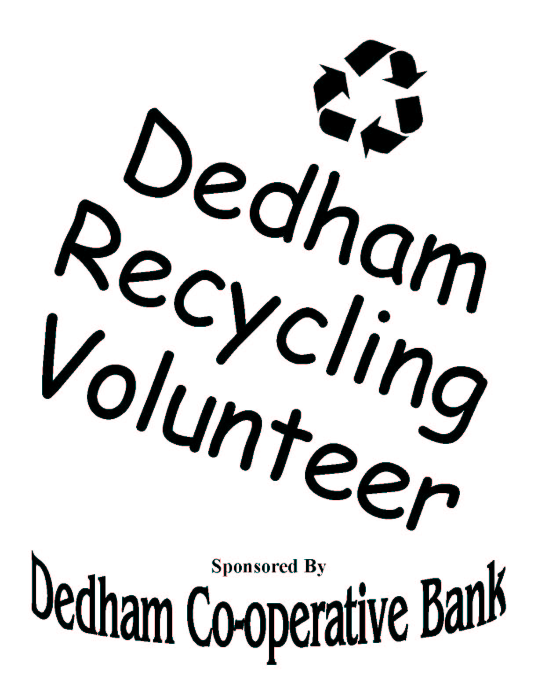
T-shirt Design
Volunteers were provided with the following materials to use during their door to door visits. Samples of most of these materials can be found below.
With one exception, noted below, the front of each door hanger is always on the left and the back on the right.
The space at the top allows a round hole and slit to be die cut on the door hangers.
Although there are elements in color on the door hanger artwork, they were produced in black ink only.
Dave, please move this note to the first door hanger.

- A list of addresses to visit, with spaces to record whether someone was reached at each address and to record resident requests.
- A map of the neighborhood
- A list of topics to cover in their conversations with residents
- A facsimile of the pledge card, with reminders of facts to mention to residents as each recyclable item was discussed.
- Photographs of the driver and from the recycling facility
- Map showing where Dedham’s recycables go and what they are made into.
- A list of frequently asked questions (volunteers indicated that they rarely referred to this list. Each volunteer was provided with a cell phone number at which they could reach project staff from the field if they encountered a question that they couldn’t answer.)
- A list of outlets for recyclables not accepted at curbside.
- Sufficient pledge cards to complete their rounds. The pledge card was a two part NCR form. The bottom part was always left with the householder as a reminder of what they had pledged to do.
- A small number of Dedham recycling brochures. A brochure was left with a resident only if they asked a question that indicated they needed the brochure as a reminder (e.g. the hours when they could get a sticker for electronics collection; the schedule for yard waste collection, etc.)
Address List

Address List
Topic List

Please try to cover these items in your conversations with residents:

- My name is _________. I live on ________ Street and I’m a volunteer with the Oakdale Recycling Campaign. Did you get the notices that we’d be coming around to answer your questions about recycling?

- Do you have questions about recycling or is there anything you find difficult?

- Pledge Card

- “New items have been added to the recycling program over the years. Can I read the items off in case any of them are new to you?”
- Dispel myths about recyclables preparation.
- Describe recyclables markets here in MA.
- Goal: Recycle 3,700 bins full by the end of June.
- Reward: Dedham Co-operative Bank will donate three new trees for Oakdale Elementary School
f) Will you pledge to begin recycling new items or to continue recycling all you can to help meet goal?
- One additional bag of paper per household each pick up day will do it.
h) Dedham Times will do story and will include name of everyone who has pledged. Would you like your name included?
i) It costs the Town less to recycle trash than to throw it away. Town saved $124,000 due to recycling last year, enough to pay one teacher and one police officer. We are still literally throwing away at least $86,000 per year.
- Can we count on you to continue recycling these items even after the campaign is over at the end of June?
- Remember to give them the yellow copy.

- Do you need a bin, or, would you like a sticker? Bins are $5; check only – made out to “Town of Dedham. We can only deliver bins on Saturdays in May as part of the campaign.

The highlighted items constitute a more abbreviated conversation, to be used if the resident isn’t that interested or doesn’t have much time.

- Recycled paper made from scrap paper that was being thrown away at the Oakdale School.

- T-shirt made from recycled cotton and polyester thread made from soda bottles.

- Photos of truck and driver, pile of bottles and cans, bales of plastic, map showing markets.

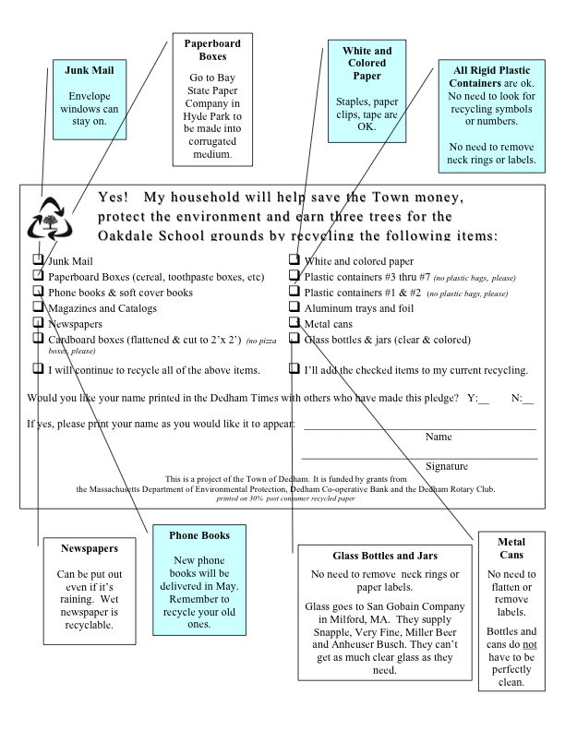
Facsimile of the Pledge Card with Reminders for Volunteers

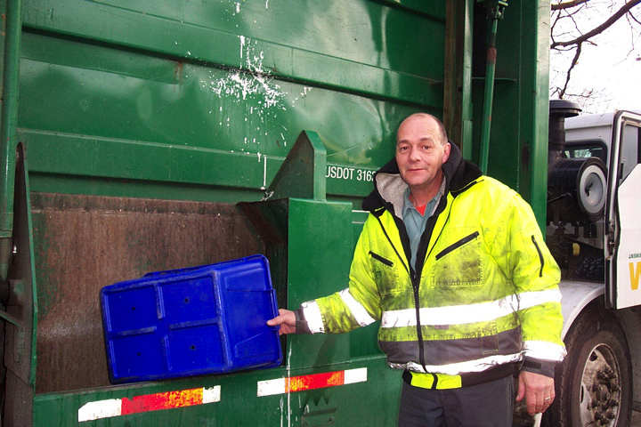
Photo of Dedham Recycling Truck Driver Calvin White

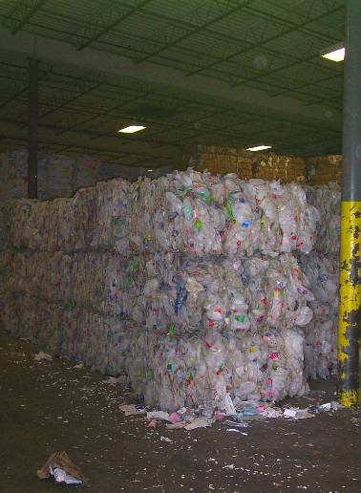

Recycling Facility Photos

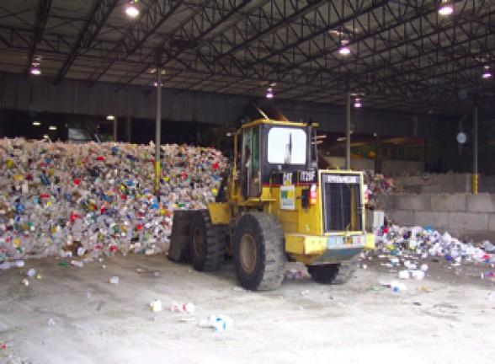

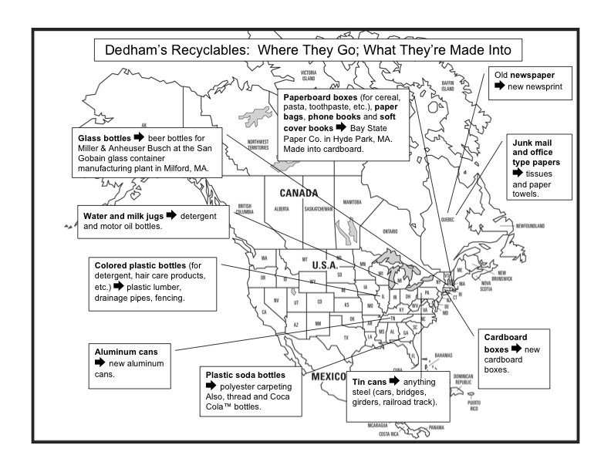
End Products Map

Frequently Asked Questions

Recycling Paper and Bottles and Cans

Paper

Q: Can I mix papers with bottles and cans in my bin?

A: No. We can’t intermingle the papers and bottles and cans loose in the bin.

You have three options.
- You can put the paper in a paper bag standing up inside your recycling bin, next to the bottles and cans.
- You can put the bag of paper on top of your other recyclables in the bin.
- You can put paper loose in a separate bin.

WHY - The paper goes in a different compartment of the truck than the bottles and cans, so the driver needs to be able to be able to grab the paper quickly and put it in one compartment, and then dump the bottles and cans out of the bin into a different compartment.

Q: Can I mix different types of paper together in a bag or bin?

A: Yes.

That includes newspaper, magazines and catalogs, junk mail, paperboard products such as cereal, cracker and toothpaste boxes, phone books, soft cover books, and white and colored office-type paper.

Q: If it’s raining out, should I avoid putting paper out the night before my trash day?

A: There is no need to delay in putting paper out if it’s raining. Put it out whenever it’s most convenient for you.

WHY: Paper is still recyclable even if it’s wet.
Q: Can pizza boxes be recycled?

A: No.

WHY: Pizza boxes often have food left in them. At the recycling facility, there isn’t time to open each box to find out. If there is food mixed in with the paper, the recycling facility won’t be able to sell the paper. So, the recycling facility can’t accept pizza boxes, and they should be thrown away.

Q: Can paper be put in plastic bags?

A: No.

OPTIONS:
- Put paper in a separate bin
- Put paper in paper bags

If getting a hold of paper bags for storing paper is a problem, ask your grocery store to bag your groceries in a paper bag inside a plastic bag. You can store newspaper, magazines, junk mail, etc. all together in a paper bag that’s in a plastic bag. Then, when you take it out to the curb for pick up, just slip the plastic bag off and reuse it or recycle it. Plastic bags cannot be recycled at the curb, but most grocery stores in Dedham take back plastic bags for recycling.

WHY: Plastics bags cause real problems in the paper manufacturing process, and it would be virtually impossible to remove all plastic bags if they were commonly used to recycle paper. So, the recycling facility does not accept them.

Q: If I recycle my junk mail, don’t I have to worry about identity theft?

A: While the likelihood of problems is low, it is not zero. Junk mail in your recycling or in your trash is accessible to those who would use it for the wrong reasons. Tear up potentially revealing junk mail before recycling it, or, if you are serious about preventing identity theft, buy a shredder, and shred papers with personal or financial information. The shredded paper can then be recycled.

Q: How do I recycle big cardboard boxes?

A: Flatten the box and cut or bend it to 2’x2’ square. Put the cardboard with your recycling, well away from your trash.

WHY: The cardboard can jam up the truck if it is too big. The flyers in the past have said cardboard can be as big as 3’x3’, but to be sure everything can be collected, the drivers have asked for 2’x2’.

Q: Are milk and juice cartons recyclable?

A: No.

Bottles and Cans

Q: Does the town only take plastics labeled #1 or #2?

A: No, for a number of years now, the town has accepted all plastic containers for curbside recycling, except for plastic bags. There is no need to look for recycling symbols or numbers on the containers at all. If it’s a plastic container (as long as it’s not a plastic bag), you can recycle it at the curb.

Q: Why do bottle caps have to be removed?

A: Bottle caps are too small to be captured by the systems used to sort recyclables. So they don’t end up getting recycled.

Q: Why do bottles and cans have to be rinsed before recycling?

A: The most important reason is because washing containers before putting them in your recycling bin will help prevent odors and pests.

Q: Can I tie a bunch of milk or water jugs together so they don’t blow away.

A: No.

OPTION: A better option to save space and prevent plastic containers from blowing around is to flatten them before putting them in your bin. Stepping on the containers is an easy way to flatten them.

WHY: If the sorters at the recycling facility don’t see the string/twine/rope and remove it, it would be considered a contaminant in a load of plastic, and would lower the value of that plastic. If there is a lot of contamination in a load of plastic, it could even by rejected by the manufacturer to whom it is sold.

Recycling Containers

Q: Does the town prefer that I use one of the bins they sell?

A: It’s fine to use other containers besides a standard recycling bin. In fact, you can use any sturdy container that is roughly similar to a recycling bin in how much it holds. The Town can supply a long sticker that you can put on a container of your own choosing to identify it as a recycling container.

Some options:
- a laundry basket
- a plastic crate
- a plastic storage tub
- an indoor trash can

Please do not use the following as recycling containers:

- Trash barrels

WHY: Waste Management prefers that you not put your recycling in an outdoor trash barrel. Barrels are awkward for the driver to handle and can put him at risk of injury if they are heavy with glass or paper. Occasional use of a barrel is ok if you have an overflow of recyclables, but Waste Management asks that they not be used on a regular basis.

- Cardboard boxes

WHY: If it rains, the cardboard box could fall apart when the driver lifts it, causing recyclables to fall out the bottom. This results in a mess and lost time for the driver in cleaning up and retrieving all the recyclables.

Q: How do I get a bin?

A: You have two options:

- In the area where we are going door-to-door, we are delivering bins the first three Saturdays in May to people who need them. The cost is $5, payable to check made out to the Town of Dedham.
- Bins can be purchased for $5 at the DPW at 55 River St during open hours.

Recycling Difficulties

Q: I always forget what week I am. How can I find out?

A: Here are three suggestions:
- If your neighbors recycle, sometimes it’s easiest just to look outside and see what others are doing.
- The Town’s most recent recycling flyer lists the streets on each recycling route. [Show list on back of flyer.] Once you know whether you are in A or B week, you can look on the calendar on the front of the flyer to find out which week is your recycling week. [ Show how to figure this out with calendar.]
- If you have access to the internet, you can find out on the towns recycling website at www.town.dedham.ma.us/recycle

Q: I have difficulty finding enough space to store recyclables between pick ups.

A: Using a tall, narrow indoor trash can for bottles and cans may help by taking up less floor space than a bin. Or stack bins on top of each other once they fill up. If you put your paper in paper bags, they can be stored in nooks and crannies where a bin won’t fit.

Q: I don’t have time to recycle.

A: If you don’t have time to recycle the full range of items, you can still make a big difference by recycling the items that involve the least amount of preparation. Just put the items below in a paper bag or a bin, and set them out when your neighbors do.

Option 1: Just recycle newspaper.
Option 2: No newspaper? Recycle magazines, catalogs and junk mail.

The Recycling Process

Q: Does everything get mixed together in the recycling truck?

A: No.

WHY: There are several compartments on the side of the truck. The driver puts paper in the front compartments and bottles and cans in the back compartments. When the compartments are full, he pulls a lever, and the compartments are lifted up. The top of the truck opens, and the material in the compartments dumps into the truck. The truck has a partition inside that separates the front of the truck, where the paper is, from the back of the truck, where the bottles and cans are.

Q: Where do my papers and bottles and cans go after they are picked up?

A: They go to a recycling facility in Avon, MA. There, they are sorted, baled and shipped to manufacturers around the US and Canada.

Q: How are all of the materials, like the plastics, metals and glass separated from each other at the recycling facility?

A: The materials are put on a conveyor belt and sorted by a combination of manual and mechanical means. For example, tin cans are steel inside, so they separate them by putting a powerful magnet above the belt. When the cans pass under the magnet, they jump right off the belt and stick to the magnet. The light plastics and aluminum are separated from the heavy glass using a stream of air. The air blows the light plastics and aluminum in one direction, whereas the heavy glass is unaffected and continues along its original path. The different types of plastics are usually sorted from each other by hand.

Yard Waste

Q: What is the price of the yard bags sold through the town compared to what I might pay at Home Depot or another store that sells them independently?

A: Bags sold thru the town cost about the same as through a store.

Q: Why is the cost of yard bags so high?

A: The town has been losing money on them for a good 4 or 5 years now. They finally decided to raise the price just to break even.

Q: If Town makes money recycling, why can’t they subsidize the bags?

A: The town never intended to subsidize the bags, they had originally sold them because Dedham was among the first communities to start yard waste collections, so the bags needed to say Town of Dedham, so we could distinguish them from other towns yard waste. Now that this is not necessary, the bags are simply sold at town hall as a service.

Q: Can I put yard waste in a trash barrel?

A: Yes, as long as it is marked with a yard waste sticker, which can be picked up at Town Hall.

Q: Will the Town pick up tree branches with the yard waste?

A: Branches less than 1” in diameter will be picked up. The branches must be cut into 4’ lengths, bundled and tied. Larger branches should be disposed of through a private contractor.

Q: Why did the drivers have so many problems picking up yard waste last year?

A: The explanation given to us was that they got a massive amount of leaves in a short period of time, and so they got backed up and that carried on throughout the rest of the season. This year, we are really going to be pushing the collection company to stay on schedule. If the yard waste is late again, the best solution is to call Waste Management to let them know and keep your yard waste outside for them to pick it up.

Q: Is it true that there is only one pickup a month in June, July and August?

A: Yes, the reason for this was that in the summer months, very little is actually collected, whereas a lot is collected in the spring and late fall. So yard waste collection started two weeks earlier in the spring and extended two more weeks into December. If you have a lot of grass clippings, you can actually mow the lawn without a bag and leave the clippings on the lawn. This actually helps keep your lawn healthier.

Q: Could the town continue to collect yard waste after Thanksgiving?

A: Actually, yard waste is now collected through December 17th.

Recycling Items Other than Paper, Bottles, Cans and Yard Waste

Q: How do I get a sticker to have a television or computer picked up?

A: Stickers can be purchased at the Town Collector’s Office during regular Town Hall hours. A pick up date will be provided when the sticker is purchased. [Provide the resident with a copy of the flyer, and point out that this information on the inside of the front page, in case they need a refresher at some point.]

Q: How do I get an appliance picked up?

A: Call 1-800-262-5633 and a pick up date will be provided. [Provide resident with a copy of the flyer and point out that this information is on the inside of the front page]

Miscellaneous

Q: How is Dedham’s recycling compared to that of other communities?

A: The average community recycling rate statewide in 2002 was about 33%, meaning that on average, Massachusetts communities are recycling 33% of the trash that they used to throw away. In Dedham, the recycling rate was about 24% in 2002. It has gone down a little from 2001, when it was 26%. Westwood recycles 37% and Natick recycles 30% of their trash.

Q: Would the Town consider every week collection?

A: There are no plans to switch to every other week collection at this time.

Where to Recycle:
List of Outlets for Recyclables Not Accepted at Curbside

Cell phones
- Board of Health, Town Hall, 26 Bryant St.
- Staples 450 Providence Hwy

Batteries (Rechargeable)
- Board of Health, Town Hall, 26 Bryant St.
- Radio Shack, Dedham Mall

Clothing
- St. Vincent DePaul Drop Boxes
- 1524 VFW Parkway
- 420 High St.
- Allied Dr. T Stop

Inkjet and Laser Cartridges
- Board of Health, Town Hall, 26 Bryant St.
- Staples 450 Providence Hwy

Mercury Containing Devices (Thermometers, Thermostats)
Board of Health, Town Hall, 26 Bryant St.

Plastic Bags (Recycling bin usually located near bottle area in stores)

Stop & Shop  180 Providence Hwy | Star Market  75 Spring St.  West Roxbury
Star Market  - Providence Hwy | Roche Bros.  338 Washington St.  Westwood
Stop & Shop  1025 Truman Hwy  Hyde Park | Roche Bros.  - Centre St.  West Roxbury

Styrofoam Peanuts
- Mailboxes, Etc.
- 25 E. Hoyle, Norwood
- 675 VFW Pkwy, W. Roxbury

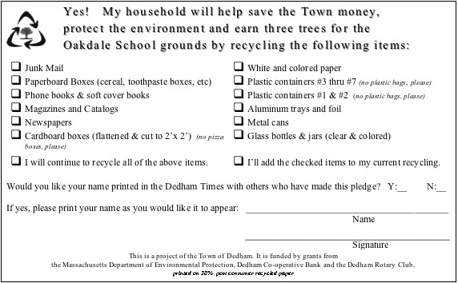
Pledge Card

Appendix F

Door-to-Door Outreach Statistics

Appendix G

Product Specifications

Pledge Card Specification

The Town of Dedham seeks printing services as specified below.

Title: Pledge card

Quantity: 325

Description: 8 ½” x 5 ½” form

Artwork: MSWord file supplied via email by customer

Stock: NCR two part form; 30% post-consumer content; white

Ink: Soy or Vegetable Ink, Black,

Proof: Via email or fax to Jan Aceti

Bindery: Adhesive at top edge attaching top and bottom form

Sandwich Board Signs

We borrowed four sandwich board sign frames from Arlington and Concord, which they had received as grant items from DEP. Concord had made pieces of plexiglass which fit over the paper signs and were held on by the snap-on frames. The plexiglass eliminated the need to have the paper signs laminated to protect them from the weather. This saved a considerable amount of money.

We had four paper signs made by Service Point USA (see vendor information below). Using Powerpoint, we created artwork in the exact proportions that we wanted these large signs to have. When printed out, the artwork filled a space 23.5” wide and 39.5” long. The signs were printed on paper 28” wide and 44” wide, so that the edges of the signs would be held securely by the snap-on frames. The signs were printed in black and white on matte paper. The print type was HP.

We placed the signs at intersections where they had a high likelihood of being seen by people entering or leaving the neighborhood.

T-Shirt Specification

The Town of Dedham seeks to purchase t-shirts as specified below.

Quantity: 40

Sizes 5 M; 20 L; 15 XL (Note: we could have used a few more mediums.)

Artwork: Adobe Illustrator file supplied via email by customer

Stock: Each t-shirt is 50% reclaimed cotton; 50% Ecospun.

T-shirt Color: white or off white

Ink Color: Black,

Printing: Large lettering on center front of t-shirt

Proof: Via email or fax to Jan Aceti

Ship to: Dave Hirschler
Recycling Coordinator
Town of Dedham
26 Bryant St.
Dedham, MA 02026

Ship Via: Best Way

Plastic Lumber Sign Specification and Cost Breakdown

Plastic Lumber Company Product # PLC-10585.

(See below for vendor information)
Description | Cost
018”x32”x3/4” Sign  Double-sided, routed letter  Color: Beige Background with routed red letters | $310
Two 3 ½” Round x 7’ Steel Reinforced Plastic Posts  Color: Brown | $125
Packaging Fee  (fee applies only if posts are ordered) | $15
Estimated freight (sign and posts) | $130
TOTAL | $580

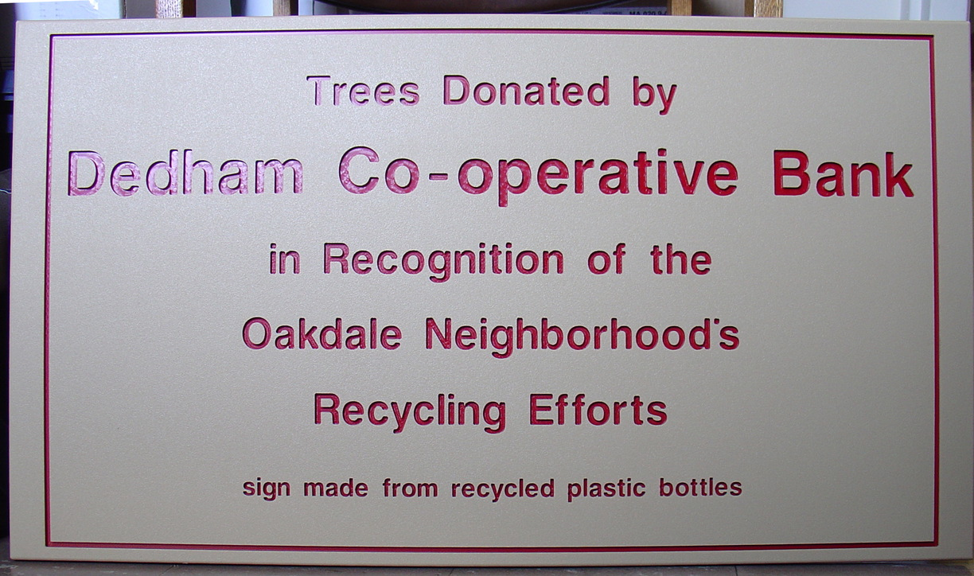

Appendix H

Vendors
Door Hanger Production | Louis Lopilato  Commonwealth Copy  710 Commonwealth Ave  Boston, MA 02215-2423  Ph: 617-536-6666 • Fax: 617-247-3100 Louis@commcopy.com
Pledge Cards | Michael Morin  Environmental Printing Alternatives  175 West Main Street  Millbury, MA 01527  508-865-0400  www.epa-soyboys.com
Sandwich Board Signs | Service Point USA  45 Batterymarch St.  Boston, MA  781-935-6020 x527  www.servicepointusa.com
T-Shirts | Claudia Thompson  Signature Marketing  134 West Street  Simsbury, CT 06070  800-658-7172
Recycled Plastic Clipboards | Nelson Office Products  199 Winter St.  Hanover, MA 02339  (781) 878-4474
Trees | Northeast Nursery  234 Newbury St.  Route 1 South  Peabody, MA 01960  978-535-6550  www.northeastnursery.com
Plastic Lumber Sign | Timothy E. Pinnow  Plastic Lumber Company, Inc.  115 W. Bartges St.  Akron, OH 44311  800-886-8990 x208  tpinnow@plasticlumber.com  www.plasticlumber.com

Appendix I

Advertisement in the Dedham Times

