The Concord Outdoor Water Efficiency Strategy

Background
The Town of Concord, Massachusetts supplies its residents and businesses with water supplied by groundwater wells and Nagog Pond, in nearby Littleton and Acton, MA. Since 1997, the Town has implemented a multi-faceted water conservation program that incorporates a tiered rate system, water-saving device give-aways, residential water audits, and numerous outreach programs. Water conservation is part of the Town’s long-term strategy to maintain water quality and reliability of service. Over the past eight years, Concord’s water consumption has gone down seven percent while the number of customers has grown by seven percent.

Despite these successes, the Town believes more can be done, particularly during periods of high water demand in the summertime. Summer water use in Concord jumps at least 50 percent. In some neighborhoods it triples and it is not unusual for some residents to use ten times more water in the summer than during the rest of the year. The Town recognizes that its conservation message needs to reach deeper into the community and that it needed to be more creative with its outreach method. With grant funding from the Massachusetts Department of Environmental Protection, the Town embarked on a new initiative and piloted a strategy in 2005 to promote more efficient outdoor water use in these neighborhoods.

In order to understand the factors influencing high water users, the Town conducted a focus group composed of residents who are in the top 10% of water users, based on an average of the last three years’ water consumption. Of the eight participants, four were men and four were women. Two of the participants were between 35 and 44 years old; three were between 45 and 54 and three were between 55 and 69 years old. All had college degrees. One participant had an annual household income in the range of $35,000 - $50,000; one in the range of $50,000 - $100,000; two in the range of $100,000 - $200,000 and four had household incomes greater than $200,000 per year. Two participants do all or virtually all of their lawn and garden care. The others hire one or more contractors to do the labor, but make day-to-day decisions about how their lawn and/or gardens are cared for. Six of the eight focus group members have in-ground irrigation systems.

The strategy addressed several factors that were identified as a result of the focus group research:

Barriers to Reducing Outdoor Water Use
Lack of Knowledge
- More than half of the focus group participants volunteered that they were unaware of a problem with water use in Concord or didn’t see the threat as credible, if they had heard about it.
- About half of the focus group members, all high water users, volunteered the opinion that they and other members of the group are already water efficient. Research done by the Irrigation Association also indicates that high water users tend to be unaware of their status as such.
- Many people don’t have accurate knowledge about how much water a lawn needs. Even if they do, they tend not to know how to determine if their lawn is getting that much or not.
- Focus group members were largely unaware of the most effective way to reduce the amount of water necessary to maintain a healthy lawn, which is to improve overall soil health.
- The most commonly expressed barrier to replacing lawn with drought resistant plants was the need to be convinced that the alternatives would be more attractive than lawn.
Desire for a Well-Maintained Lawn
- Even if the cost of water influences people’s lawn watering practices at all, it is secondary to people’s desire to have a good-looking lawn.
Opposition to Regulations and Water Conservation Rates
- For half of the individuals in the group, the town’s lawn watering regulations and higher rates for peak consumption generate resentment, or at best, a sense of resignation.

Motivations for Reducing Outdoor Water Use
- There was some agreement among focus group participants that a concrete, simple and compelling explanation of the threat would mobilize people.
- Focus group members by and large view themselves, their neighbors and Concord residents as responsible and willing to do the right thing for the common good.

Sources of Lawn Care Information
- Focus group participants get lawn and garden care information from multiple sources, most commonly including neighbors and friends.
- If participants had the opportunity to take advantage of other sources of information, they would most value the advice of an independent expert, such as a university extension agent.
- It is important to note that other research reveals a broad pattern indicating that education about lawn care comes mainly from TV commercials, product labels, store attendants and lawn care companies. Responses from Concord focus group members on this topic are an exception to the rule.

The Strategy
The strategy that the Town developed, in conjunction with its consultant, Aceti Associates, used a number of behavior change tools to overcome the barriers and strengthen the motivations listed above. The strategy was piloted among thirty-one households on Partridge Lane. Fifteen of the thirty-one households on this street are in the top 10% of Concord residential water users. Five of the fifteen households have higher than average winter water use, indicating that large families or other factors may have pushed them into the top 10%. The remaining ten households have average winter water use, but use much more water than average in the summer.

The median age of the homeowners on Partridge Lane is fifty. The homes on the street are 10-15 years old and most properties are about ½ acre. Assessed home/property values run from $900,000 to $1.4 million.

The strategy had three components:
- A series of three one-page, double-sided newsletters that were sent to the households on Partridge Lane. The newsletters can be found at www.concordnet.org/dpw/w&s/html/ smartscapemain.htm.
- Customized letters sent to the ten households with high summer water usage and
- Follow up phone calls made to these ten households to urge them to take specific actions to reduce their water use.

Newsletters
The lead article in the first newsletter was designed to overcome lack of knowledge about the threat facing the Town if summer water use was not reduced, and to communicate the credibility of that threat. Literature in the field of stress and coping suggests that we first need to judge an issue to be a threat before we are likely to take appropriate action. However, people are much more likely to take action to alleviate a threat if they perceive that they have the ability to right the problem. The newsletter article outlining the threat also noted town-wide reductions in water use to date, and coupled the threatening message with specific suggestions regarding actions individuals could take to reduce the amount of water used for lawn maintenance.

The article also fostered the likelihood of high water users discussing water efficient practices with neighbors, a process known as social diffusion. The article quoted Leonard D., a Partridge Lane resident who keeps his summer water bills low by using his in-ground irrigation system in a water efficient manner. Mr. D.’s description of his technique also served as a model for other Partridge Lane residents. Finally, the article conveyed the idea that acting responsibly – a Concord norm - includes conserving water.

Throughout the series of newsletters, articles featuring local residents were included in order to enhance social diffusion. Descriptions of water efficient practices used by these residents, often in their own words, provided models that others could follow. The newsletters also featured skill-building articles that provided residents with specific instructions on actions such as aerating their lawn, getting a soil test and determining how much water their irrigation system is supplying to their lawn. A soil test order form was included with the final newsletter, further clarifying the steps involved in getting a test, and making it more convenient to do so.

Customized Letters
With the first newsletter, high water users on Partridge Lane received a letter alerting them to the fact that their water use is higher than that of comparable properties on the street. The letter was careful to acknowledge that people view an attractive looking lawn as a valuable asset, and that far from sacrificing that asset, water efficient practices can improve a landscape’s resiliency. The letter also let residents know that they would be receiving a call from Concord’s Water Conservation Coordinator to offer free water conservation advice and services.

Due to the timing of the grant funding for this project, the newsletters, letters and follow up phone calls were delivered during July and August, peak vacation season. Further, many Concord residents, including those on Partridge Lane, tend to spend the season in extended travel or time at vacation homes. While voice mail messages were left for each high water user, the calls resulted in only a few actual conversations with residents. Vacationing patterns in Concord may explain these results.

In order to compensate for the difficulty in reaching people in person, another customized letter was sent to each high water user with the second newsletter. Since there is evidence that many high water users in Concord have in-ground irrigation systems, this letter stressed the availability of a free irrigation system audit offered by the Town. Further, this letter sought to gain people’s attention and increase the likelihood of action by framing the message in terms of the money the household was losing due to high water use.

Copies of the customized letters can be found in Appendix A.

Follow Up Phone Calls
The newsletters fostered communication between neighbors. The follow up phone calls added another element of personal contact to the strategy. Research on persuasion demonstrates that the major influence on our attitudes and behavior is our contact with other people. Joanne Bissetta, Concord’s Water Conservation Coordinator phoned the high water users on Partridge Lane after the first newsletter went out. Joanne offered residents a free irrigation system audit if they have an in-ground system and a free rain gauge if they don’t. An irrigation system auditor checks sprinkler heads, evaluates a landscape’s watering needs and inspects the soil. The audit results in recommendations for repairs and/or improvements that can save water. A rain gauge tells the homeowner how much rainfall has occurred, allowing them to reduce watering accordingly.

Joanne was also prepared to discuss several other options for saving water and improving lawn health with high water users. These included deep, infrequent watering, mowing high and soil health, with a focus on top dressing with compost. The phone conversations concluded with a request to the resident to commit to getting an audit and/or to carrying out one of the other actions.

There are a number of improvements to the phone conversation format that could make it more effective in the future. The commitment request could be coupled with an inquiry as to the date by which the resident expects to have begun the action. Further, Joanne could offer to call back around that time to see if they’re having any problems. Gaining a verbal commitment from people to begin carrying out an action by a certain date should increase the likelihood that people will do it. Following up with another phone call to troubleshoot is good customer service and further increases the sense of accountability. Joanne could also ask those who commit to carrying out a particular action for permission to publish their name and address in the next newsletter so that other neighbors might talk with them about the action they took. In addition to enhancing social diffusion, making commitments public increases motivation to act.

Strategy Results
Reductions in Water Use
The timing of the outreach during vacation season made it unlikely that residents would have had time to take action to reduce water use during those same summer months. Further, a number of the suggested actions take time to accomplish. For example, scheduling an irrigation system audit may take several weeks. Subsequently, an irrigation or lawn care contractor may need to be called to make repairs or adjustments. Some improvements to soil health, such as aeration or applying a compost top dressing, are generally done in the fall. Therefore, the Town did not attempt to evaluate changes in water use on Partridge Lane during summer 2005.

However, the Town will monitor the water use on Partridge Lane next summer to assess whether reductions may have occurred. Water use during summer 2006 will be compared to the average use for these households over the last four years. The amount of rainfall and average air temperature from year to year will also be taken into account in these comparisons.

Impact of Newsletters
In late September 2005, a newcomer to Partridge Lane called Joanne in response to a notice directing her to register her irrigation system with the Town. Her greeting indicated that she had read the second newsletter. “I’m calling from Partridge Lane, which uses all the water,” she said. “That graph really caught my eye. And, I live right across the street from the family that is testing the smart controller on their irrigation system. I’d be interested in trying one of those, too.” Although the Town had exhausted its limited supply of smart controllers available for pilot testing, the resident agreed to have her irrigation system audited and wanted to place a “Healthy Lawns for Healthy Families” sign in her pesticide-free yard.

The Town also gauged the impact of the newsletters by surveying Partridge Lane residents. A free rain gauge and inclusion in a drawing for a rain barrel were offered as incentives for responding to the mail-in survey. Thirteen of the thirty-one households completed the survey and mailed it back. Eleven of the thirteen survey respondents said they recalled receiving information about landscape care and water use during the summer. Of those eleven, ten respondents replied to a survey question about what they found most interesting. By and large, they were most interested in the practical, how-to information (e.g. “info on amount of water required,” “how to track water use”) included in the newsletters. Of the eleven who recalled receiving information, seven indicated that they either currently or intend to follow some of water-saving suggestions highlighted in the newsletters (e.g., water deeply and infrequently, get an irrigation audit, aerating lawn, etc.).

It is important to note that only two of the thirteen survey respondents were high-water-use households. As a result, the survey responses do not provide a good picture of the impact of the newsletters or customized letters on the primary target audience. The fact that so few high-water-use households responded to the survey may be an indication that the strategy failed to engage them. However, results from the follow-up phone calls, described below, indicate that exposure to the newsletters combined with a phone conversation may have the potential to influence high water users’ intention to act.

Impact of Follow-up Phone Calls
Four of the ten high-water-use households were reached in person as result of the follow up phone calls. Two of these residents had remote access to voice mail from their vacation homes and responded to the messages that Joanne had left. Neither had seen the newsletters, due to their absence. Joanne invited them to call her once they had gotten back to town and read the newsletters. The other two high water users agreed to have irrigation audits done. One of these will wait until the spring, when the Town will be hiring a new irrigation audit contractor with the ability to do more sophisticated audits. In October 2005, the Town followed up by phone with the other resident who had agreed to get an irrigation system audit this fall. She had not taken action on her commitment.

Another high-water-use household reached only by voice mail requested and received an irrigation audit. However, since the audits were also promoted town-wide in the local newspaper, it is unclear what specifically motivated this resident to request the audit.

Expanding the Strategy – Recommended Components
There are several additional elements that could be incorporated into this strategy.
- In order to maximize social diffusion, publicize the water-saving actions of residents who have broad personal networks in the neighborhood.
- As an incentive to have an irrigation system audit, offer the resident a coupon to offset the cost of paying their irrigation or landscaping company to come and reprogram or repair the system if needed.
- Provide a free soil test with a follow up visit by a master gardener. The master gardener would advise the resident on interpreting the results and taking recommended actions to improve soil health and lawn care. An attempt was made to recruit volunteer master gardeners for the 2005 pilot in Concord, but it was unsuccessful. It may be effective to pay experienced, knowledgeable gardeners a small stipend to serve in this capacity. Input from Concord focus group participants indicates that independent experts who are not in the landscaping business would be most credible.
- The master gardener would also advise the resident on drought resistant/low maintenance plants that are attractive alternatives to lawn. Photos can vividly illustrate the appeal of alternatives.
- Many residents in affluent communities such as Concord use lawn care contractors for some or all of their lawn care. Involve the contractor in the visit by the master gardener. Facilitate an agreement between the resident and his/her contractor to mow high.
- Promote yearly top dressing with compost to improve soil health. Help lawn care contractors position themselves as providers of this new service.
- Set a water use reduction goal for the neighborhood and provide feedback on progress towards the goal in the newsletters.
- Towards the end of the outreach campaign, continue to develop supportive norms and promote social diffusion by publishing a booklet with neighbors’ photographs, descriptions and photos of what they did to improve the appearance of their property while using less water and a map showing where they’re located.
Additional Research Needed
In Concord, outreach on water efficient lawn care is likely to be more effective if it is delivered in May and June rather than during peak vacation season in July and August. With better-timed outreach, it would be beneficial to conduct a rigorous evaluation of this strategy by comparing changes in summer water use in a test neighborhood to changes in a control neighborhood where no targeted outreach was done. The response to the follow up phone calls shows some promise, but it would be important to confirm their effectiveness by including a larger number of households in a future pilot.

Prepared by:

Jan Aceti
Aceti Associates
Arlington, MA
781-646-4593
jan@acetiassociates.com
www.acetiassociates.com
Appendix A
Customized Letters
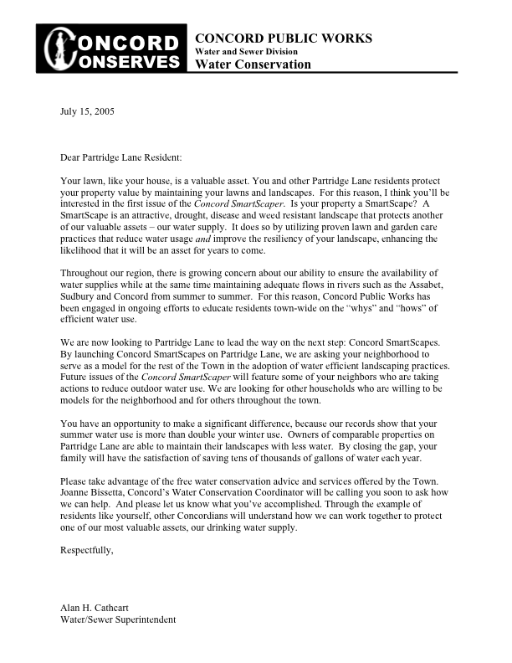
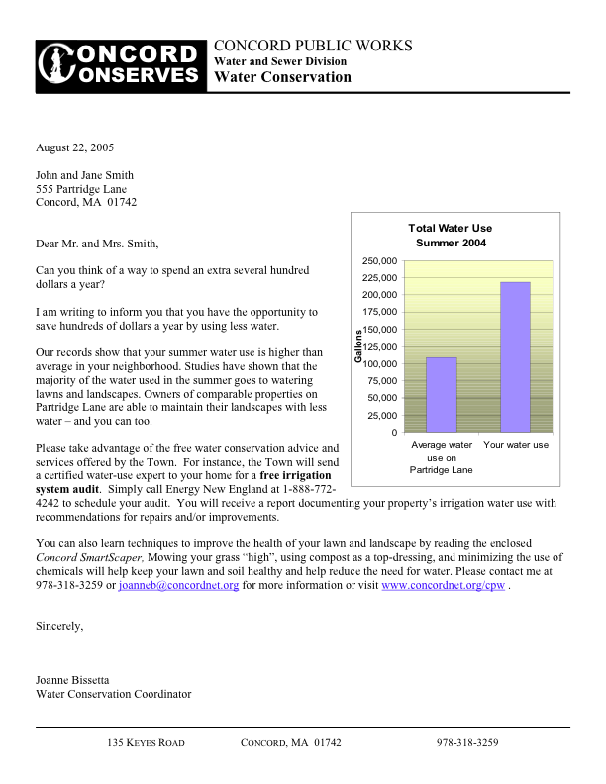

Planned Marketing Solutions International. (2003). Market Transformation Strategy. Report prepared for the Irrigation Association.
Aceti, J. (2002). Reducing Pesticide Use in Lawn Care: Barriers and Opportunities. Report prepared for the Massachusetts Department of Environmental Protection, Boston, MA.

